CORE BANKING & TRANSACTION MANAGEMENT SYSTEM

PROJECT REPORT REVIEW 3
Submitted by

MIRZA MOHAMMAD ABBAS (24BDS0202)
ADITYA KUMAR SAHU (24BAI0128)
RISHAV MANJHI (24BAI0001)

Prepared For

DATABASE SYSTEMS (BCSE302P) -Lab PROJECT

Submitted To

Dr. Anand Bihari

School of Computer Science and Engineering



Abstract
The Core Banking & Transaction Management System implements a relational banking laboratory in PostgreSQL with twelve connected operational entities. It supports KYC onboarding, multi-branch customer accounts, positive-valued transaction events, loan origination and repayment, fixed deposits, saved beneficiaries, employee records and independent audit events. Postal and bank directories isolate shared facts; primary, unique, foreign-key, domain and date constraints enforce the declared data model.
The database layer combines thirty-five standard SQL demonstrations and ten managerial business queries with three views, two business functions, two core procedures, two triggers and two explicit cursor batches. Fund transfers lock both accounts before posting and commit account, history and trigger effects together. A rejected validation or later SQL failure undoes the enclosing transaction. Successful loan repayments reduce outstanding debt through a trigger; stored generated expressions compute EMI and deposit maturity from their input terms.
A Python FastAPI service and React 19 interface expose customer and bank-official workflows. Six customer sections show exact account ownership, statements, transfers, beneficiaries, loans, deposits and KYC. Seven official sections combine analytics, customer 360-degree inspection, account controls, loan sanctioning, fixed-deposit books, infrastructure and batch audit evidence. Both light and dark display modes are supported.
Review 2 establishes the schema, SQL coverage, programmability, transactions, indexing and role grants. Review 3 retains that evidence and adds final test outcomes, an observed two-session lock conflict, a timed demonstration runbook and complete application input/output descriptions. The implementation is a university demonstration with simulated portal identity selection; database roles are verified separately. Historical fixtures represent illustrative events and opening balances, not a complete double-entry ledger.

Table of Contents
1 Introduction 4
2 Project Scope 4
3 Key Contacts and Stakeholders 4
4 Project Resource Requirements 5
5 ER Diagram 6
6 Tables and Constraints 11
7 SQL Implementation 23
8 Advanced SQL Implementation 59
8.1 Complex Business Queries 59
8.2 Database Views 73
8.3 Stored Procedures 78
8.4 User Defined Functions 82
8.5 Triggers 85
8.6 Explicit Cursors 88
8.7 SQL Security Implementation 92
8.8 Transactions Indexing and Query Optimization 98
8.9 Review 2 Requirements Checklist 101
9 Work break down 103
10 Review Requirements 104
10.1 Concurrency and Locking Demonstration 104
10.2 Comprehensive Verification Test Suite 105
10.3 Live Demonstration Runbook 114
10.4 Working Application Modules 115
10.5 Viva Preparation and Evaluation Anchors 129
11 REVIEW EVALUATION 132

1 Introduction
Banks maintain interdependent facts about customers, servicing branches and financial products. Repeating those facts in one large relation creates update anomalies and makes ownership, debt and audit history difficult to reconcile. Our project separates those responsibilities into twelve relations and executes financial mutations within database transaction boundaries.
PostgreSQL is the authority for declared keys, relationships, generated amounts, triggers and stored workflow validation. FastAPI uses parameterized Psycopg2 statements and isolates failed requests through rollback and connection cleanup. React presents the same underlying relationships to customers and officials, making a constraint failure, successful commit or trigger-generated event visible during the viva.
The independently stored facts are designed for third normal form. Stored generated financial expressions are treated explicitly as constrained derived projections: they cannot be independently supplied or updated. Their formal functional-dependency qualification is discussed in Section 6 rather than hidden by the interface.

2 Project Scope
Area | Implemented scope
Customer lifecycle | Adult KYC record, unique identity/contact fields, approval state, searchable customer discovery and exact account ownership.
Banking products | Savings, Current and Salary accounts; five loan purposes; generated EMI; customer FDs with generated actual-day maturity.
Transactional workflows | Deposit, withdrawal, internal transfer, saved beneficiary transfer, EMI payment, funded FD creation and optional loan disbursement.
Operations and evidence | Branch/staff directories, aggregate views, cursor batches, balance audits, role grants, indexes, rollback tests and two-session row-lock proof.
System boundary | Local academic deployment. No real interbank rails, authenticated internet banking, regulatory NPA aging engine, joint-account model, general ledger, password store or repayment due-date calendar.

3 Key Contacts and Stakeholders
Name | Registration Number | Phone Number
MIRZA MOHAMMAD ABBAS | 24BDS0202 | 9451792098
ADITYA KUMAR SAHU | 24BAI0128 | 7870457312
RISHAV MANJHI | 24BAI0001 | 6287568398

Prepared for DATABASE SYSTEMS (BCSE302P) -Lab PROJECT. Submitted to Dr. Anand Bihari, School of Computer Science and Engineering.

4 Project Resource Requirements

4.1 Software Resource Requirements
Resource | Requirement and project use
Operating system | Windows 11, macOS or Linux; this evidence run used the local Windows project workspace.
DBMS | PostgreSQL 16 or later; live server reports PostgreSQL 18.6. PL/pgSQL, transactional DDL and stored generated columns are used.
Containerization | Docker; banking-postgres exposes PostgreSQL on localhost:5432.
Backend | Python 3.x (project requires >= 3.12), FastAPI, Psycopg2 and Pydantic; uv manages dependencies and execution.
Frontend | React 19, Vite, Tailwind CSS v4 with its Vite plugin, Axios, React Router, Recharts and Lucide Icons.
Database client | DBeaver for manual SQL execution, catalogue inspection and evaluator screenshots; psql for scripted execution.
System design tools | Mermaid.js flowcharts rendered in the browser as Chen rectangles, diamonds and ovals; source diagrams and PNG exports are retained in docs/diagrams. Draw.io can also edit a manually recreated version.
Report tooling | python-docx, live PostgreSQL catalogue/result capture, Word pagination and rendered-page quality checks.

4.2 Deployment and Reproducibility
uv sync
uv run uvicorn backend.main:app --reload
# In a separate terminal
cd frontend
npm install
npm run dev

FastAPI runs at http://localhost:8000 with interactive schemas at /docs. React runs at http://localhost:5173. The reports use .report_work/evidence.json, generated by collect_report_evidence.py. Report regeneration starts from immutable backups in report_backups/original, not from previously expanded reports.

5 ER Diagram
The Chen model below represents all twelve entities and eleven declared foreign-key relationships in sql/01_ddl.sql. The overview shows the relationship structure; four following attribute panels show all 81 columns without crowding the overview.
Notation: rectangle = entity; diamond = relationship; oval = attribute; underlined label = primary key; dashed oval = generated derived value. 1:N labels give maximum cardinality. Each child foreign key is mandatory, while a parent can have zero or many children. FK suffixes in the attribute panels identify physical reference columns.
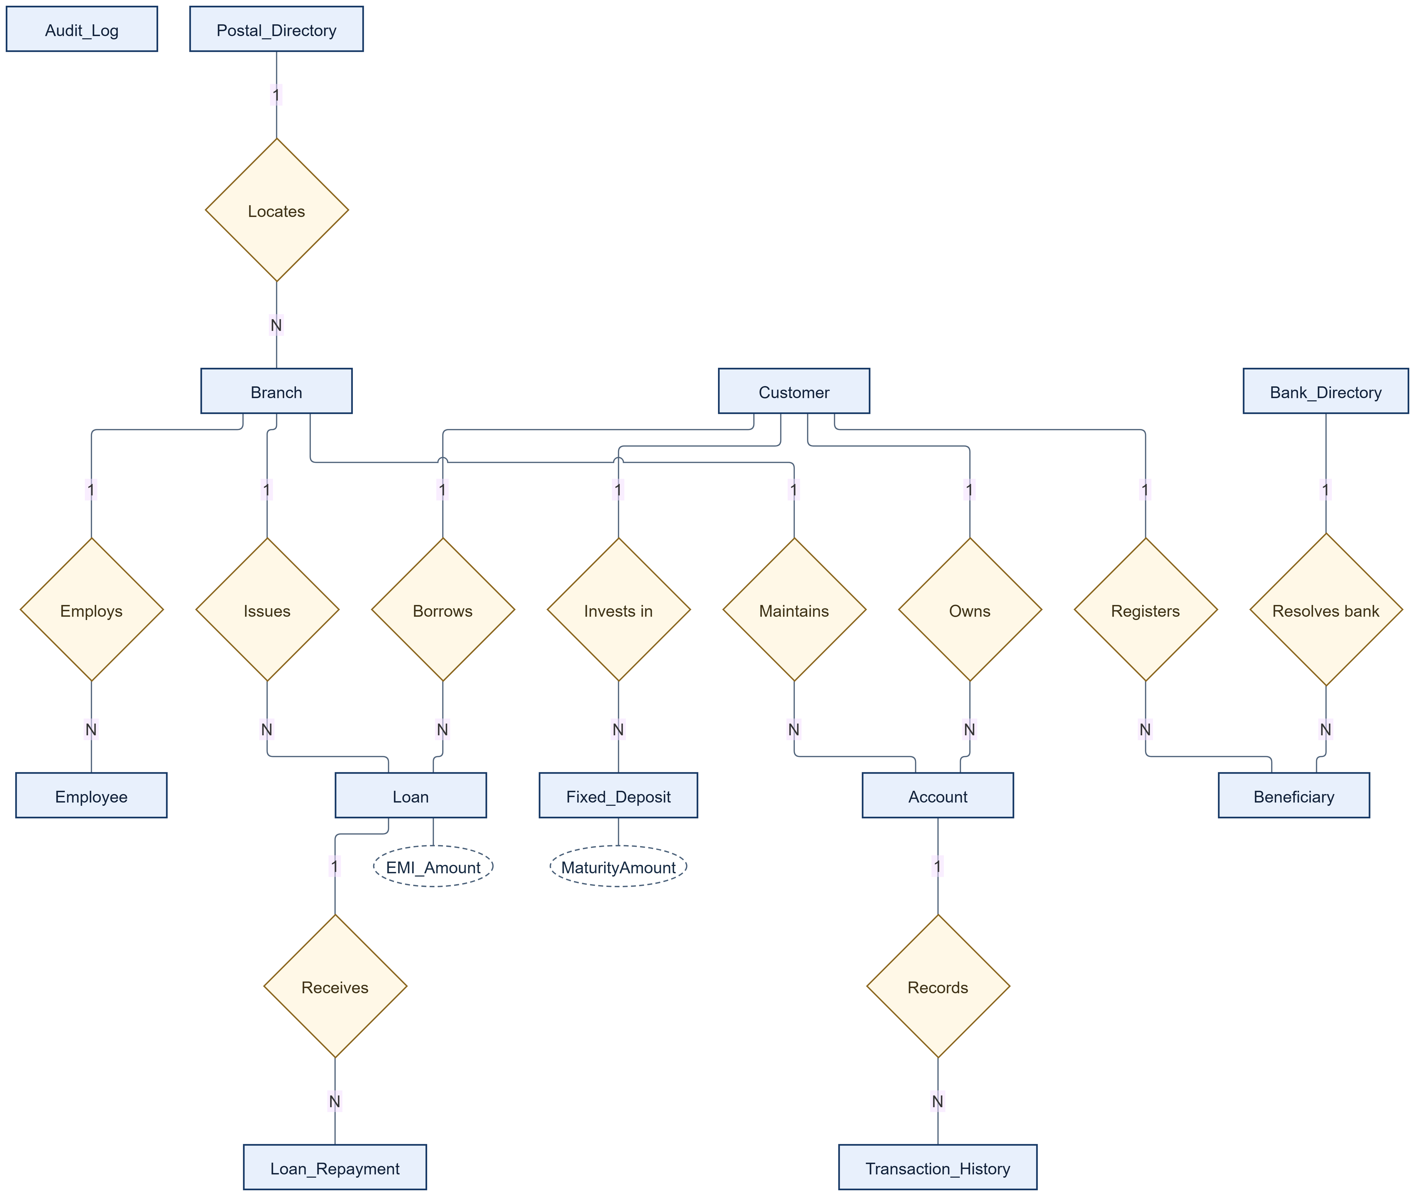
Figure 5.1 Chen relationship overview of the twelve-table banking schema
Audit_Log is independent: its TableName and RecordID identify an audit target without a declared FK. Branch.IFSC_Code does not reference Bank_Directory, and Beneficiary.LinkedAccountNo does not reference Account. External beneficiary destinations are allowed. Fixed-deposit branch attribution is a reporting rule through the customer account, rather than a declared FD-to-Branch relationship.

5.1 Customer accounts and transaction attributes
Underlined oval labels are primary keys. FK identifies a physical foreign-key column; corresponding relationships are in the overview. Dashed ovals are generated derived values. All remaining columns appear as ordinary attribute ovals.
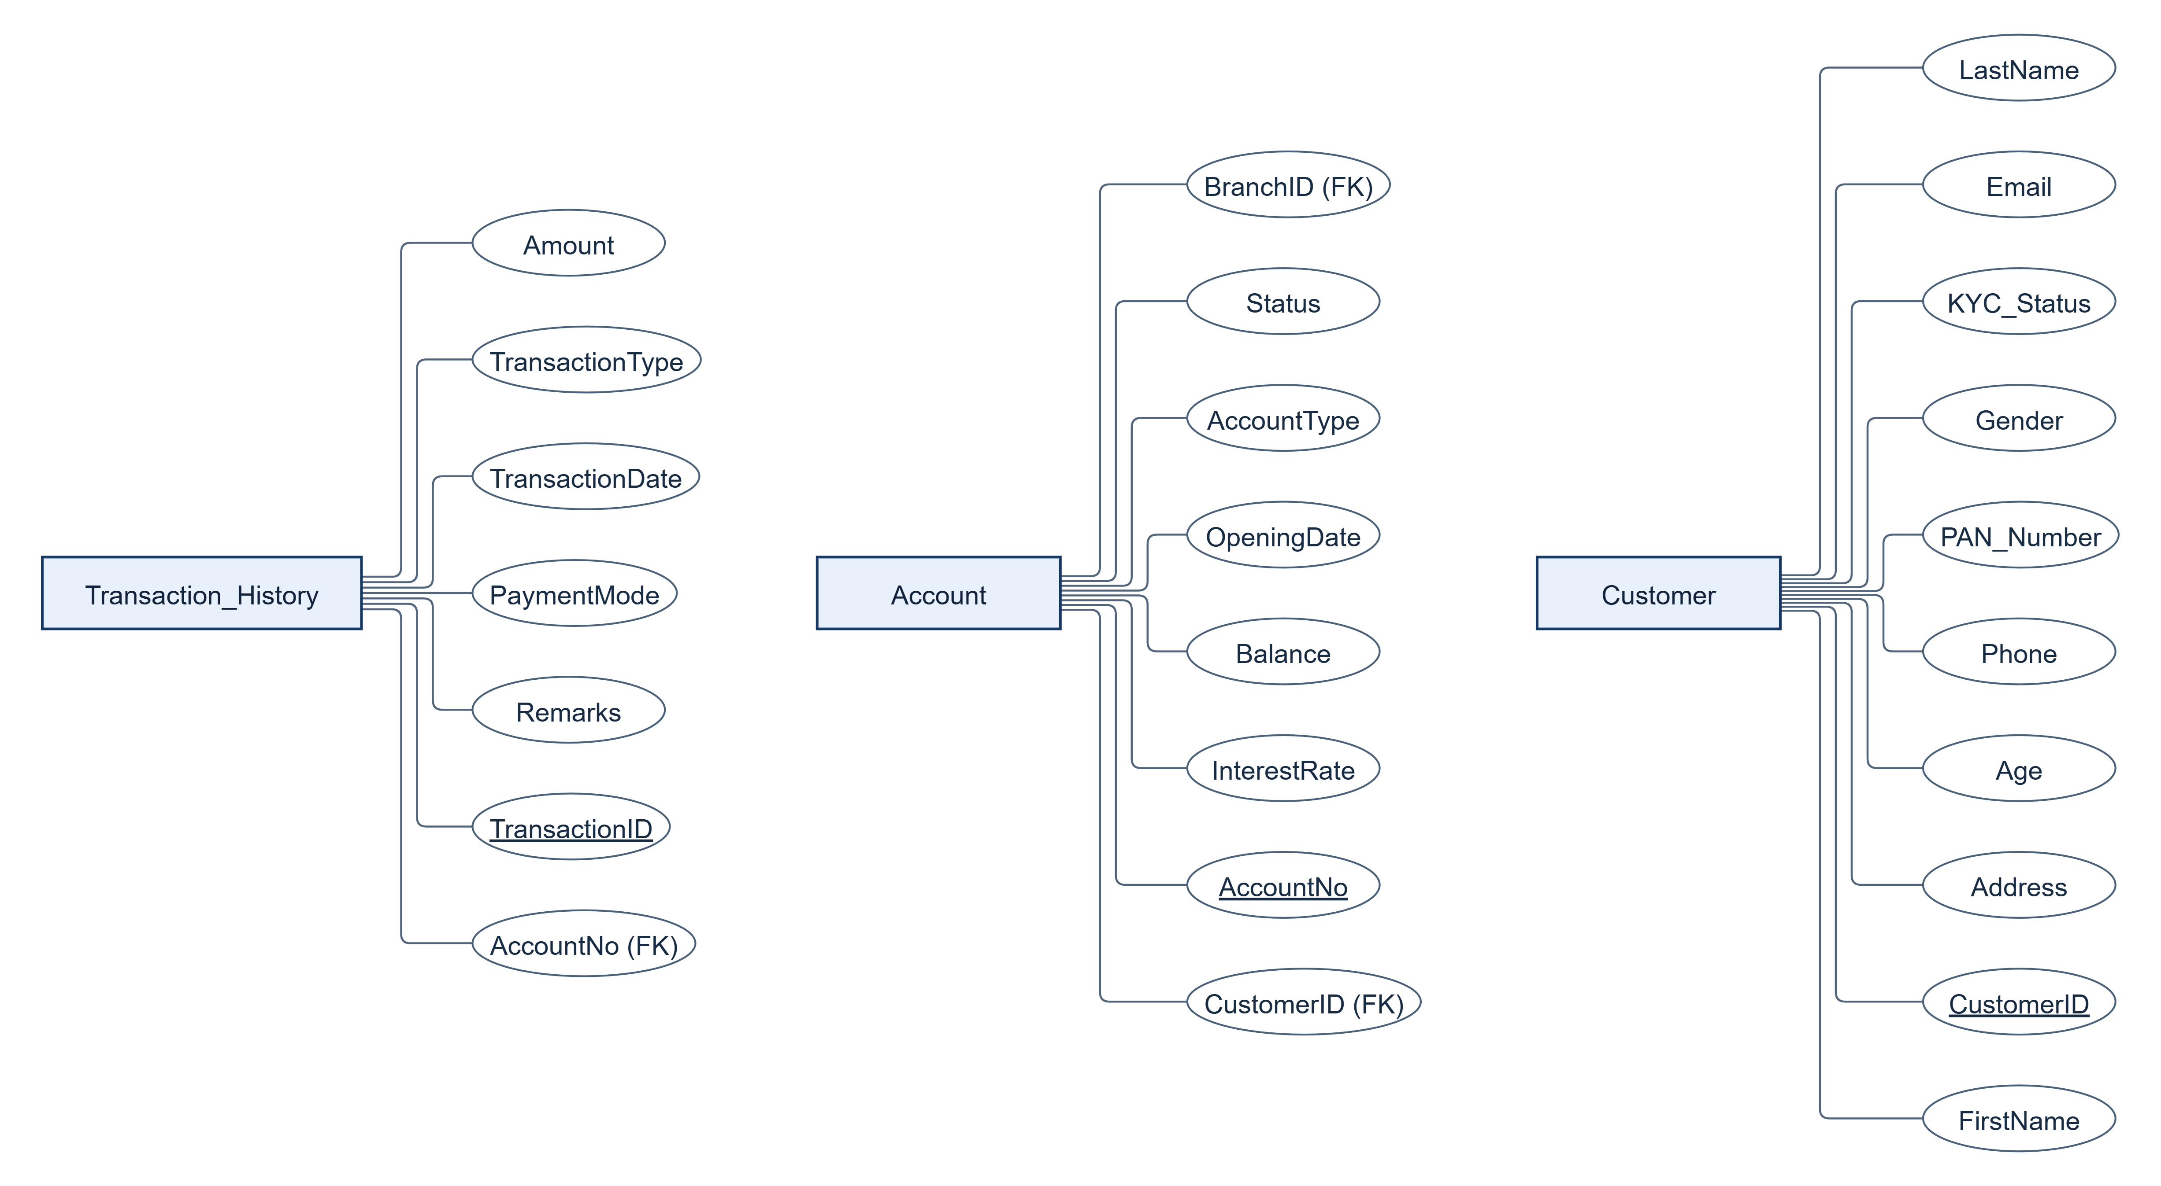
Figure 5.2 Customer accounts and transaction attributes

5.2 Loan repayment and fixed deposit attributes
Underlined oval labels are primary keys. FK identifies a physical foreign-key column; corresponding relationships are in the overview. Dashed ovals are generated derived values. All remaining columns appear as ordinary attribute ovals.
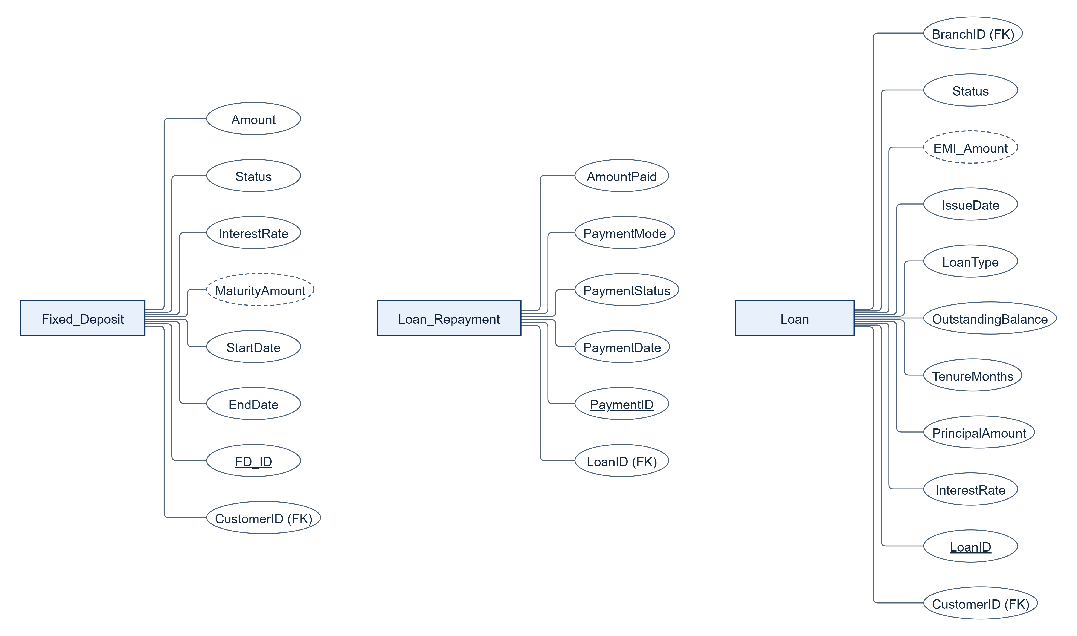
Figure 5.3 Loan repayment and fixed deposit attributes

5.3 Branch employee and postal attributes
Underlined oval labels are primary keys. FK identifies a physical foreign-key column; corresponding relationships are in the overview. Dashed ovals are generated derived values. All remaining columns appear as ordinary attribute ovals.
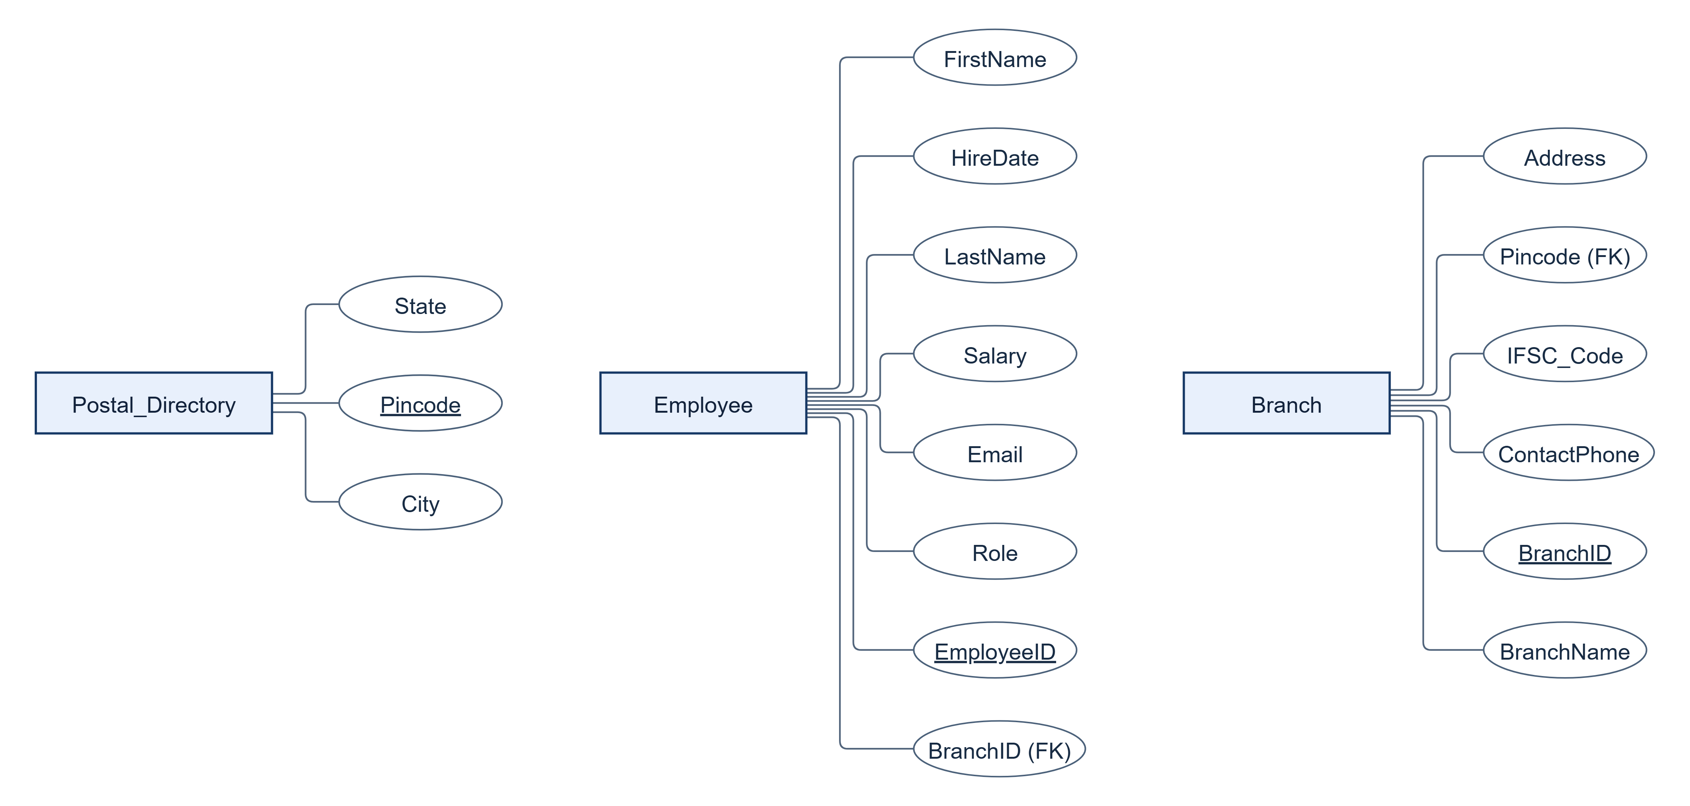
Figure 5.4 Branch employee and postal attributes

5.4 Beneficiary bank directory and audit attributes
Underlined oval labels are primary keys. FK identifies a physical foreign-key column; corresponding relationships are in the overview. Dashed ovals are generated derived values. All remaining columns appear as ordinary attribute ovals.
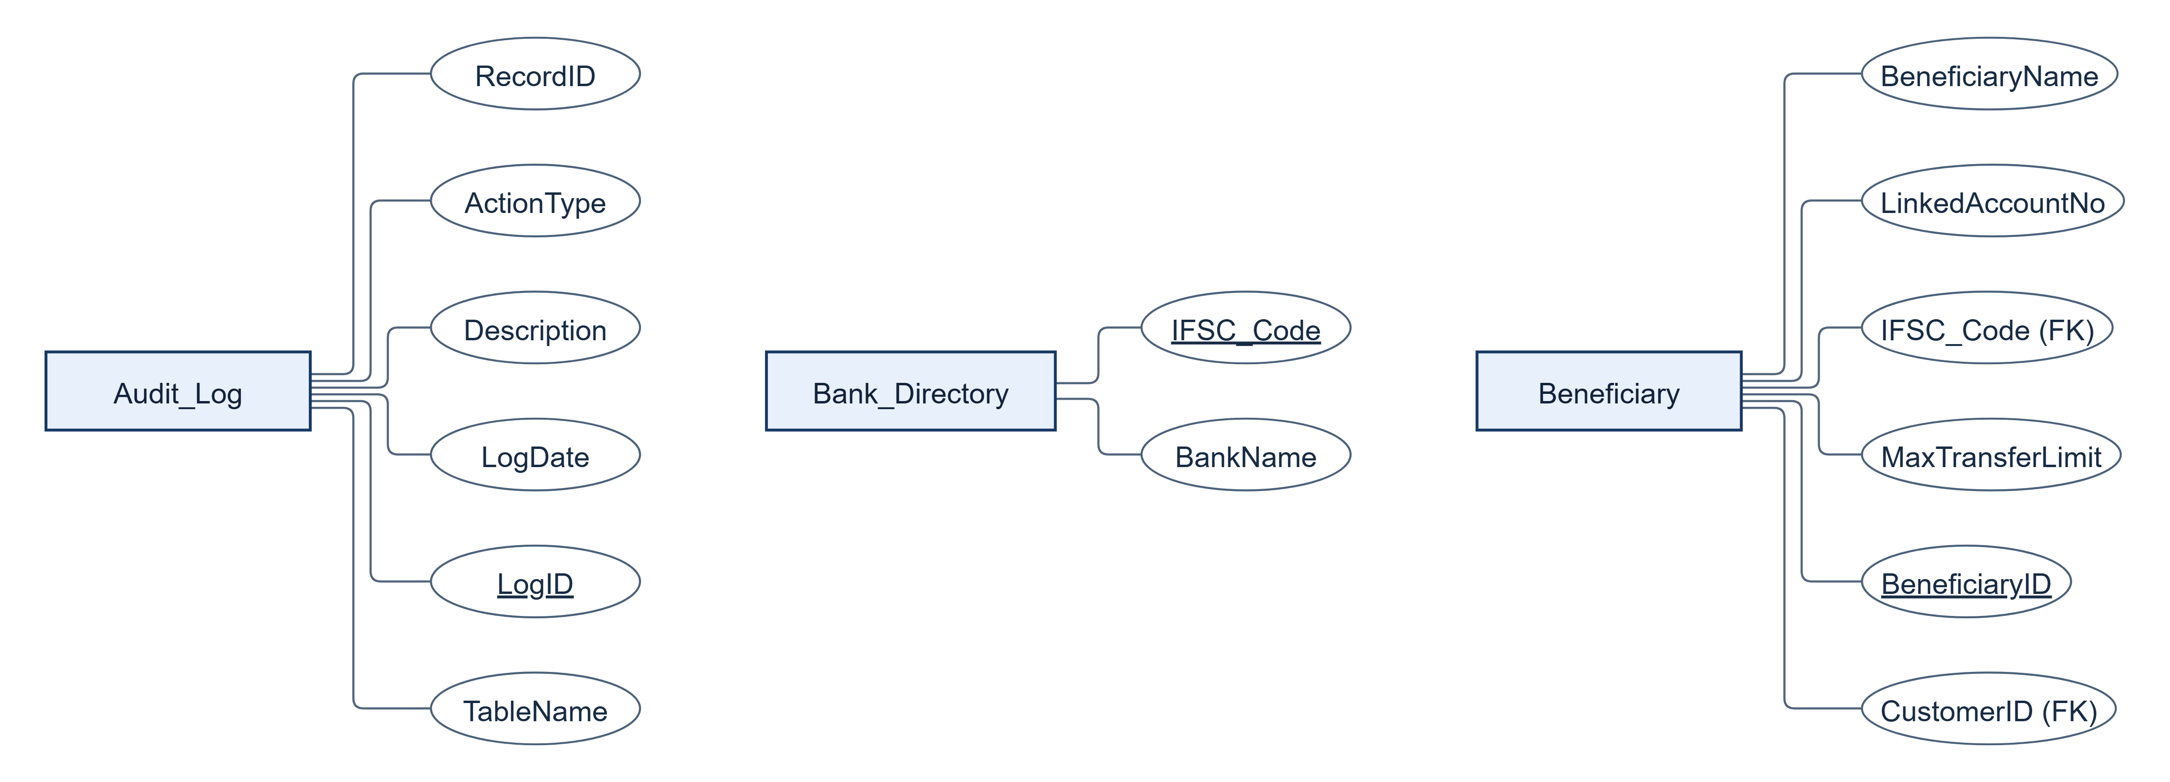
Figure 5.5 Beneficiary bank directory and audit attributes
EMI_Amount is derived from PrincipalAmount, InterestRate and TenureMonths. MaturityAmount is derived from Amount, InterestRate, StartDate and EndDate. PostgreSQL stores both as GENERATED ALWAYS expressions; their exact formulas and normalization qualification are documented in Section 6.

6 Tables and Constraints

6.1 Design Changes Since Review 1
The following change log records the requested Review 1 feedback baseline. Postal and bank lookup decomposition removes repeated directory facts; operational columns make constraints and workflow outcomes demonstrable. The current DDL is the authority for exact implementation details.
Changed component | Upgrade | Reason and integrity effect
Branch and Postal_Directory | Branch adds Address, Pincode and ContactPhone. Table 1 Postal_Directory stores City and State once per Pincode. | Removes Pincode -> City, State from Branch; avoids inconsistent edits to shared location facts.
Beneficiary and Bank_Directory | Beneficiary adds IFSC_Code and MaxTransferLimit. Table 2 Bank_Directory stores IFSC_Code -> BankName. | Separates a destination-bank fact from a customer-specific saved payee and cap.
Customer | Adds Gender, Age, Address and PAN_Number; Age >= 18 and allowed Gender CHECKs; PAN uniqueness. | Makes KYC attributes explicit and enforces adult ownership and identity uniqueness.
Loan | Adds LoanType, TenureMonths, IssueDate, OutstandingBalance and generated stored EMI_Amount. | Database computes EMI consistently from the current contract inputs; the generated value cannot be independently edited.
Fixed_Deposit | Adds StartDate, EndDate, Status and generated stored MaturityAmount. | EndDate must follow StartDate; the database enforces one maturity expression.
Other operational entities | Transaction_History adds PaymentMode and Remarks; Loan_Repayment adds PaymentMode and PaymentStatus; Account adds InterestRate and OpeningDate; Employee adds Email, Salary and HireDate; Audit_Log adds TableName and RecordID. | Makes channels, lifecycle states, product terms and audit targets available for demonstrable workflows.

6.2 Normalization and Derived Attributes
1NF: each relation has scalar attributes, one value per cell and a declared primary key; repeating products and payment attempts are separate rows. 2NF: every declared primary key is a single column, so no non-key fact depends on only part of a composite key. 3NF: owner, branch, postal and bank-name facts are separated according to the functional dependencies described for each relation below.
Formal qualification for generated attributes. In the independently stored Loan facts, LoanID determines the terms and state. However, (PrincipalAmount, InterestRate, TenureMonths) also determines EMI_Amount, and is not a superkey. Likewise (Amount, InterestRate, StartDate, EndDate) determines MaturityAmount in Fixed_Deposit. If those stored generated outputs are counted as ordinary relation attributes, strict textbook 3NF is not satisfied by that extension. The base business facts are normalized and the redundant outputs are controlled, immutable generated expressions. This is more precise than claiming that GENERATED ALWAYS automatically proves 3NF.
No additional normalization rule is silently enforced: CHECK constraints can allow NULL unless NOT NULL is also declared. Defaulted KYC/product statuses and some timestamps are nullable in the exact schema. Branch.IFSC_Code is unique but has no Bank_Directory FK; PAN format and interest-rate positivity outside Loan are principally application/domain decisions unless an explicit CHECK is listed.

6.3 Table Definitions and Creation Scripts

6.3.1 Postal_Directory
TABLE NAME: Postal_Directory
DESCRIPTION: Canonical postal location lookup shared by branches.
NORMAL FORM: 3NF. 1NF uses atomic values. 2NF follows from the single-column primary key. 3NF justification: Pincode determines City and State. Both are atomic facts about the whole postal key; neither City nor State determines a unique pincode in this model.
Attribute | Data Type | Constraint
pincode | VARCHAR(10) | NOT NULL; NOT NULL pincode; PRIMARY KEY (pincode)
city | VARCHAR(50) | NOT NULL; NOT NULL city
state | VARCHAR(50) | NOT NULL; NOT NULL state

CREATE TABLE source from sql/01_ddl.sql
CREATE TABLE Postal_Directory (
Pincode VARCHAR(10) PRIMARY KEY,
City VARCHAR(50) NOT NULL,
State VARCHAR(50) NOT NULL
);

6.3.2 Bank_Directory
TABLE NAME: Bank_Directory
DESCRIPTION: Bank-name lookup for a beneficiary destination IFSC.
NORMAL FORM: 3NF. 1NF uses atomic values. 2NF follows from the single-column primary key. 3NF justification: IFSC_Code determines BankName. A bank name may have many IFSC codes, so BankName is not a determinant of any other non-key fact in this relation.
Attribute | Data Type | Constraint
ifsc_code | VARCHAR(15) | NOT NULL; NOT NULL ifsc_code; PRIMARY KEY (ifsc_code)
bankname | VARCHAR(100) | NOT NULL; NOT NULL bankname

CREATE TABLE source from sql/01_ddl.sql
CREATE TABLE Bank_Directory (
IFSC_Code VARCHAR(15) PRIMARY KEY,
BankName VARCHAR(100) NOT NULL
);

6.3.3 Branch
TABLE NAME: Branch
DESCRIPTION: Servicing branch identity, contact details and postal reference.
NORMAL FORM: 3NF. 1NF uses atomic values. 2NF follows from the single-column primary key. 3NF justification: BranchID determines the branch facts; IFSC_Code and ContactPhone are additional unique candidate keys. City and State are looked up through Pincode instead of being repeated here.
Attribute | Data Type | Constraint
branchid | INT | NOT NULL; NOT NULL branchid; PRIMARY KEY (branchid)
branchname | VARCHAR(100) | NOT NULL; NOT NULL branchname
address | VARCHAR(200) | NOT NULL; NOT NULL address
pincode | VARCHAR(10) | NOT NULL; FOREIGN KEY (pincode) REFERENCES postal_directory(pincode); NOT NULL pincode
ifsc_code | VARCHAR(15) | NOT NULL; NOT NULL ifsc_code; UNIQUE (ifsc_code)
contactphone | VARCHAR(15) | NOT NULL; NOT NULL contactphone; UNIQUE (contactphone)

CREATE TABLE source from sql/01_ddl.sql
CREATE TABLE Branch (
BranchID INT PRIMARY KEY,
BranchName VARCHAR(100) NOT NULL,
Address VARCHAR(200) NOT NULL,
Pincode VARCHAR(10) NOT NULL REFERENCES Postal_Directory(Pincode),
IFSC_Code VARCHAR(15) UNIQUE NOT NULL,
ContactPhone VARCHAR(15) UNIQUE NOT NULL
);

6.3.4 Customer
TABLE NAME: Customer
DESCRIPTION: KYC identity and contact master for a bank customer.
NORMAL FORM: 3NF. 1NF uses atomic values. 2NF follows from the single-column primary key. 3NF justification: CustomerID determines the identity facts. Phone, Email and PAN_Number are declared unique candidate keys. No non-key determinant of another independent customer fact is assumed.
Attribute | Data Type | Constraint
customerid | INT | NOT NULL; NOT NULL customerid; PRIMARY KEY (customerid)
firstname | VARCHAR(50) | NOT NULL; NOT NULL firstname
lastname | VARCHAR(50) | NOT NULL; NOT NULL lastname
gender | VARCHAR(10) | NOT NULL; CHECK (((gender)::text = ANY ((ARRAY['Male'::character varying, 'Female'::character varying, 'Other'::character varying])::text[]))); NOT NULL gender
age | INT | NOT NULL; CHECK ((age >= 18)); NOT NULL age
address | VARCHAR(200) | NOT NULL; NOT NULL address
phone | VARCHAR(15) | NOT NULL; NOT NULL phone; UNIQUE (phone)
email | VARCHAR(100) | NOT NULL; NOT NULL email; UNIQUE (email)
pan_number | VARCHAR(10) | NOT NULL; NOT NULL pan_number; UNIQUE (pan_number)
kyc_status | VARCHAR(20) | NULL allowed; DEFAULT 'Pending'::character varying; CHECK (((kyc_status)::text = ANY ((ARRAY['Pending'::character varying, 'Approved'::character varying, 'Rejected'::character varying])::text[])))

CREATE TABLE source from sql/01_ddl.sql
CREATE TABLE Customer (
CustomerID INT PRIMARY KEY,
FirstName VARCHAR(50) NOT NULL,
LastName VARCHAR(50) NOT NULL,
Gender VARCHAR(10) NOT NULL CHECK (Gender IN ('Male', 'Female', 'Other')),
Age INT NOT NULL CHECK (Age >= 18),
Address VARCHAR(200) NOT NULL,
Phone VARCHAR(15) UNIQUE NOT NULL,
Email VARCHAR(100) UNIQUE NOT NULL,
PAN_Number VARCHAR(10) UNIQUE NOT NULL,
KYC_Status VARCHAR(20) DEFAULT 'Pending'
CHECK (KYC_Status IN ('Pending', 'Approved', 'Rejected'))
);

6.3.5 Account
TABLE NAME: Account
DESCRIPTION: A single-owner Savings, Current or Salary account at one branch.
NORMAL FORM: 3NF. 1NF uses atomic values. 2NF follows from the single-column primary key. 3NF justification: AccountNo determines CustomerID, BranchID and account-specific facts. Owner and branch descriptions remain in their own relations, removing identity and location transitive dependencies.
Attribute | Data Type | Constraint
accountno | INT | NOT NULL; NOT NULL accountno; PRIMARY KEY (accountno)
customerid | INT | NOT NULL; FOREIGN KEY (customerid) REFERENCES customer(customerid) ON DELETE CASCADE; NOT NULL customerid
branchid | INT | NOT NULL; FOREIGN KEY (branchid) REFERENCES branch(branchid); NOT NULL branchid
accounttype | VARCHAR(20) | NOT NULL; CHECK (((accounttype)::text = ANY ((ARRAY['Savings'::character varying, 'Current'::character varying, 'Salary'::character varying])::text[]))); NOT NULL accounttype
balance | DECIMAL(15,2) | NOT NULL; CHECK ((balance >= (0)::numeric)); NOT NULL balance
interestrate | DECIMAL(5,2) | NOT NULL; DEFAULT 3.50; NOT NULL interestrate
openingdate | DATE | NOT NULL; DEFAULT CURRENT_DATE; NOT NULL openingdate
status | VARCHAR(15) | NULL allowed; DEFAULT 'Active'::character varying; CHECK (((status)::text = ANY ((ARRAY['Active'::character varying, 'Dormant'::character varying, 'Frozen'::character varying, 'Closed'::character varying])::text[])))

CREATE TABLE source from sql/01_ddl.sql
CREATE TABLE Account (
AccountNo INT PRIMARY KEY,
CustomerID INT NOT NULL REFERENCES Customer(CustomerID) ON DELETE CASCADE,
BranchID INT NOT NULL REFERENCES Branch(BranchID),
AccountType VARCHAR(20) NOT NULL CHECK (AccountType IN ('Savings', 'Current', 'Salary')),
Balance DECIMAL(15, 2) NOT NULL CHECK (Balance >= 0),
InterestRate DECIMAL(5, 2) DEFAULT 3.50 NOT NULL,
OpeningDate DATE DEFAULT CURRENT_DATE NOT NULL,
Status VARCHAR(15) DEFAULT 'Active'
CHECK (Status IN ('Active', 'Dormant', 'Frozen', 'Closed'))
);

6.3.6 Transaction_History
TABLE NAME: Transaction_History
DESCRIPTION: Positive-valued account events with channel, narrative and timestamp.
NORMAL FORM: 3NF. 1NF uses atomic values. 2NF follows from the single-column primary key. 3NF justification: TransactionID determines one event. AccountNo can repeat and does not determine Amount, PaymentMode or TransactionDate; account and owner facts are not copied into the event.
Attribute | Data Type | Constraint
transactionid | SERIAL | NOT NULL; sequence default; NOT NULL transactionid; PRIMARY KEY (transactionid)
accountno | INT | NOT NULL; FOREIGN KEY (accountno) REFERENCES account(accountno); NOT NULL accountno
amount | DECIMAL(15,2) | NOT NULL; CHECK ((amount > (0)::numeric)); NOT NULL amount
transactiontype | VARCHAR(20) | NOT NULL; CHECK (((transactiontype)::text = ANY ((ARRAY['Deposit'::character varying, 'Withdrawal'::character varying, 'Transfer'::character varying])::text[]))); NOT NULL transactiontype
paymentmode | VARCHAR(20) | NOT NULL; CHECK (((paymentmode)::text = ANY ((ARRAY['UPI'::character varying, 'NEFT'::character varying, 'RTGS'::character varying, 'IMPS'::character varying, 'Cash'::character varying, 'Internal'::character varying])::text[]))); NOT NULL paymentmode
remarks | VARCHAR(255) | NULL allowed
transactiondate | TIMESTAMP | NULL allowed; DEFAULT CURRENT_TIMESTAMP

CREATE TABLE source from sql/01_ddl.sql
CREATE TABLE Transaction_History (
TransactionID SERIAL PRIMARY KEY,
AccountNo INT NOT NULL REFERENCES Account(AccountNo),
Amount DECIMAL(15, 2) NOT NULL CHECK (Amount > 0),
TransactionType VARCHAR(20) NOT NULL CHECK (TransactionType IN ('Deposit', 'Withdrawal', 'Transfer')),
PaymentMode VARCHAR(20) NOT NULL CHECK (PaymentMode IN ('UPI', 'NEFT', 'RTGS', 'IMPS', 'Cash', 'Internal')),
Remarks VARCHAR(255) NULL,
TransactionDate TIMESTAMP DEFAULT CURRENT_TIMESTAMP
);

6.3.7 Loan
TABLE NAME: Loan
DESCRIPTION: Borrower and issuing-branch loan contract, debt state and generated EMI.
NORMAL FORM: 3NF base facts with a controlled stored generated extension. 1NF uses atomic values. 2NF follows from the single-column primary key. 3NF justification: LoanID determines the independently stored contract and state facts. Borrower and branch descriptions are separated. EMI_Amount is an enforced generated projection of PrincipalAmount, InterestRate and TenureMonths; see the formal derived-column qualification below.
Attribute | Data Type | Constraint
loanid | INT | NOT NULL; NOT NULL loanid; PRIMARY KEY (loanid)
customerid | INT | NOT NULL; FOREIGN KEY (customerid) REFERENCES customer(customerid); NOT NULL customerid
branchid | INT | NOT NULL; FOREIGN KEY (branchid) REFERENCES branch(branchid); NOT NULL branchid
loantype | VARCHAR(30) | NOT NULL; CHECK (((loantype)::text = ANY ((ARRAY['Home'::character varying, 'Personal'::character varying, 'Auto'::character varying, 'Education'::character varying, 'Business'::character varying])::text[]))); NOT NULL loantype
principalamount | DECIMAL(15,2) | NOT NULL; CHECK ((principalamount > (0)::numeric)); NOT NULL principalamount
interestrate | DECIMAL(5,2) | NOT NULL; CHECK ((interestrate > (0)::numeric)); NOT NULL interestrate
tenuremonths | INT | NOT NULL; CHECK ((tenuremonths > 0)); NOT NULL tenuremonths
emi_amount | DECIMAL(15,2) | NULL allowed; GENERATED ALWAYS AS (...) STORED; full expression in DDL below
outstandingbalance | DECIMAL(15,2) | NOT NULL; CHECK ((outstandingbalance >= (0)::numeric)); NOT NULL outstandingbalance
issuedate | DATE | NOT NULL; DEFAULT CURRENT_DATE; NOT NULL issuedate
status | VARCHAR(20) | NULL allowed; DEFAULT 'Approved'::character varying; CHECK (((status)::text = ANY ((ARRAY['Pending'::character varying, 'Approved'::character varying, 'Active'::character varying, 'Closed'::character varying, 'Defaulted'::character varying])::text[])))

CREATE TABLE source from sql/01_ddl.sql
CREATE TABLE Loan (
LoanID INT PRIMARY KEY,
CustomerID INT NOT NULL REFERENCES Customer(CustomerID),
BranchID INT NOT NULL REFERENCES Branch(BranchID),
LoanType VARCHAR(30) NOT NULL CHECK (LoanType IN ('Home', 'Personal', 'Auto', 'Education', 'Business')),
PrincipalAmount DECIMAL(15, 2) NOT NULL CHECK (PrincipalAmount > 0),
InterestRate DECIMAL(5, 2) NOT NULL CHECK (InterestRate > 0),
TenureMonths INT NOT NULL CHECK (TenureMonths > 0),
EMI_Amount DECIMAL(15, 2) GENERATED ALWAYS AS (
ROUND((PrincipalAmount * (InterestRate / 1200.0)
* POWER(1 + (InterestRate / 1200.0), TenureMonths))
/ (POWER(1 + (InterestRate / 1200.0), TenureMonths) - 1), 2)
) STORED,
OutstandingBalance DECIMAL(15, 2) NOT NULL CHECK (OutstandingBalance >= 0),
IssueDate DATE DEFAULT CURRENT_DATE NOT NULL,
Status VARCHAR(20) DEFAULT 'Approved'
CHECK (Status IN ('Pending', 'Approved', 'Active', 'Closed', 'Defaulted'))
);

6.3.8 Loan_Repayment
TABLE NAME: Loan_Repayment
DESCRIPTION: A loan payment attempt, including pending and failed attempts.
NORMAL FORM: 3NF. 1NF uses atomic values. 2NF follows from the single-column primary key. 3NF justification: PaymentID determines LoanID and attempt-specific facts. LoanID can repeat across installments; loan terms and borrower identity are not redundantly stored with each attempt.
Attribute | Data Type | Constraint
paymentid | SERIAL | NOT NULL; sequence default; NOT NULL paymentid; PRIMARY KEY (paymentid)
loanid | INT | NOT NULL; FOREIGN KEY (loanid) REFERENCES loan(loanid) ON DELETE CASCADE; NOT NULL loanid
amountpaid | DECIMAL(15,2) | NOT NULL; CHECK ((amountpaid > (0)::numeric)); NOT NULL amountpaid
paymentmode | VARCHAR(20) | NOT NULL; CHECK (((paymentmode)::text = ANY ((ARRAY['Auto-Debit'::character varying, 'UPI'::character varying, 'NEFT'::character varying, 'Cash'::character varying])::text[]))); NOT NULL paymentmode
paymentstatus | VARCHAR(20) | NULL allowed; DEFAULT 'Success'::character varying; CHECK (((paymentstatus)::text = ANY ((ARRAY['Success'::character varying, 'Pending'::character varying, 'Failed'::character varying])::text[])))
paymentdate | TIMESTAMP | NULL allowed; DEFAULT CURRENT_TIMESTAMP

CREATE TABLE source from sql/01_ddl.sql
CREATE TABLE Loan_Repayment (
PaymentID SERIAL PRIMARY KEY,
LoanID INT NOT NULL REFERENCES Loan(LoanID) ON DELETE CASCADE,
AmountPaid DECIMAL(15, 2) NOT NULL CHECK (AmountPaid > 0),
PaymentMode VARCHAR(20) NOT NULL CHECK (PaymentMode IN ('Auto-Debit', 'UPI', 'NEFT', 'Cash')),
PaymentStatus VARCHAR(20) DEFAULT 'Success'
CHECK (PaymentStatus IN ('Success', 'Pending', 'Failed')),
PaymentDate TIMESTAMP DEFAULT CURRENT_TIMESTAMP
);

6.3.9 Beneficiary
TABLE NAME: Beneficiary
DESCRIPTION: Customer-owned destination record and configured transfer cap.
NORMAL FORM: 3NF. 1NF uses atomic values. 2NF follows from the single-column primary key. 3NF justification: BeneficiaryID determines the saved destination. IFSC_Code determines BankName only in Bank_Directory, preventing that transitive dependency here. LinkedAccountNo may be external and is not a local account foreign key.
Attribute | Data Type | Constraint
beneficiaryid | SERIAL | NOT NULL; sequence default; NOT NULL beneficiaryid; PRIMARY KEY (beneficiaryid)
customerid | INT | NOT NULL; FOREIGN KEY (customerid) REFERENCES customer(customerid) ON DELETE CASCADE; NOT NULL customerid
beneficiaryname | VARCHAR(100) | NOT NULL; NOT NULL beneficiaryname
linkedaccountno | BIGINT | NOT NULL; NOT NULL linkedaccountno
ifsc_code | VARCHAR(15) | NOT NULL; FOREIGN KEY (ifsc_code) REFERENCES bank_directory(ifsc_code); NOT NULL ifsc_code
maxtransferlimit | DECIMAL(15,2) | NOT NULL; DEFAULT 100000.00; NOT NULL maxtransferlimit

CREATE TABLE source from sql/01_ddl.sql
CREATE TABLE Beneficiary (
BeneficiaryID SERIAL PRIMARY KEY,
CustomerID INT NOT NULL REFERENCES Customer(CustomerID) ON DELETE CASCADE,
BeneficiaryName VARCHAR(100) NOT NULL,
LinkedAccountNo BIGINT NOT NULL,
IFSC_Code VARCHAR(15) NOT NULL REFERENCES Bank_Directory(IFSC_Code),
MaxTransferLimit DECIMAL(15, 2) DEFAULT 100000.00 NOT NULL
);

6.3.10 Fixed_Deposit
TABLE NAME: Fixed_Deposit
DESCRIPTION: Customer investment principal, term, rate and generated maturity value.
NORMAL FORM: 3NF base facts with a controlled stored generated extension. 1NF uses atomic values. 2NF follows from the single-column primary key. 3NF justification: FD_ID determines the independently stored deposit facts. Customer details are separated. MaturityAmount is generated from Amount, InterestRate, StartDate and EndDate; see the formal derived-column qualification below.
Attribute | Data Type | Constraint
fd_id | INT | NOT NULL; NOT NULL fd_id; PRIMARY KEY (fd_id)
customerid | INT | NOT NULL; FOREIGN KEY (customerid) REFERENCES customer(customerid); NOT NULL customerid
amount | DECIMAL(15,2) | NOT NULL; CHECK ((amount >= (1000)::numeric)); NOT NULL amount
interestrate | DECIMAL(5,2) | NOT NULL; NOT NULL interestrate
startdate | DATE | NOT NULL; DEFAULT CURRENT_DATE; CHECK ((enddate > startdate)); NOT NULL startdate
enddate | DATE | NOT NULL; CHECK ((enddate > startdate)); NOT NULL enddate
maturityamount | DECIMAL(15,2) | NULL allowed; GENERATED ALWAYS AS (...) STORED; full expression in DDL below
status | VARCHAR(20) | NULL allowed; DEFAULT 'Active'::character varying; CHECK (((status)::text = ANY ((ARRAY['Active'::character varying, 'Matured'::character varying, 'Closed'::character varying])::text[])))

CREATE TABLE source from sql/01_ddl.sql
CREATE TABLE Fixed_Deposit (
FD_ID INT PRIMARY KEY,
CustomerID INT NOT NULL REFERENCES Customer(CustomerID),
Amount DECIMAL(15, 2) NOT NULL CHECK (Amount >= 1000),
InterestRate DECIMAL(5, 2) NOT NULL,
StartDate DATE DEFAULT CURRENT_DATE NOT NULL,
EndDate DATE NOT NULL,
MaturityAmount DECIMAL(15, 2) GENERATED ALWAYS AS (
ROUND(Amount + (Amount * InterestRate * (EndDate - StartDate) / 36500.0), 2)
) STORED,
Status VARCHAR(20) DEFAULT 'Active' CHECK (Status IN ('Active', 'Matured', 'Closed')),
CHECK (EndDate > StartDate)
);

6.3.11 Employee
TABLE NAME: Employee
DESCRIPTION: A branch official with role, unique email and employment details.
NORMAL FORM: 3NF. 1NF uses atomic values. 2NF follows from the single-column primary key. 3NF justification: EmployeeID and the unique Email are candidate keys. Salary and HireDate are employee-specific; Role does not determine a fixed salary, and branch descriptions are not repeated.
Attribute | Data Type | Constraint
employeeid | INT | NOT NULL; NOT NULL employeeid; PRIMARY KEY (employeeid)
branchid | INT | NOT NULL; FOREIGN KEY (branchid) REFERENCES branch(branchid); NOT NULL branchid
firstname | VARCHAR(50) | NOT NULL; NOT NULL firstname
lastname | VARCHAR(50) | NOT NULL; NOT NULL lastname
email | VARCHAR(100) | NOT NULL; NOT NULL email; UNIQUE (email)
role | VARCHAR(30) | NOT NULL; NOT NULL role
salary | DECIMAL(12,2) | NOT NULL; CHECK ((salary > (0)::numeric)); NOT NULL salary
hiredate | DATE | NOT NULL; DEFAULT CURRENT_DATE; NOT NULL hiredate

CREATE TABLE source from sql/01_ddl.sql
CREATE TABLE Employee (
EmployeeID INT PRIMARY KEY,
BranchID INT NOT NULL REFERENCES Branch(BranchID),
FirstName VARCHAR(50) NOT NULL,
LastName VARCHAR(50) NOT NULL,
Email VARCHAR(100) UNIQUE NOT NULL,
Role VARCHAR(30) NOT NULL,
Salary DECIMAL(12, 2) NOT NULL CHECK (Salary > 0),
HireDate DATE DEFAULT CURRENT_DATE NOT NULL
);

6.3.12 Audit_Log
TABLE NAME: Audit_Log
DESCRIPTION: Independent chronological evidence of record-level database activity.
NORMAL FORM: 3NF. 1NF uses atomic values. 2NF follows from the single-column primary key. 3NF justification: LogID determines the event facts. TableName plus RecordID identifies a referenced business record but may appear in many audit events. Neither determines the event description or timestamp.
Attribute | Data Type | Constraint
logid | SERIAL | NOT NULL; sequence default; NOT NULL logid; PRIMARY KEY (logid)
tablename | VARCHAR(50) | NOT NULL; NOT NULL tablename
recordid | INT | NOT NULL; NOT NULL recordid
actiontype | VARCHAR(50) | NOT NULL; NOT NULL actiontype
description | TEXT | NOT NULL; NOT NULL description
logdate | TIMESTAMP | NULL allowed; DEFAULT CURRENT_TIMESTAMP

CREATE TABLE source from sql/01_ddl.sql
CREATE TABLE Audit_Log (
LogID SERIAL PRIMARY KEY,
TableName VARCHAR(50) NOT NULL,
RecordID INT NOT NULL,
ActionType VARCHAR(50) NOT NULL,
Description TEXT NOT NULL,
LogDate TIMESTAMP DEFAULT CURRENT_TIMESTAMP
);

6.4 Table Relationships
Parent | Child | Child foreign key | Cardinality and delete rule
branch | account | branchid | 1:N; NO ACTION (default)
customer | account | customerid | 1:N; CASCADE
customer | beneficiary | customerid | 1:N; CASCADE
bank_directory | beneficiary | ifsc_code | 1:N; NO ACTION (default)
postal_directory | branch | pincode | 1:N; NO ACTION (default)
branch | employee | branchid | 1:N; NO ACTION (default)
customer | fixed_deposit | customerid | 1:N; NO ACTION (default)
branch | loan | branchid | 1:N; NO ACTION (default)
customer | loan | customerid | 1:N; NO ACTION (default)
loan | loan_repayment | loanid | 1:N; CASCADE
account | transaction_history | accountno | 1:N; NO ACTION (default)

All eleven foreign keys are NOT NULL on the child. Customer deletion cascades only to Account and Beneficiary; Loan deletion cascades to Loan_Repayment. Other references use PostgreSQL NO ACTION and can still block a cascade when protected history exists. Audit_Log.RecordID is a polymorphic identifier, so the audit table has no FK; queries must combine TableName with RecordID to avoid matching unrelated entities.

6.5 Live Row Counts and DDL Verification
Table | Rows in banking_db
Postal_Directory | 8
Bank_Directory | 10
Branch | 8
Customer | 110
Account | 162
Transaction_History | 642
Loan | 58
Loan_Repayment | 12
Beneficiary | 10
Fixed_Deposit | 48
Employee | 10
Audit_Log | 131

The live snapshot includes the initial seed, bulk fixtures and subsequent demonstration activity. seed_bulk_data.py adds 100 Customer, 150 Account, 50 Loan, 500 Transaction_History and 40 Fixed_Deposit rows per successful run using Faker en_IN and execute_values in one transaction. Never rerun it merely to reproduce an existing count.
Clean DDL and DML execution was verified separately in a disposable PostgreSQL database using the unchanged sql/01_ddl.sql and sql/02_dml.sql. Both transactions committed; the advanced verification blocks also passed. The live banking_db was not reset.
Existing-table verification in DBeaver. All twelve installed relations and their columns are queried from PostgreSQL metadata. This screenshot verifies the existing schema; the clean CREATE TABLE execution is documented by the separate disposable-database output above.
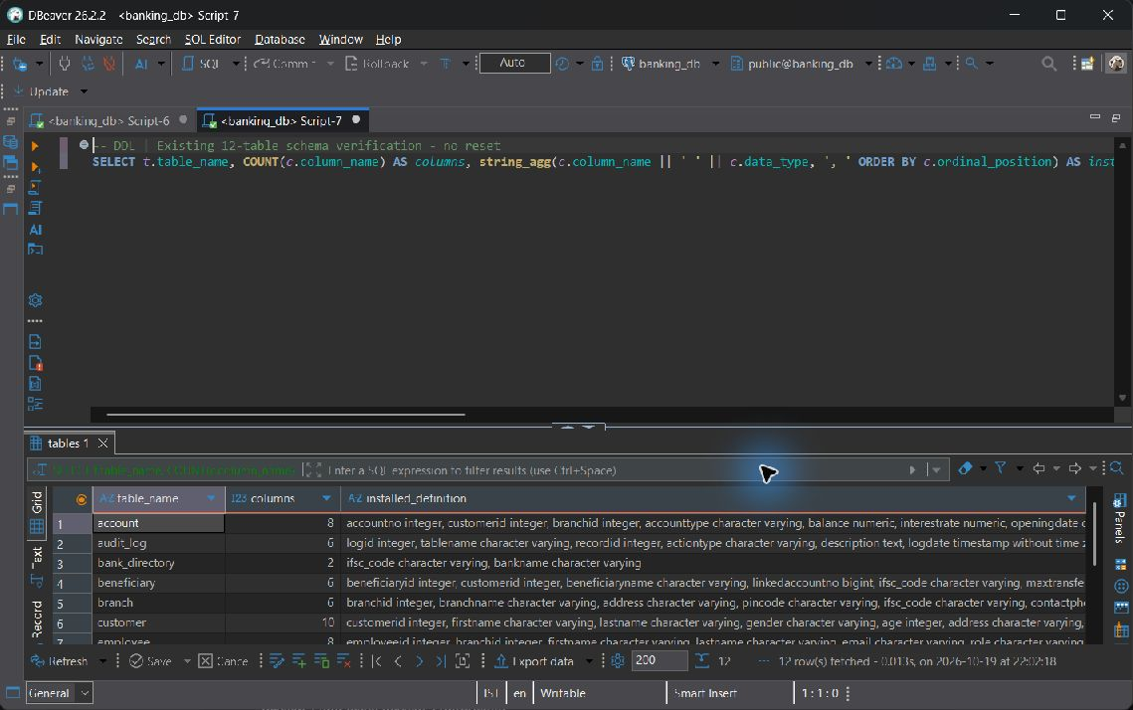

6.6 DML Operations
BEGIN;
INSERT INTO Beneficiary
(BeneficiaryID,CustomerID,BeneficiaryName,LinkedAccountNo,IFSC_Code)
VALUES (-1,1,'Temporary DML demonstration',999999999999,'NMBK0000001');
UPDATE Beneficiary SET MaxTransferLimit=25000 WHERE BeneficiaryID=-1;
DELETE FROM Beneficiary WHERE BeneficiaryID=-1;
COMMIT;

The exact INSERT -> UPDATE -> DELETE sequence appears in sql/02_dml.sql and was executed during the clean verification. Its temporary negative ID leaves no final beneficiary row. The twelve live counts above document the operational dataset rather than the smaller rebuild fixture.

7 SQL Implementation
Category | Required coverage | Min queries
A Basic | SELECT, WHERE, ORDER BY, DISTINCT, BETWEEN, IN, LIKE, IS NULL | 6; implemented 6
B Aggregate | COUNT, SUM, AVG, MIN, MAX, GROUP BY, HAVING; WHERE versus HAVING | 5; implemented 5
C Joins | INNER, LEFT, RIGHT, FULL OUTER, SELF and meaningful CROSS | 6; implemented 6
D Subqueries | Scalar, single-row, multi-row IN/ANY/ALL, correlated, EXISTS, NOT EXISTS, NOT IN with NULL fix | 6; implemented 6
E Set operations | UNION, UNION ALL, INTERSECT, EXCEPT | 4; implemented 4
F Advanced functions | CASE, COALESCE, NULLIF, AGE/EXTRACT, UPPER/CONCAT, ROUND | 4-6; implemented 4
G Window and analytic | RANK/DENSE_RANK, ROW_NUMBER, running SUM, LAG/LEAD | 4; implemented 4

Category A Basic

A-01 SELECT the customer directory in a deterministic order
SELECT CustomerID, FirstName, LastName, KYC_Status
FROM Customer
ORDER BY CustomerID;

Actual output: 110 row(s); first 3 shown. NULL denotes a missing SQL value.
customerid | firstname | lastname | kyc status
1 | Aarav | Sharma | Approved
2 | Ananya | Iyer | Approved
3 | Rohan | Rao | Approved

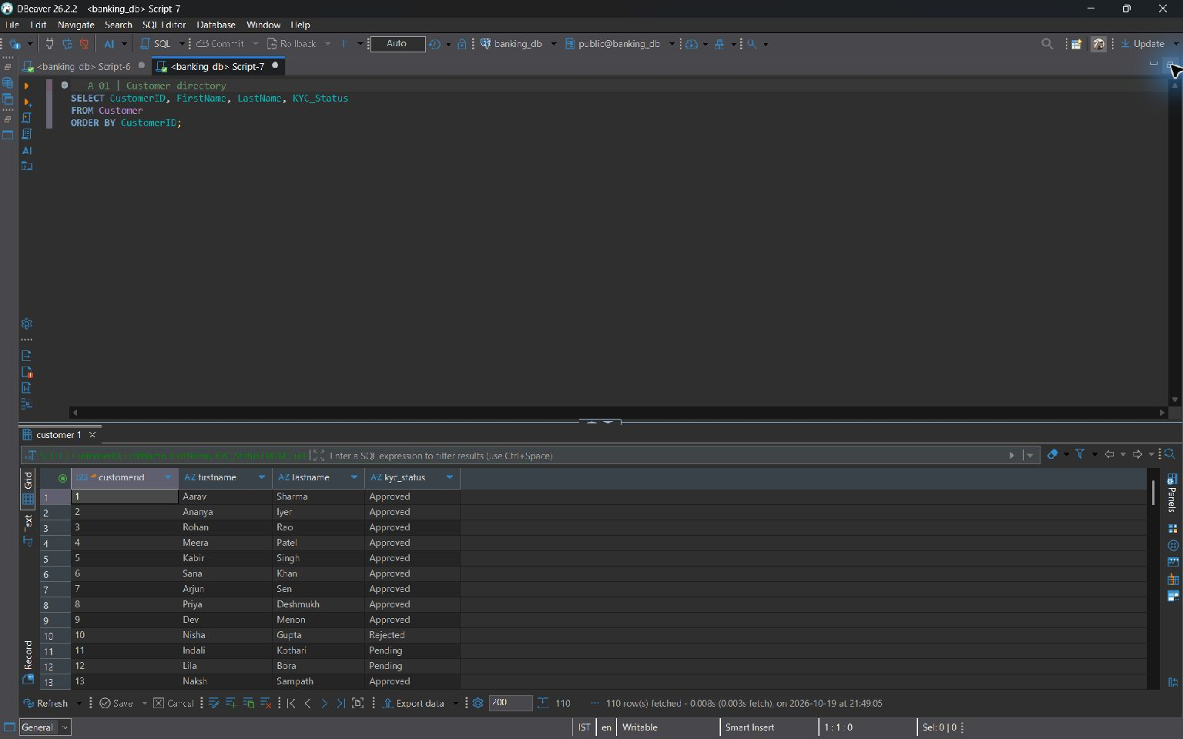
A-01 — live screenshot, 2026-10-19.

A-02 WHERE filters individual accounts; ORDER BY prioritizes balances
SELECT AccountNo, CustomerID, AccountType, Balance
FROM Account
WHERE Status = 'Active'
ORDER BY Balance DESC, AccountNo;

Actual output: 120 row(s); first 3 shown. NULL denotes a missing SQL value.
accountno | customerid | accounttype | balance
100001 | 1 | Savings | 1196030.18
100009 | 7 | Current | 740000.00
100053 | 51 | Savings | 498206.09

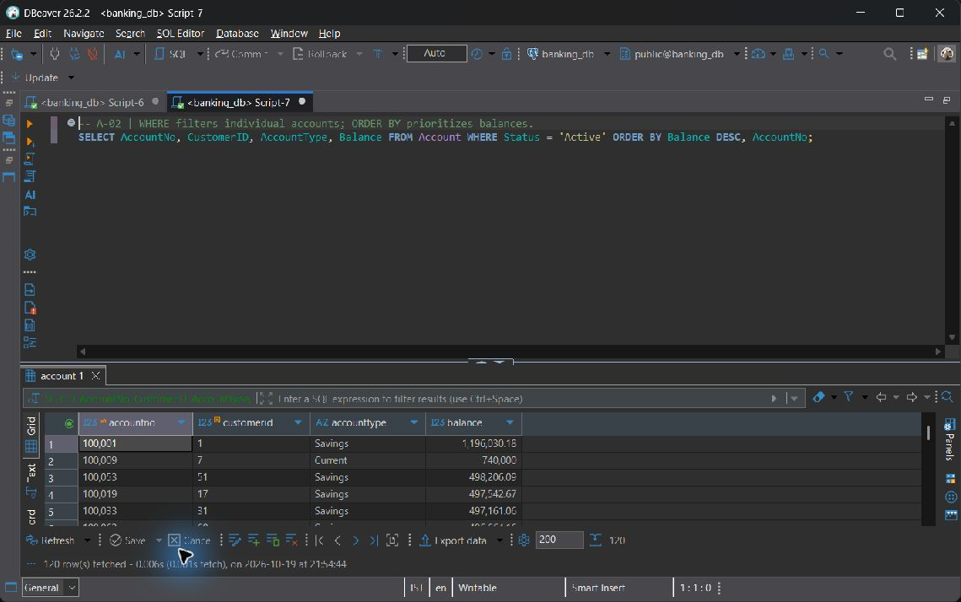
A-02 — live screenshot, 2026-10-19.

A-03 DISTINCT removes repeated account types
SELECT DISTINCT AccountType
FROM Account
ORDER BY AccountType;

Actual output: 3 row(s); first 3 shown. NULL denotes a missing SQL value.
accounttype
Current
Salary
Savings

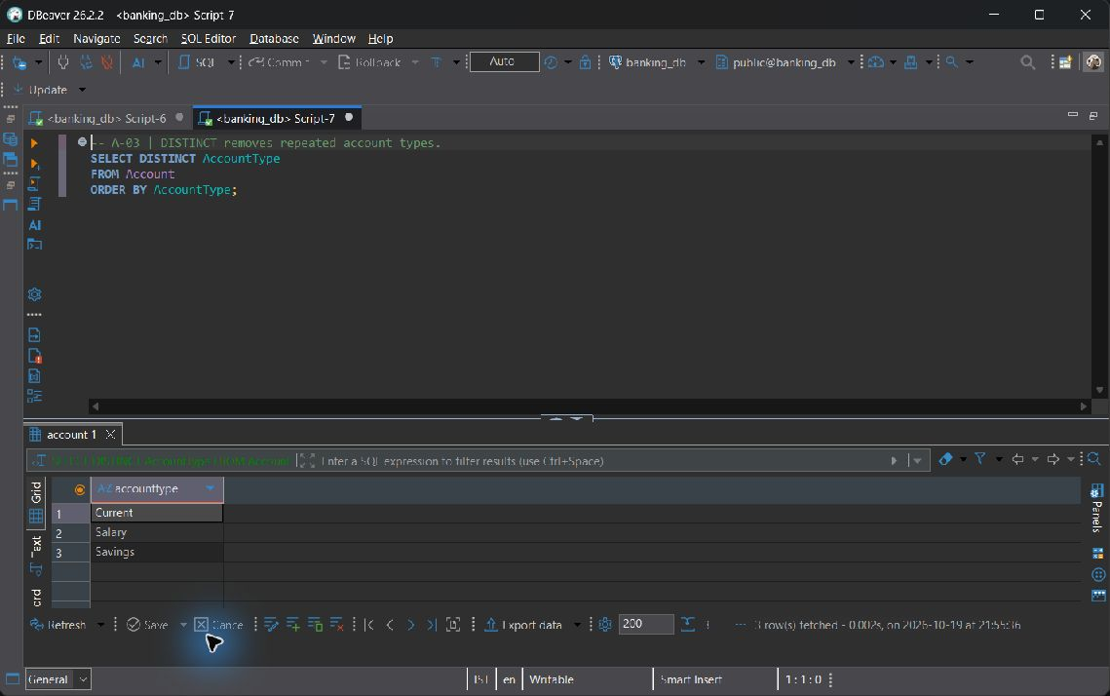
A-03 — live screenshot, 2026-10-19.

A-04 BETWEEN includes both endpoints of this balance range
SELECT AccountNo, Balance
FROM Account
WHERE Balance BETWEEN 50000 AND 250000
ORDER BY Balance, AccountNo;

Actual output: 59 row(s); first 3 shown. NULL denotes a missing SQL value.
accountno | balance
100112 | 51285.43
100010 | 56163.33
100044 | 61554.81

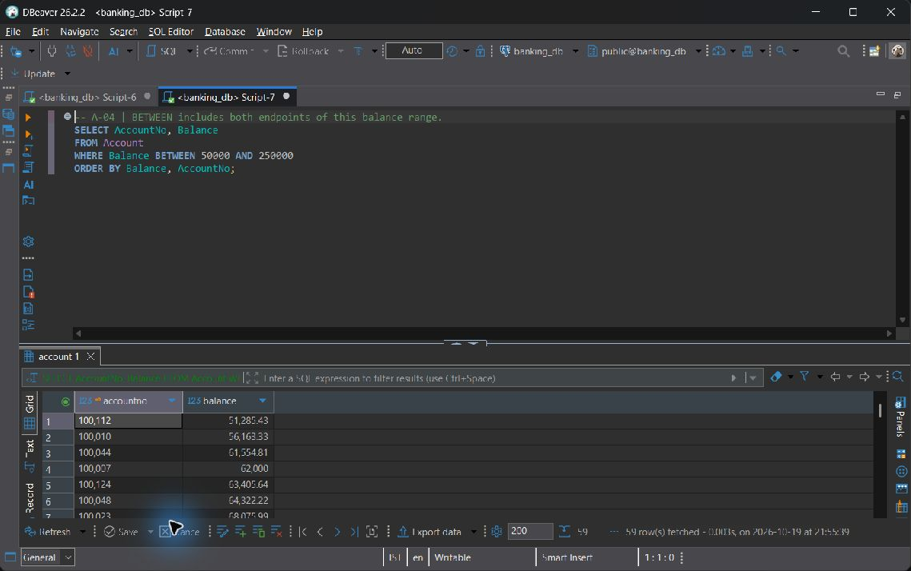
A-04 — live screenshot, 2026-10-19.

A-05 IN selects allowed KYC states; LIKE matches a name prefix
SELECT CustomerID, FirstName, LastName, KYC_Status
FROM Customer
WHERE KYC_Status IN ('Approved', 'Pending') AND FirstName LIKE 'A%'
ORDER BY FirstName, CustomerID;

Actual output: 12 row(s); first 3 shown. NULL denotes a missing SQL value.
customerid | firstname | lastname | kyc status
1 | Aarav | Sharma | Approved
19 | Aarush | Sarin | Approved
52 | Aarush | Hora | Pending

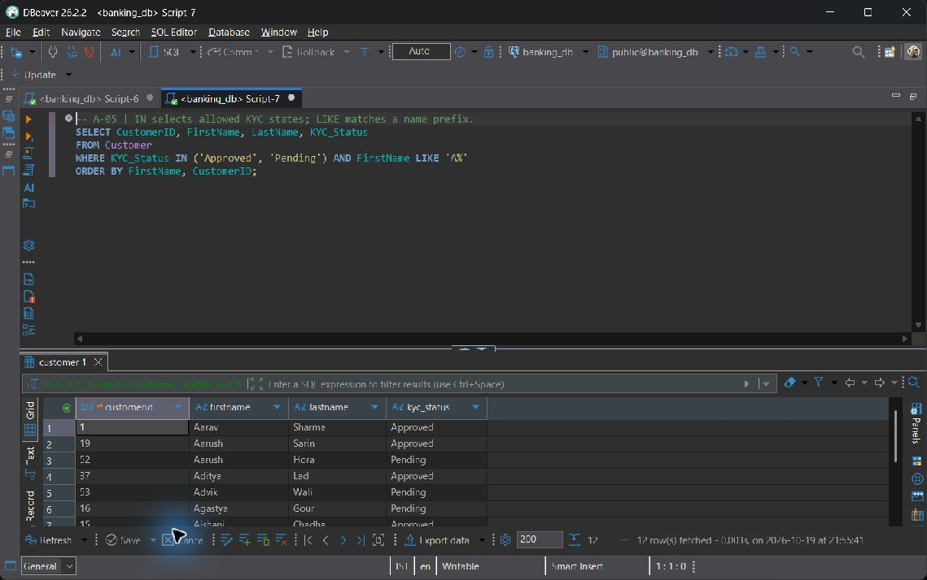
A-05 — live screenshot, 2026-10-19.

A-06 NULL must be tested with IS NULL, not equality
SELECT TransactionID, AccountNo, Amount, Remarks
FROM Transaction_History
WHERE Remarks IS NULL
ORDER BY TransactionID;

Actual output: 54 row(s); first 3 shown. NULL denotes a missing SQL value.
transactionid | accountno | amount | remarks
2 | 100001 | 2500.00 | NULL
6 | 100003 | 1500.00 | NULL
11 | 100006 | 80000.00 | NULL

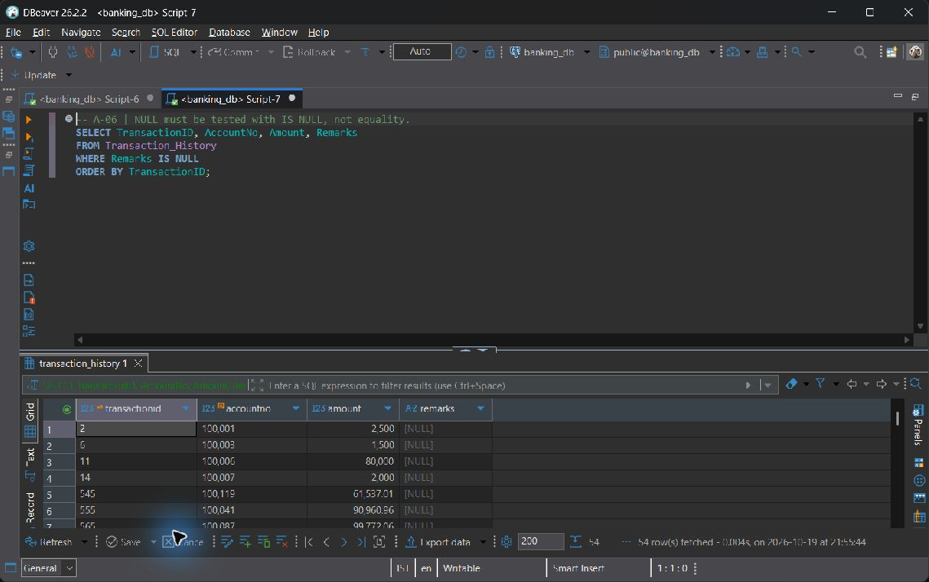
A-06 — live screenshot, 2026-10-19.

Category B Aggregate

B-01 COUNT(*) counts customers, including nullable KYC states if present
SELECT KYC_Status, COUNT(*) AS customer_count
FROM Customer
GROUP BY KYC_Status
ORDER BY KYC_Status NULLS LAST;

Actual output: 3 row(s); first 3 shown. NULL denotes a missing SQL value.
kyc status | customer count
Approved | 84
Pending | 15
Rejected | 11

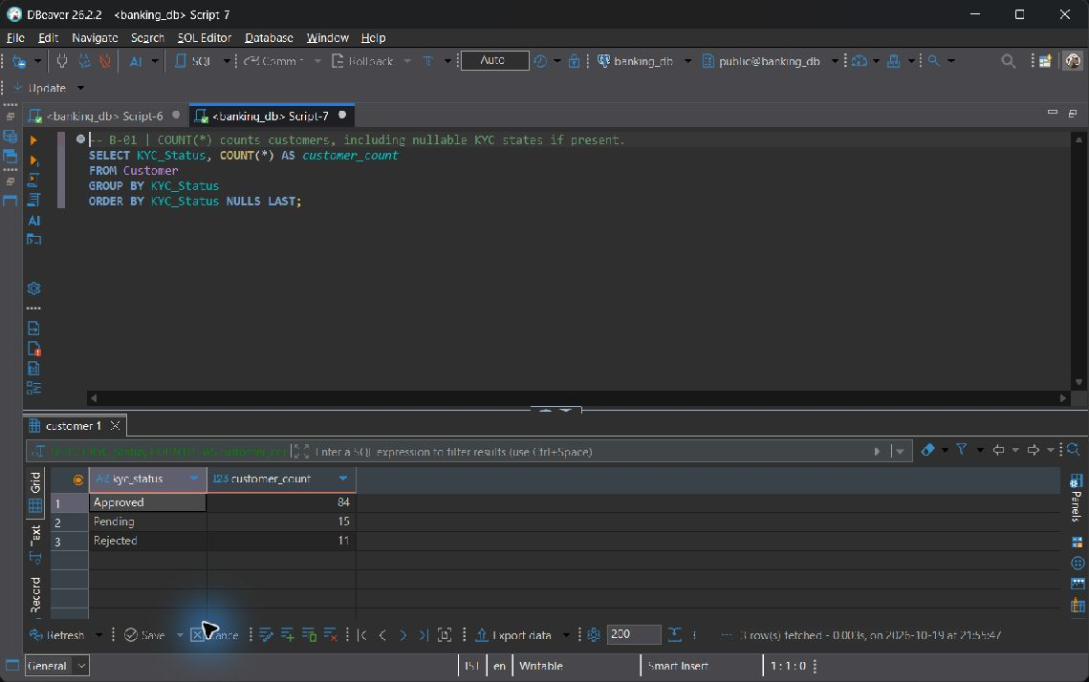
B-01 — live screenshot, 2026-10-19.

B-02 SUM reports balances by product, including all account statuses
SELECT AccountType, SUM(Balance) AS total_balance
FROM Account
GROUP BY AccountType
ORDER BY AccountType;

Actual output: 3 row(s); first 3 shown. NULL denotes a missing SQL value.
accounttype | total balance
Current | 4963194.37
Salary | 4305841.27
Savings | 31328239.72

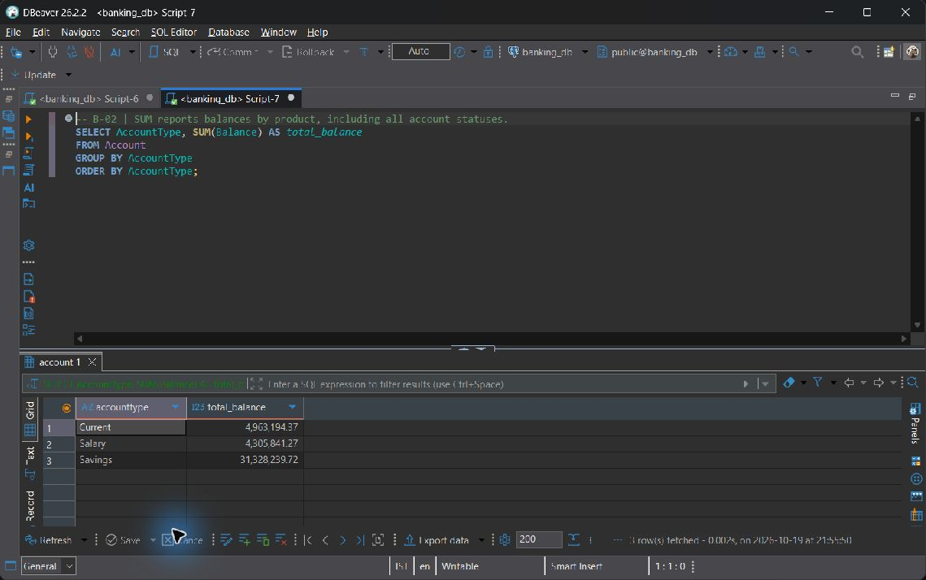
B-02 — live screenshot, 2026-10-19.

B-03 AVG, MIN, and MAX describe the range of staff salaries per role
SELECT Role, ROUND(AVG(Salary), 2) AS average_salary,
MIN(Salary) AS minimum_salary, MAX(Salary) AS maximum_salary
FROM Employee
GROUP BY Role
ORDER BY Role;

Actual output: 4 row(s); first 3 shown. NULL denotes a missing SQL value.
role | average salary | minimum salary | maximum salary
Branch Manager | 83750.00 | 78000.00 | 90000.00
Cashier | 41000.00 | 40000.00 | 42000.00
KYC Officer | 47000.00 | 46000.00 | 48000.00

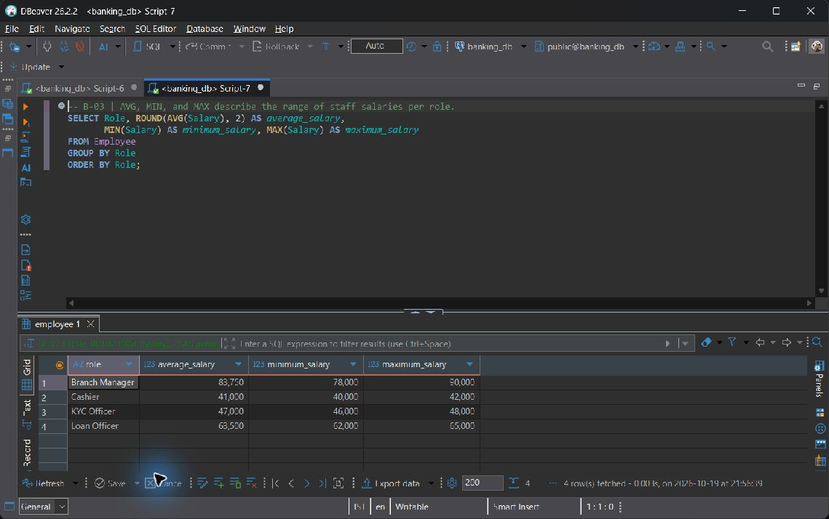
B-03 — live screenshot, 2026-10-19.

B-04 WHERE vs HAVING, explicitly contrasted:
WHERE filters individual rows before GROUP BY. HAVING filters the aggregate branch groups afterward. Removing non-Active accounts with HAVING alone would let their balances enter the sum; applying SUM(Balance) in WHERE is invalid at that query level.
SELECT BranchID, COUNT(*) AS active_account_count,
SUM(Balance) AS active_balance
FROM Account
WHERE Status = 'Active'
GROUP BY BranchID
HAVING SUM(Balance) >= 100000
ORDER BY active_balance DESC, BranchID;

Actual output: 8 row(s); first 3 shown. NULL denotes a missing SQL value.
branchid | active account count | active balance
1 | 20 | 5597576.09
6 | 18 | 4918200.68
4 | 15 | 4636684.20

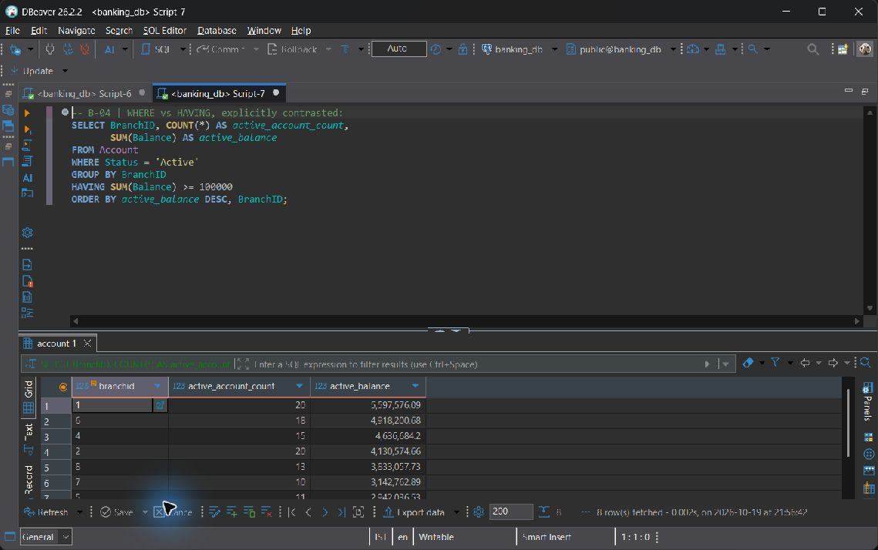
B-04 — live screenshot, 2026-10-19.

B-05 Count and sum observed transaction events per payment channel
SELECT PaymentMode, COUNT(*) AS transaction_count,
SUM(Amount) AS gross_amount, ROUND(AVG(Amount), 2) AS average_amount
FROM Transaction_History
GROUP BY PaymentMode
ORDER BY gross_amount DESC, PaymentMode;

Actual output: 6 row(s); first 3 shown. NULL denotes a missing SQL value.
paymentmode | transaction count | gross amount | average amount
NEFT | 186 | 9728934.94 | 52306.10
IMPS | 169 | 8649284.46 | 51179.20
UPI | 161 | 8398915.02 | 52167.17

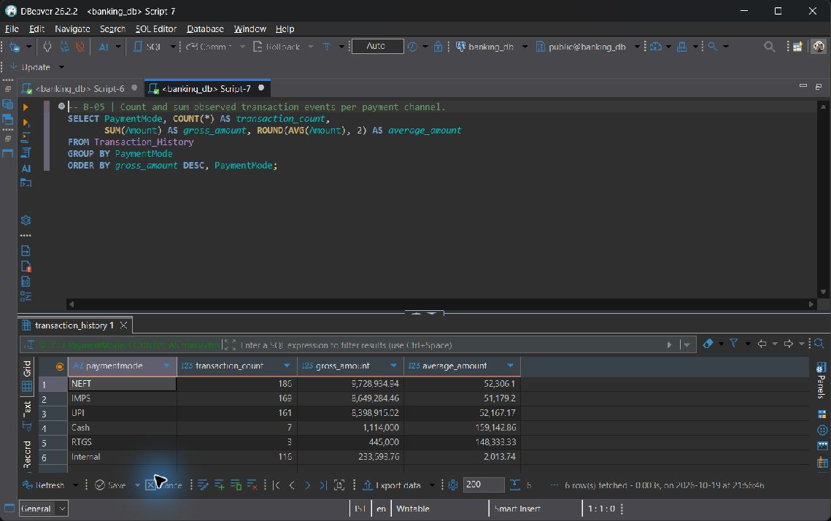
B-05 — live screenshot, 2026-10-19.

Category C Joins

C-01 INNER JOIN returns accounts with their owners and servicing branches
SELECT a.AccountNo, c.FirstName, c.LastName, b.BranchName, a.Balance
FROM Account a
INNER JOIN Customer c ON c.CustomerID = a.CustomerID
INNER JOIN Branch b ON b.BranchID = a.BranchID
ORDER BY a.AccountNo;

Actual output: 162 row(s); first 3 shown. NULL denotes a missing SQL value.
accountno | firstname | lastname | branchname | balance
100001 | Aarav | Sharma | Vellore Main | 1196030.18
100002 | Aarav | Sharma | Vellore Main | 250000.00
100003 | Ananya | Iyer | Chennai Central | 103200.79

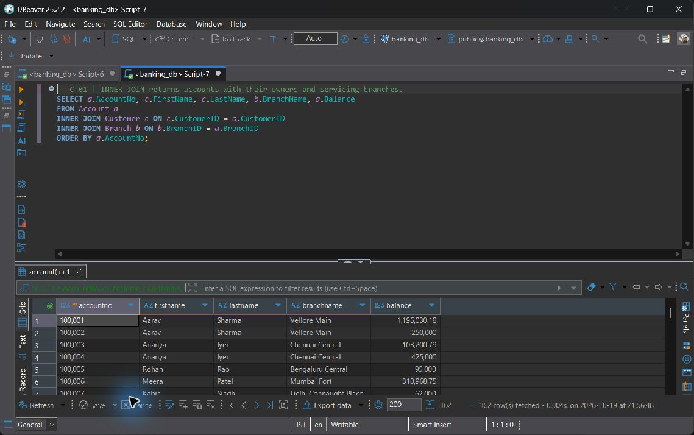
C-01 — live screenshot, 2026-10-19.

C-02 LEFT JOIN preserves customers who have never borrowed
SELECT c.CustomerID, c.FirstName, l.LoanID, l.LoanType, l.Status
FROM Customer c
LEFT JOIN Loan l ON l.CustomerID = c.CustomerID
ORDER BY c.CustomerID, l.LoanID;

Actual output: 110 row(s); first 3 shown. NULL denotes a missing SQL value.
customerid | firstname | loanid | loantype | status
1 | Aarav | 2001 | Home | Active
2 | Ananya | 2002 | Business | Active
3 | Rohan | 2003 | Auto | Active

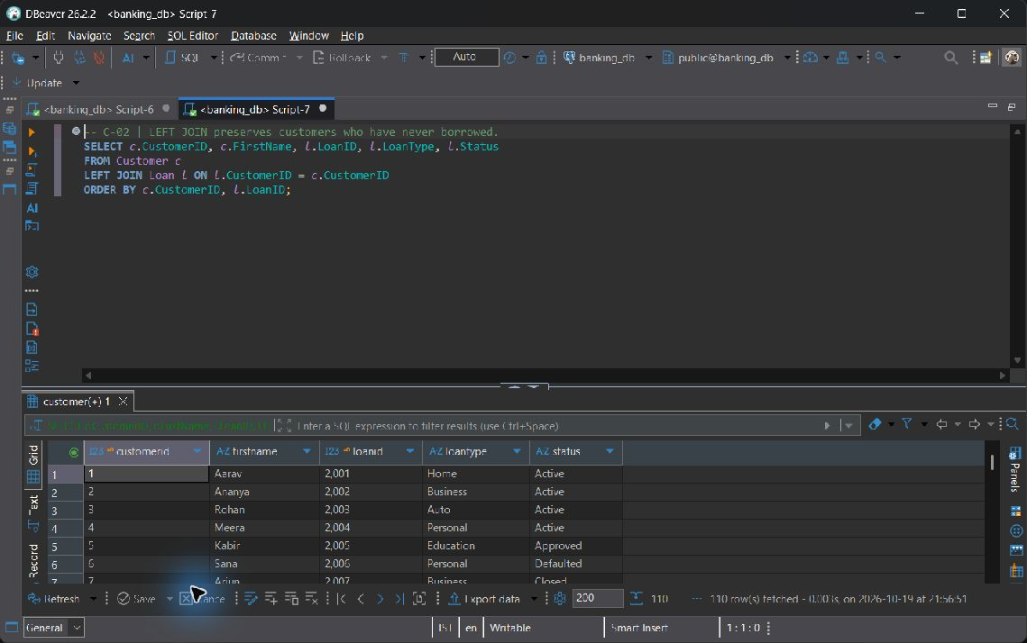
C-02 — live screenshot, 2026-10-19.

C-03 RIGHT JOIN preserves every branch, including branches without loans
SELECT b.BranchID, b.BranchName, l.LoanID, l.OutstandingBalance
FROM Loan l
RIGHT JOIN Branch b ON b.BranchID = l.BranchID
ORDER BY b.BranchID, l.LoanID;

Actual output: 58 row(s); first 3 shown. NULL denotes a missing SQL value.
branchid | branchname | loanid | outstandingbalance
1 | Vellore Main | 2001 | 2256608.84
1 | Vellore Main | 2008 | 1800000.00
1 | Vellore Main | 2010 | 5234342.07

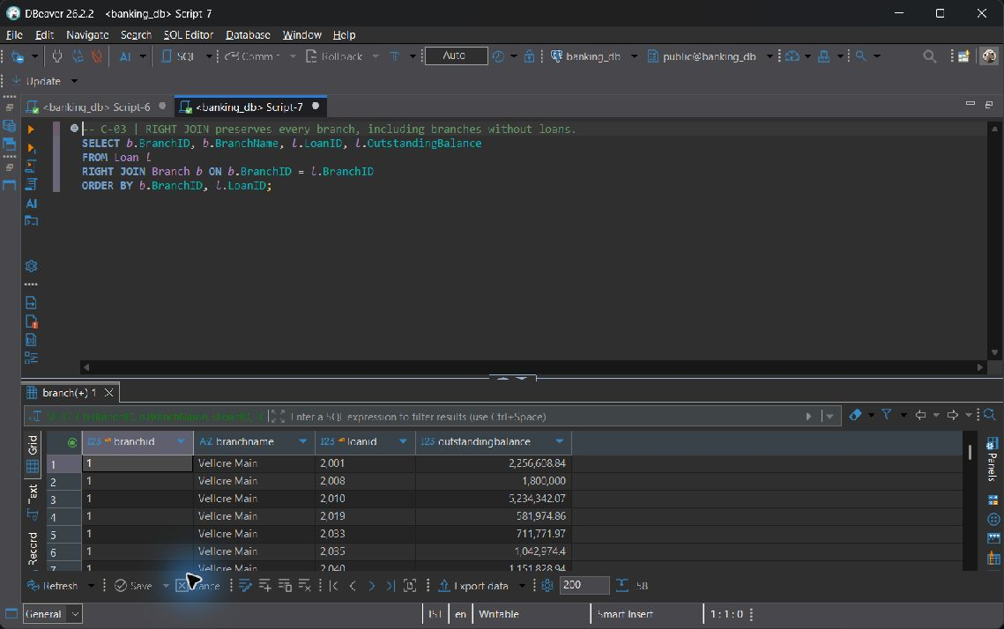
C-03 — live screenshot, 2026-10-19.

C-04 FULL OUTER JOIN reconciles directory entries and local branches
SELECT d.IFSC_Code AS directory_ifsc, d.BankName,
b.IFSC_Code AS branch_ifsc, b.BranchName
FROM Bank_Directory d
FULL OUTER JOIN Branch b ON b.IFSC_Code = d.IFSC_Code
ORDER BY COALESCE(d.IFSC_Code, b.IFSC_Code);

Actual output: 10 row(s); first 3 shown. NULL denotes a missing SQL value.
directory ifsc | bankname | branch ifsc | branchname
CBNK0000001 | Campus Bank | CBNK0000001 | Vellore Main
CBNK0000002 | Campus Bank | CBNK0000002 | Chennai Central
CBNK0000003 | Campus Bank | CBNK0000003 | Bengaluru Central

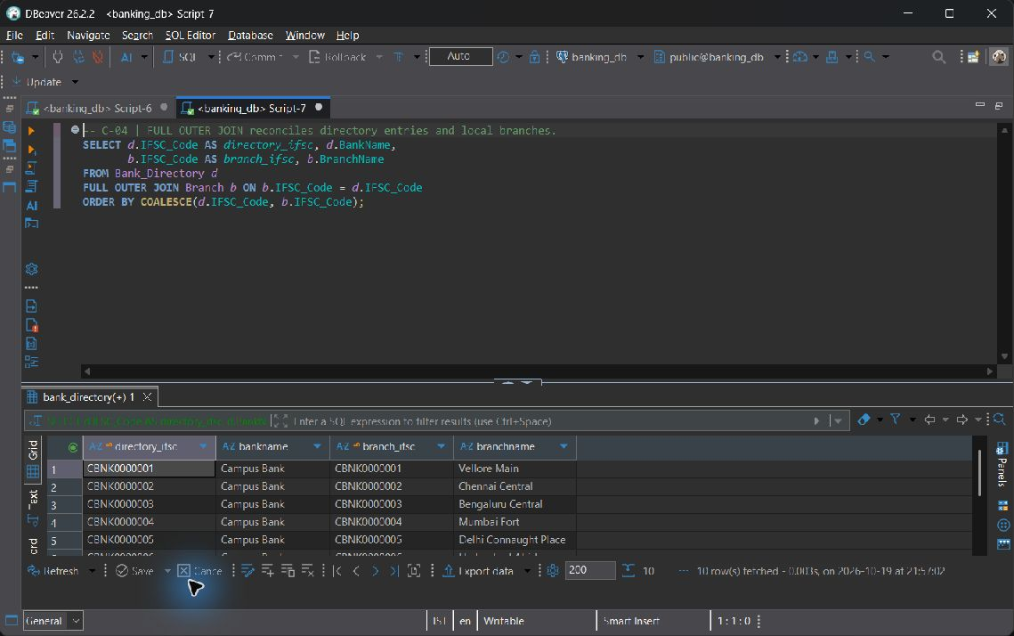
C-04 — live screenshot, 2026-10-19.

C-05 SELF JOIN finds distinct account pairs belonging to one customer
SELECT a.CustomerID, a.AccountNo AS first_account, a.AccountType AS first_type,
other.AccountNo AS second_account, other.AccountType AS second_type
FROM Account a
JOIN Account other ON other.CustomerID = a.CustomerID
AND a.AccountNo < other.AccountNo
ORDER BY a.CustomerID, a.AccountNo, other.AccountNo;

Actual output: 52 row(s); first 3 shown. NULL denotes a missing SQL value.
customerid | first account | first type | second account | second type
1 | 100001 | Savings | 100002 | Current
2 | 100003 | Savings | 100004 | Current
13 | 100015 | Savings | 100161 | Savings

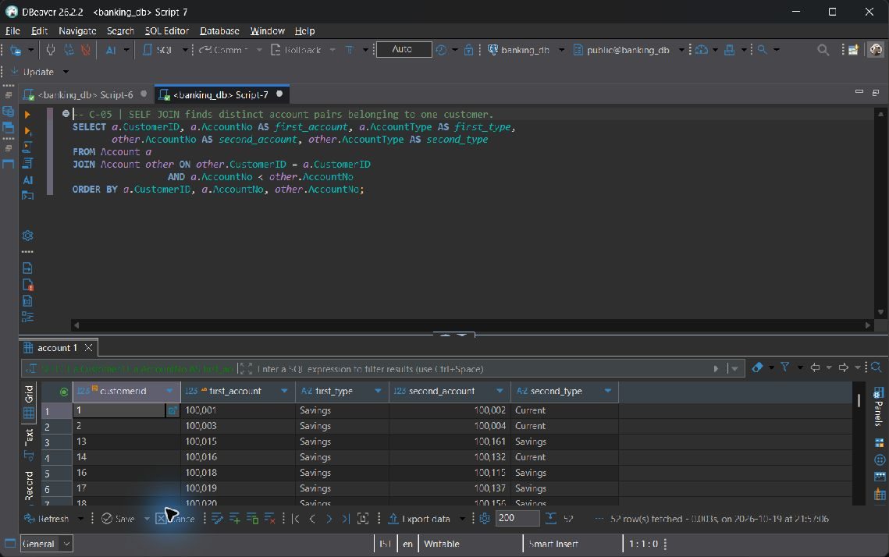
C-05 — live screenshot, 2026-10-19.

C-06 CROSS JOIN builds a branch/product coverage grid, including zeroes
SELECT b.BranchID, b.BranchName, product.AccountType,
COUNT(a.AccountNo) AS account_count
FROM Branch b
CROSS JOIN (SELECT DISTINCT AccountType FROM Account) product
LEFT JOIN Account a ON a.BranchID = b.BranchID
AND a.AccountType = product.AccountType
GROUP BY b.BranchID, b.BranchName, product.AccountType
ORDER BY b.BranchID, product.AccountType;

Actual output: 24 row(s); first 3 shown. NULL denotes a missing SQL value.
branchid | branchname | accounttype | account count
1 | Vellore Main | Current | 5
1 | Vellore Main | Salary | 4
1 | Vellore Main | Savings | 19

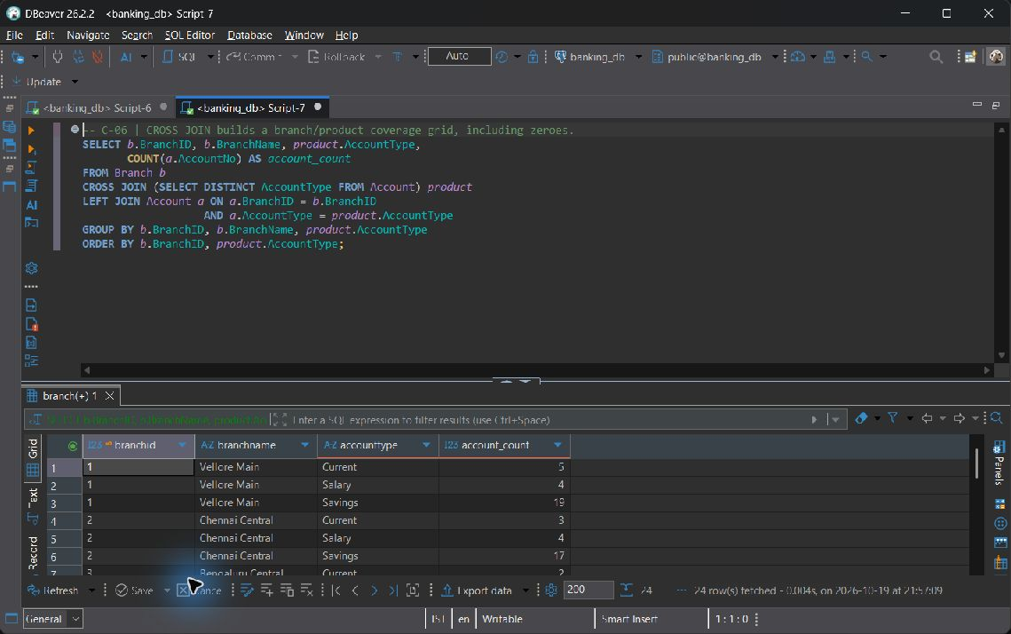
C-06 — live screenshot, 2026-10-19.

Category D Subqueries

D-01 An uncorrelated scalar aggregate subquery supplies one benchmark
SELECT AccountNo, Balance,
(SELECT ROUND(AVG(Balance), 2) FROM Account) AS bank_average_balance
FROM Account
ORDER BY Balance DESC, AccountNo;

Actual output: 162 row(s); first 3 shown. NULL denotes a missing SQL value.
accountno | balance | bank average balance
100001 | 1196030.18 | 250600.47
100009 | 740000.00 | 250600.47
100053 | 498206.09 | 250600.47

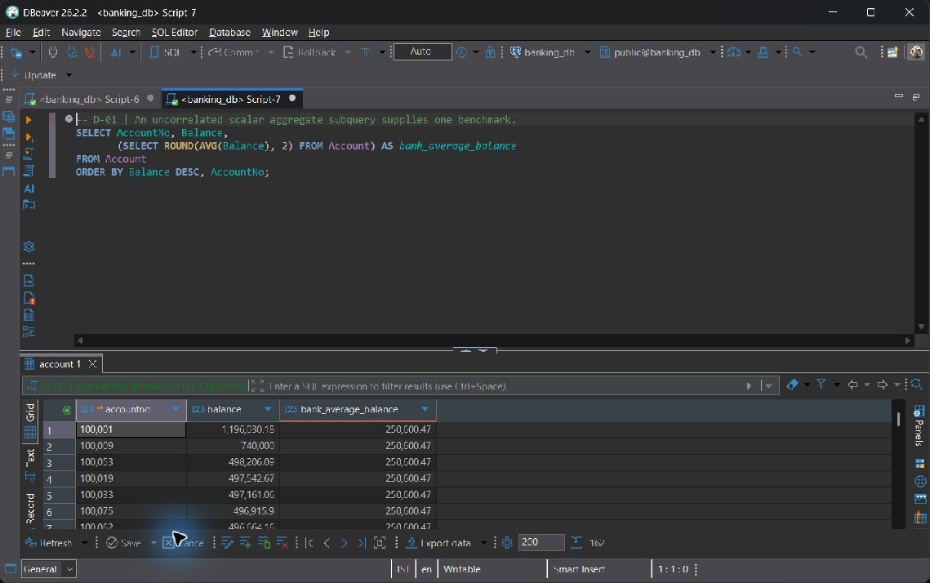
D-01 — live screenshot, 2026-10-19.

D-02 Single-row subquery identifies the highest-balance Savings account
SELECT CustomerID, FirstName, LastName
FROM Customer
WHERE CustomerID = (
SELECT CustomerID FROM Account
WHERE AccountType = 'Savings'
ORDER BY Balance DESC, AccountNo
LIMIT 1
)
ORDER BY CustomerID;

Actual output: 1 row(s); first 1 shown. NULL denotes a missing SQL value.
customerid | firstname | lastname
1 | Aarav | Sharma

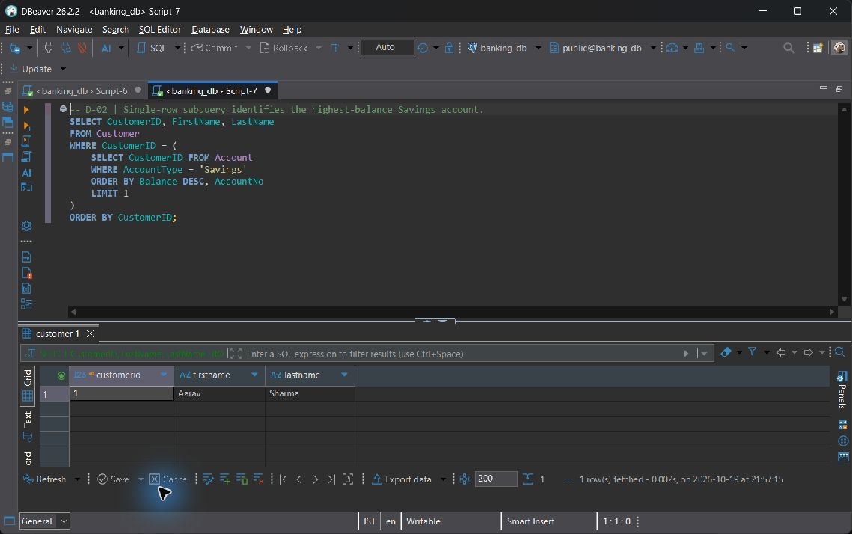
D-02 — live screenshot, 2026-10-19.

D-03 Multi-row IN, ANY, and ALL in one loan screening query
SELECT LoanID, CustomerID, LoanType, PrincipalAmount
FROM Loan
WHERE CustomerID IN (SELECT CustomerID FROM Account WHERE Status = 'Active')
AND PrincipalAmount > ANY (SELECT PrincipalAmount FROM Loan WHERE LoanType = 'Personal')
AND PrincipalAmount >= ALL (SELECT PrincipalAmount FROM Loan WHERE LoanType = 'Auto')
ORDER BY PrincipalAmount DESC, LoanID;

Actual output: 19 row(s); first 3 shown. NULL denotes a missing SQL value.
loanid | customerid | loantype | principalamount
2017 | 105 | Home | 8816000.00
2020 | 102 | Home | 8624000.00
2051 | 22 | Home | 8072000.00

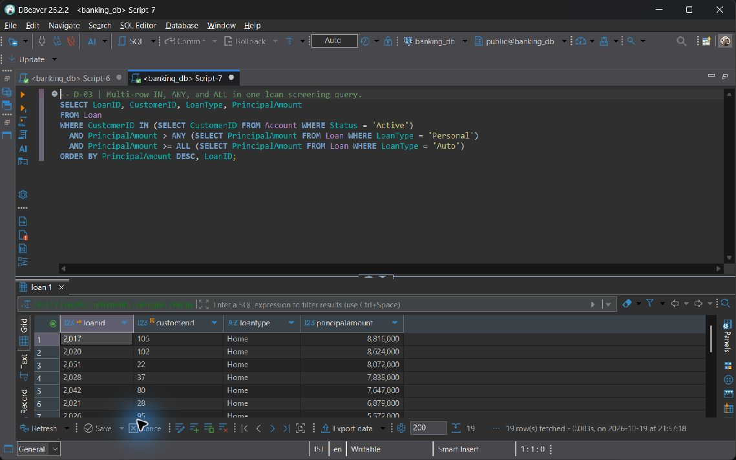
D-03 — live screenshot, 2026-10-19.

D-04 Correlated EXISTS tests each customer without multiplying rows for
SELECT c.CustomerID, c.FirstName, c.LastName
FROM Customer c
WHERE EXISTS (
SELECT 1 FROM Account a
WHERE a.CustomerID = c.CustomerID
AND a.Balance > (SELECT AVG(peer.Balance) FROM Account peer
WHERE peer.BranchID = a.BranchID)
)
ORDER BY c.CustomerID;

Actual output: 63 row(s); first 3 shown. NULL denotes a missing SQL value.
customerid | firstname | lastname
1 | Aarav | Sharma
2 | Ananya | Iyer
4 | Meera | Patel

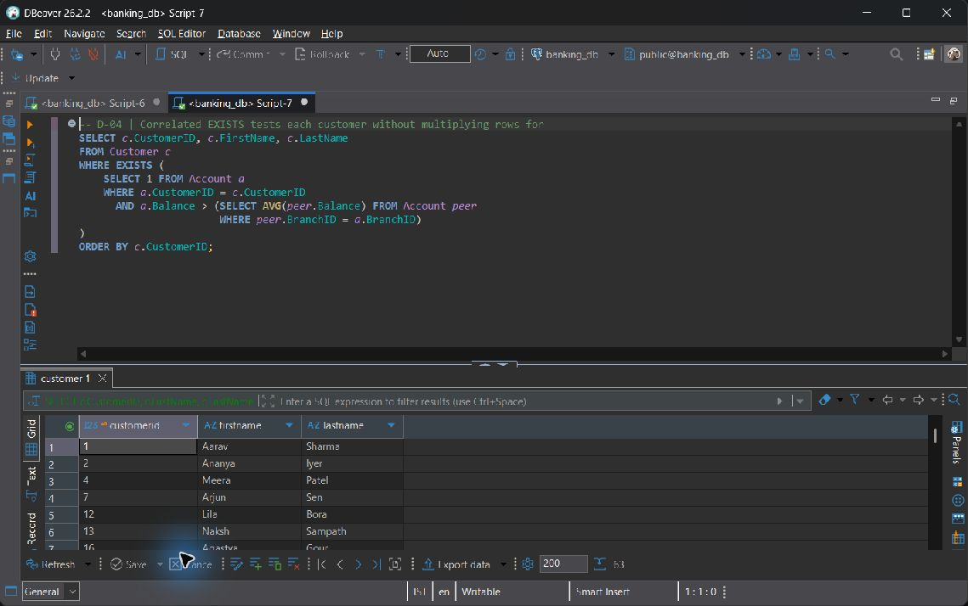
D-04 — live screenshot, 2026-10-19.

D-05 Correlated NOT EXISTS finds customers without either product
SELECT c.CustomerID, c.FirstName, c.LastName
FROM Customer c
WHERE NOT EXISTS (SELECT 1 FROM Loan l WHERE l.CustomerID = c.CustomerID)
AND NOT EXISTS (SELECT 1 FROM Fixed_Deposit f WHERE f.CustomerID = c.CustomerID)
ORDER BY c.CustomerID;

Actual output: 37 row(s); first 3 shown. NULL denotes a missing SQL value.
customerid | firstname | lastname
9 | Dev | Menon
10 | Nisha | Gupta
11 | Indali | Kothari

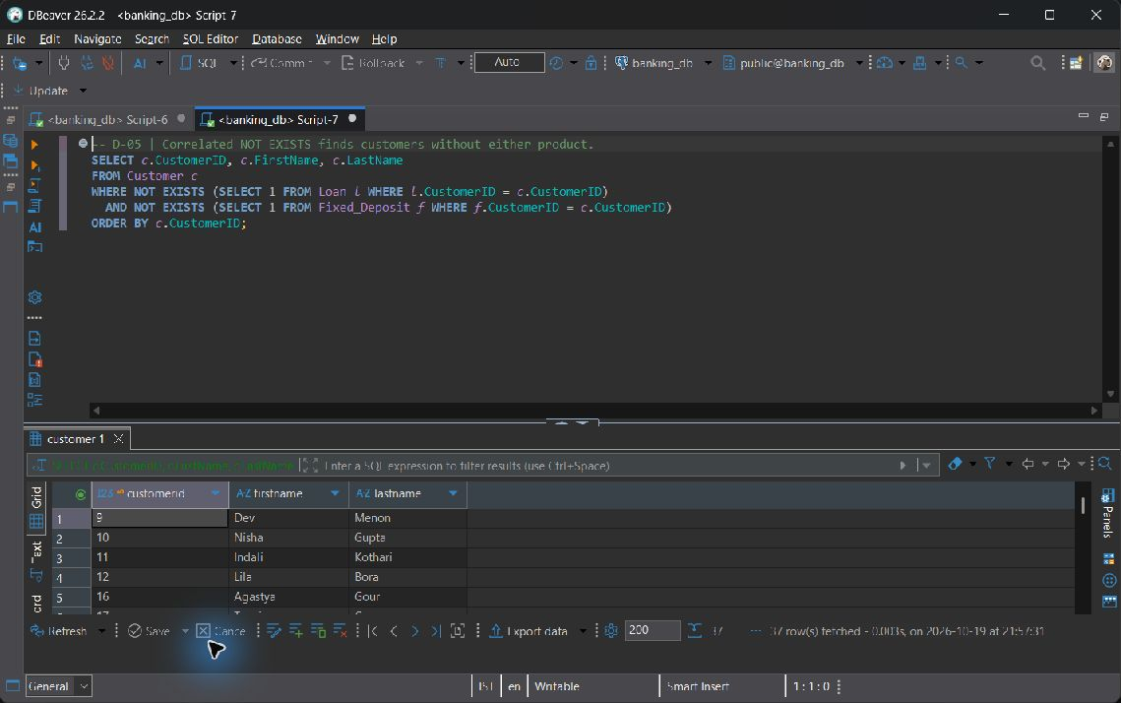
D-05 — live screenshot, 2026-10-19.

D-06 NOT IN NULL pitfall AND fix, executable as ONE statement
NULL pitfall: an unmatched value NOT IN a set containing NULL evaluates to UNKNOWN and is discarded by WHERE. Filtering inner NULLs restores the intended anti-membership test. The single statement prints the unsafe and corrected counts side by side.
WITH narratives AS (
SELECT DISTINCT Remarks FROM Transaction_History WHERE Remarks IS NOT NULL
)
SELECT '1. Unsafe NOT IN (NULL poisoned)' AS demonstration,
COUNT(*) AS matching_narratives
FROM narratives
WHERE Remarks NOT IN (
SELECT Remarks FROM Transaction_History WHERE TransactionType = 'Withdrawal'
)
UNION ALL
SELECT '2. Corrected NOT IN (NULL filtered)', COUNT(*)
FROM narratives
WHERE Remarks NOT IN (
SELECT Remarks FROM Transaction_History
WHERE TransactionType = 'Withdrawal' AND Remarks IS NOT NULL
)
ORDER BY demonstration;

Actual output: 2 row(s); first 2 shown. NULL denotes a missing SQL value.
demonstration | matching narratives
1. Unsafe NOT IN (NULL poisoned) | 0
2. Corrected NOT IN (NULL filtered) | 55

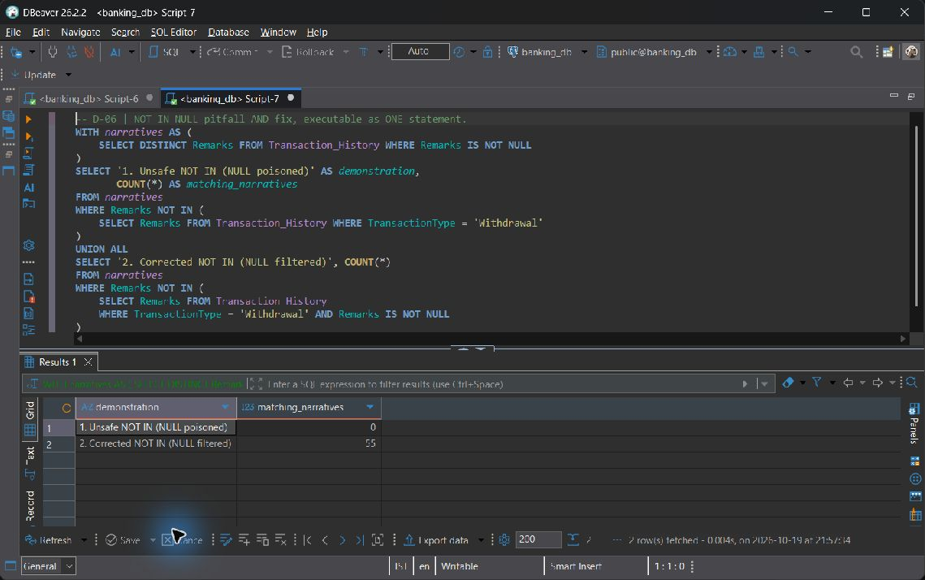
D-06 — live screenshot, 2026-10-19.

Category E Set operations

E-01 UNION removes duplicate customer IDs across the two product sets
SELECT CustomerID FROM Account WHERE AccountType = 'Savings'
UNION
SELECT CustomerID FROM Loan
ORDER BY CustomerID;

Actual output: 110 row(s); first 3 shown. NULL denotes a missing SQL value.
customerid
1
2
3

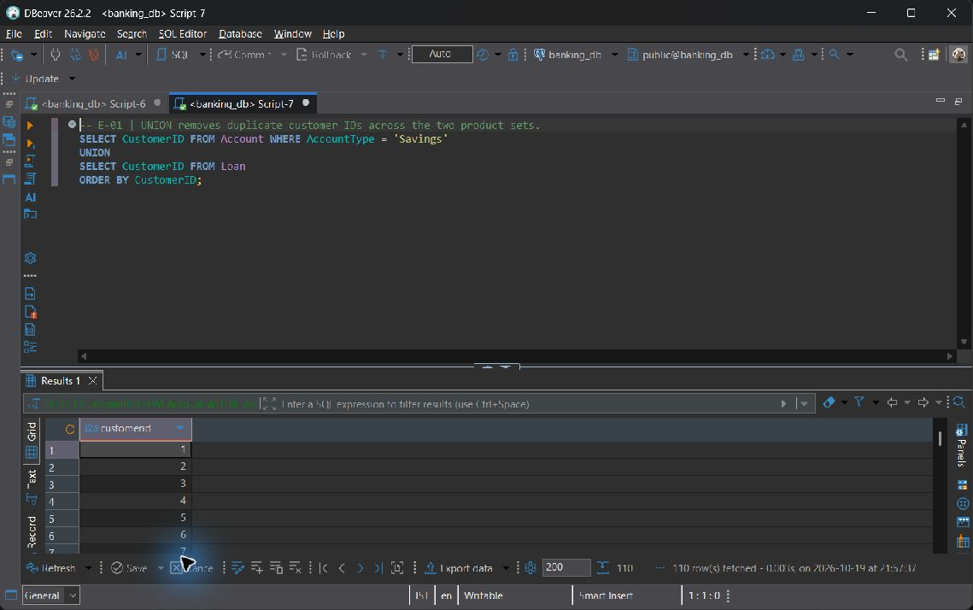
E-01 — live screenshot, 2026-10-19.

E-02 UNION ALL retains each individual product holding, even for an owner
SELECT CustomerID, 'Account' AS product, AccountNo AS product_id FROM Account
UNION ALL
SELECT CustomerID, 'Fixed Deposit', FD_ID FROM Fixed_Deposit
ORDER BY CustomerID, product, product_id;

Actual output: 210 row(s); first 3 shown. NULL denotes a missing SQL value.
customerid | product | product id
1 | Account | 100001
1 | Account | 100002
1 | Fixed Deposit | 3001

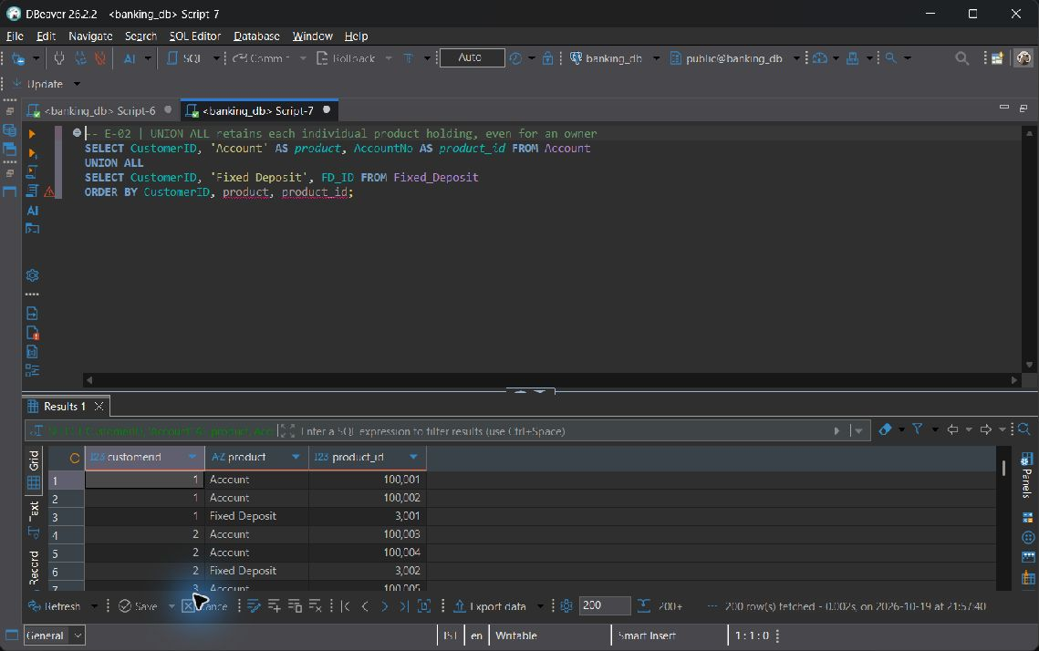
E-02 — live screenshot, 2026-10-19.

E-03 INTERSECT finds customers holding both Savings and Current accounts
SELECT CustomerID FROM Account WHERE AccountType = 'Savings'
INTERSECT
SELECT CustomerID FROM Account WHERE AccountType = 'Current'
ORDER BY CustomerID;

Actual output: 20 row(s); first 3 shown. NULL denotes a missing SQL value.
customerid
1
2
14

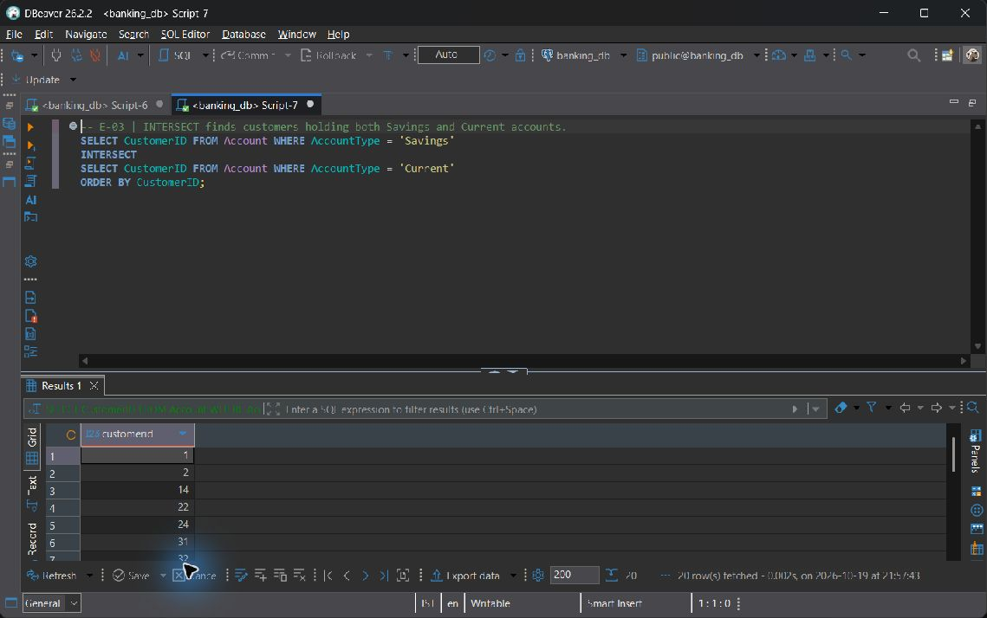
E-03 — live screenshot, 2026-10-19.

E-04 EXCEPT finds account holders who have no loan of any status
SELECT CustomerID FROM Account
EXCEPT
SELECT CustomerID FROM Loan
ORDER BY CustomerID;

Actual output: 52 row(s); first 3 shown. NULL denotes a missing SQL value.
customerid
9
10
11

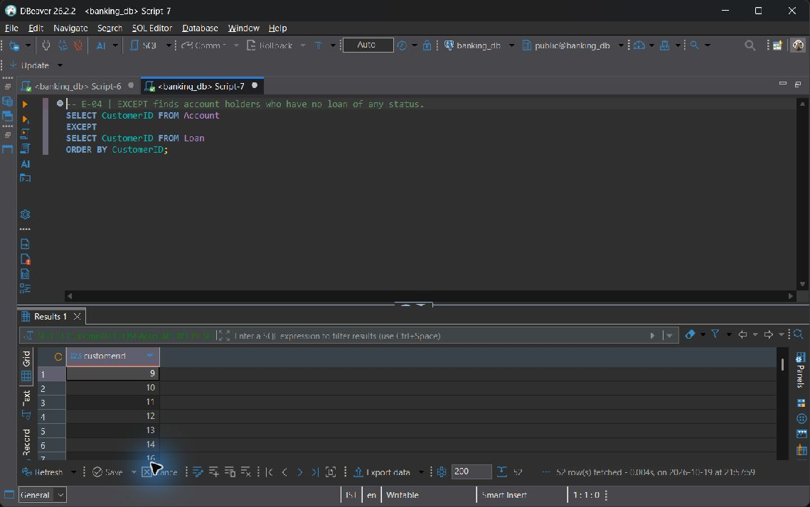
E-04 — live screenshot, 2026-10-19.

Category F Advanced functions

F-01 CASE assigns balance bands; ROUND computes a monthly interest estimate
SELECT AccountNo, Balance,
CASE WHEN Balance >= 250000 THEN 'High'
WHEN Balance >= 50000 THEN 'Medium' ELSE 'Low' END AS balance_band,
ROUND(Balance * InterestRate / 1200.0, 2) AS estimated_monthly_interest
FROM Account
ORDER BY AccountNo;

Actual output: 162 row(s); first 3 shown. NULL denotes a missing SQL value.
accountno | balance | balance band | estimated monthly interest
100001 | 1196030.18 | High | 3488.42
100002 | 250000.00 | High | 0.00
100003 | 103200.79 | Medium | 301.00

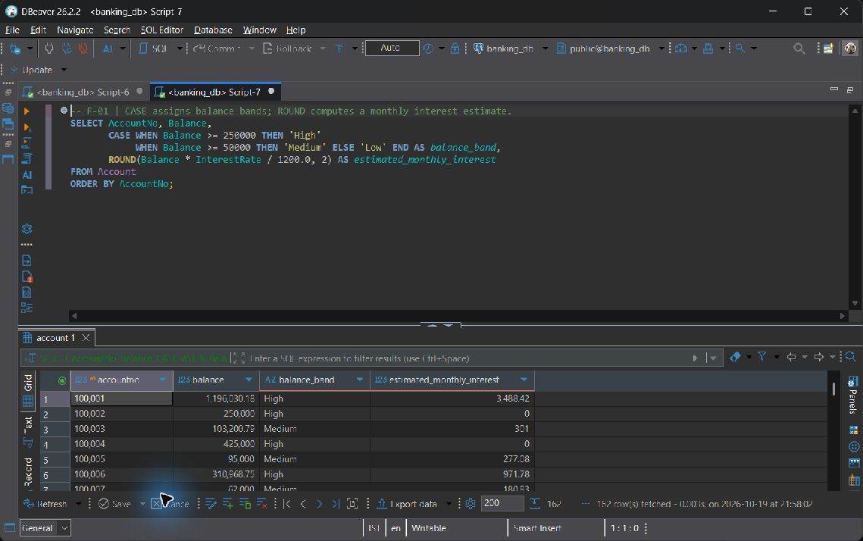
F-01 — live screenshot, 2026-10-19.

F-02 COALESCE substitutes a display value without changing stored NULLs
SELECT TransactionID, AccountNo, COALESCE(Remarks, 'No remarks provided') AS narrative
FROM Transaction_History
ORDER BY TransactionID;

Actual output: 642 row(s); first 3 shown. NULL denotes a missing SQL value.
transactionid | accountno | narrative
1 | 100001 | Salary credit
2 | 100001 | No remarks provided
3 | 100002 | Invoice settlement

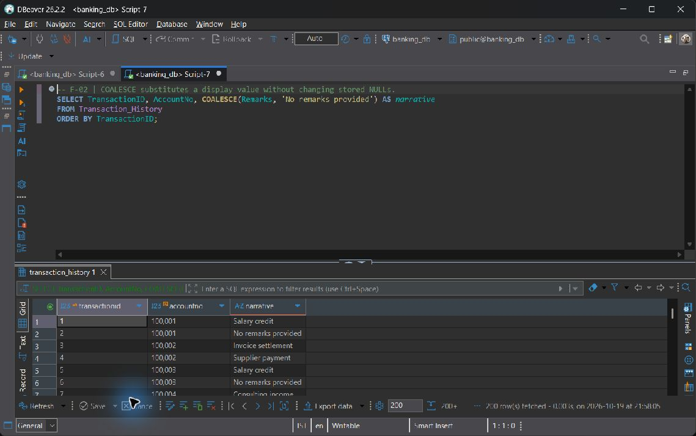
F-02 — live screenshot, 2026-10-19.

F-03 NULLIF turns a zero denominator into NULL, preventing division by zero
SELECT a.AccountNo, a.Balance,
COALESCE(SUM(t.Amount) FILTER (WHERE t.TransactionType = 'Withdrawal'), 0)
AS recorded_withdrawals,
ROUND(100.0 * COALESCE(SUM(t.Amount)
FILTER (WHERE t.TransactionType = 'Withdrawal'), 0)
/ NULLIF(a.Balance, 0), 2) AS withdrawals_to_current_balance_pct
FROM Account a
LEFT JOIN Transaction_History t ON t.AccountNo = a.AccountNo
GROUP BY a.AccountNo, a.Balance
ORDER BY a.AccountNo;

Actual output: 162 row(s); first 3 shown. NULL denotes a missing SQL value.
accountno | balance | recorded withdrawals | withdrawals to current balance pct
100001 | 1196030.18 | 45891.16 | 3.84
100002 | 250000.00 | 0 | 0.00
100003 | 103200.79 | 1500.00 | 1.45

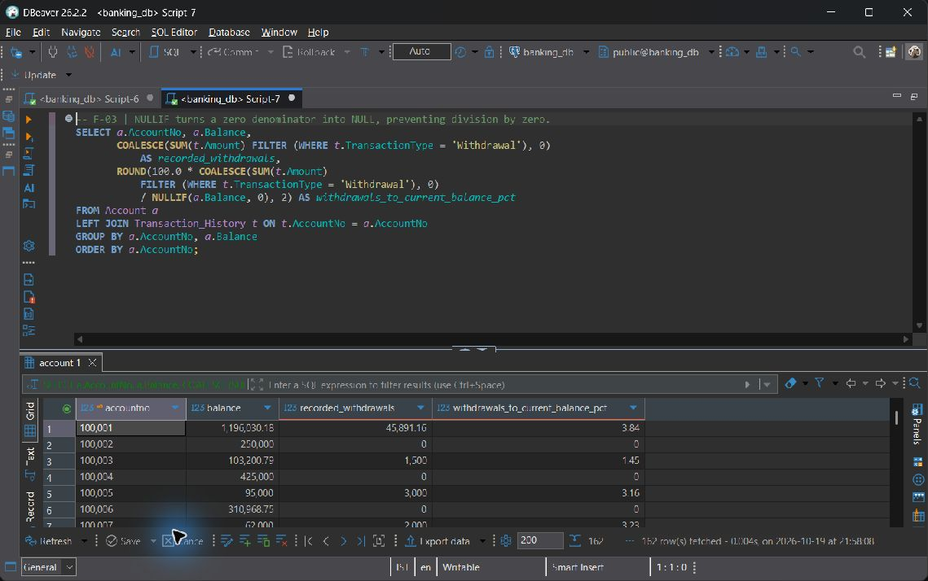
F-03 — live screenshot, 2026-10-19.

F-04 String formatting plus AGE/EXTRACT for customer account tenure
SELECT a.AccountNo, UPPER(CONCAT(c.FirstName, ' ', c.LastName)) AS display_name,
a.OpeningDate,
AGE(CURRENT_DATE::timestamp, a.OpeningDate::timestamp) AS account_tenure,
EXTRACT(YEAR FROM AGE(CURRENT_DATE::timestamp, a.OpeningDate::timestamp))
AS completed_years
FROM Account a
JOIN Customer c ON c.CustomerID = a.CustomerID
ORDER BY a.AccountNo;

Actual output: 162 row(s); first 3 shown. NULL denotes a missing SQL value.
accountno | display name | openingdate | account tenure | completed years
100001 | AARAV SHARMA | 2024-10-18 | 731 days, 0:00:00 | 2
100002 | AARAV SHARMA | 2025-02-25 | 597 days, 0:00:00 | 1
100003 | ANANYA IYER | 2025-06-05 | 499 days, 0:00:00 | 1

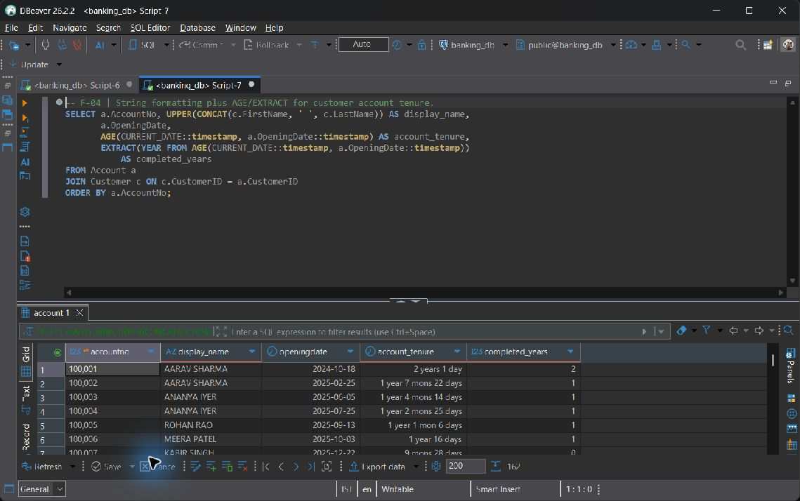
F-04 — live screenshot, 2026-10-19.

Category G Window and analytic

G-01 RANK leaves gaps after ties; DENSE_RANK does not
SELECT AccountNo, BranchID, Balance,
RANK() OVER (PARTITION BY BranchID ORDER BY Balance DESC) AS balance_rank,
DENSE_RANK() OVER (PARTITION BY BranchID ORDER BY Balance DESC) AS dense_balance_rank
FROM Account
ORDER BY BranchID, balance_rank, AccountNo;

Actual output: 162 row(s); first 3 shown. NULL denotes a missing SQL value.
accountno | branchid | balance | balance rank | dense balance rank
100001 | 1 | 1196030.18 | 1 | 1
100084 | 1 | 433922.89 | 2 | 2
100045 | 1 | 427360.66 | 3 | 3

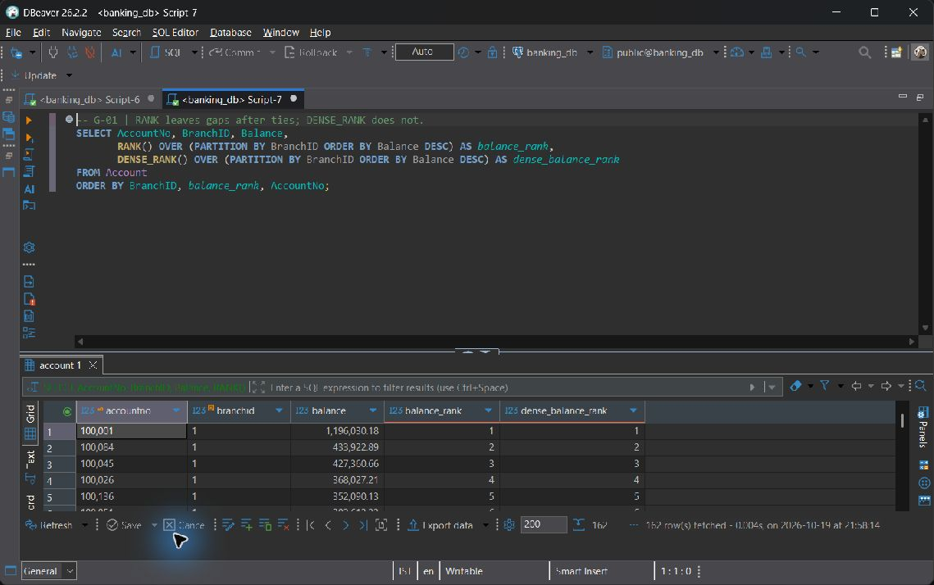
G-01 — live screenshot, 2026-10-19.

G-02 ROW_NUMBER assigns an unambiguous recency sequence per account
SELECT TransactionID, AccountNo, TransactionDate, Amount,
ROW_NUMBER() OVER (PARTITION BY AccountNo
ORDER BY TransactionDate DESC NULLS LAST, TransactionID DESC) AS recency_number
FROM Transaction_History
ORDER BY AccountNo, recency_number;

Actual output: 642 row(s); first 3 shown. NULL denotes a missing SQL value.
transactionid | accountno | transactiondate | amount | recency number
1143 | 100001 | 2026-10-19T11:17:29.350769 | 1000000.00 | 1
1141 | 100001 | 2026-10-19T10:42:52.325680 | 50.00 | 2
1053 | 100001 | 2026-10-19T09:18:21.711729 | 15899.96 | 3

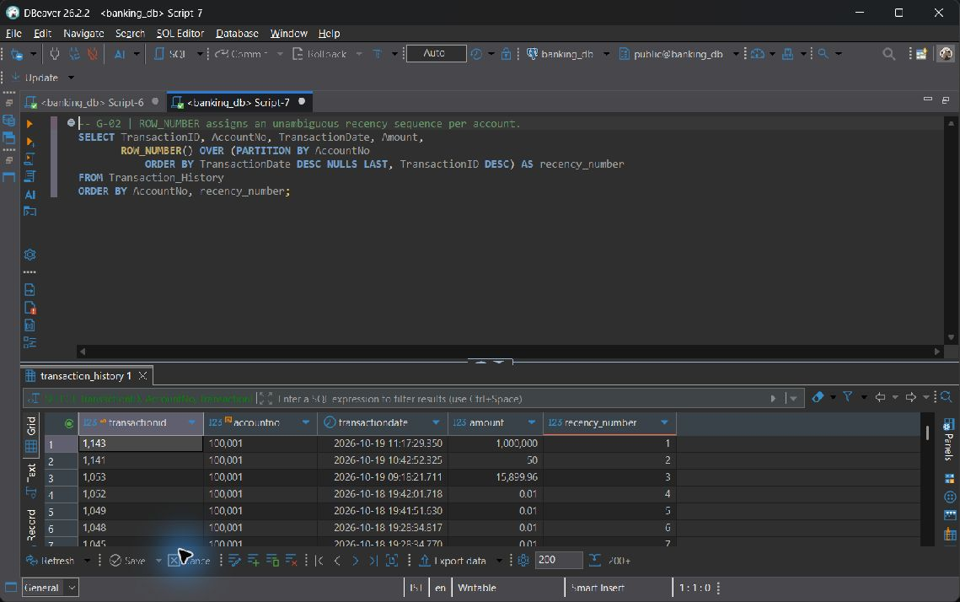
G-02 — live screenshot, 2026-10-19.

G-03 Explicit ROWS frame and ID tiebreaker make event-by-event totals stable
SELECT TransactionID, AccountNo, TransactionDate, Amount,
SUM(Amount) OVER (PARTITION BY AccountNo
ORDER BY TransactionDate NULLS LAST, TransactionID
ROWS BETWEEN UNBOUNDED PRECEDING AND CURRENT ROW) AS running_gross_volume
FROM Transaction_History
ORDER BY AccountNo, TransactionDate NULLS LAST, TransactionID;

Actual output: 642 row(s); first 3 shown. NULL denotes a missing SQL value.
transactionid | accountno | transactiondate | amount | running gross volume
1 | 100001 | 2026-09-18T18:41:46.235922 | 50000.00 | 50000.00
2 | 100001 | 2026-09-20T18:41:46.235922 | 2500.00 | 52500.00
21 | 100001 | 2026-10-18T18:54:16.997380 | 1000.00 | 53500.00

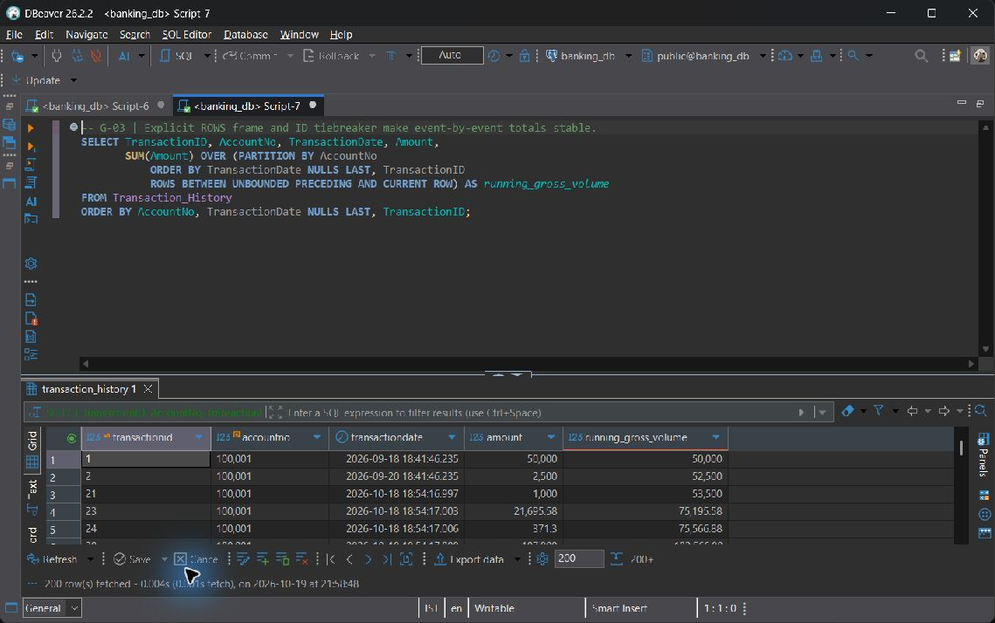
G-03 — live screenshot, 2026-10-19.

G-04 LAG and LEAD inspect adjacent account events; boundary rows yield NULL
SELECT TransactionID, AccountNo, TransactionDate, Amount,
LAG(Amount) OVER account_events AS previous_amount,
LEAD(TransactionDate) OVER account_events AS next_transaction_date
FROM Transaction_History
WINDOW account_events AS (PARTITION BY AccountNo
ORDER BY TransactionDate NULLS LAST, TransactionID)
ORDER BY AccountNo, TransactionDate NULLS LAST, TransactionID;

Actual output: 642 row(s); first 3 shown. NULL denotes a missing SQL value.
transactionid | accountno | transactiondate | amount | previous amount | next transaction date
1 | 100001 | 2026-09-18T18:41:46.235922 | 50000.00 | NULL | 2026-09-20T18:41:46.235922
2 | 100001 | 2026-09-20T18:41:46.235922 | 2500.00 | 50000.00 | 2026-10-18T18:54:16.997380
21 | 100001 | 2026-10-18T18:54:16.997380 | 1000.00 | 2500.00 | 2026-10-18T18:54:17.003027

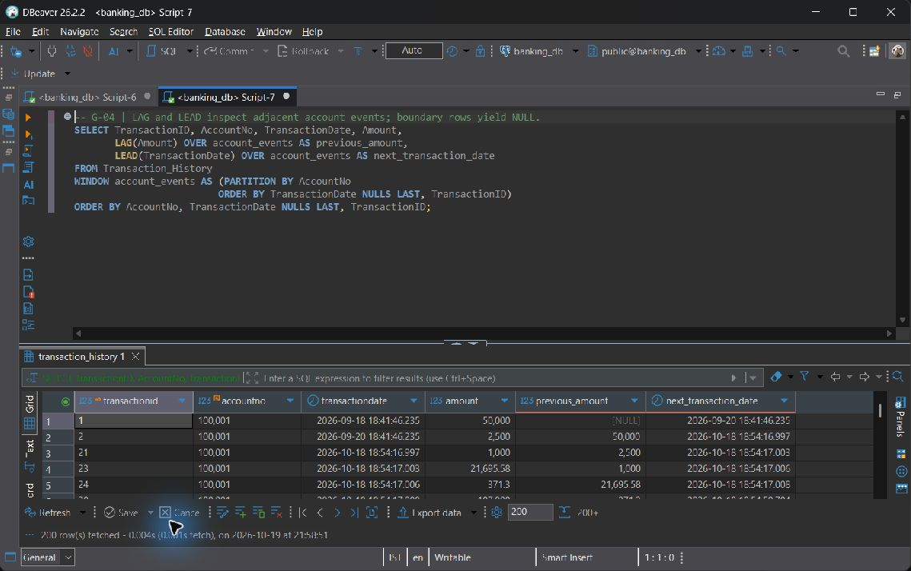
G-04 — live screenshot, 2026-10-19.

8 Advanced SQL Implementation

8.1 Complex Business Queries
Each CQ statement uses at least three base relations directly or through a multi-table CTE, with independent aggregation or analytic constructs where needed. The expected-output row states a hand-reasoned relational prediction; the actual-output row is the live result. Empty eligibility results are retained as valid evidence rather than filled with invented rows.

CQ-01
ID | CQ-01
Business question | Which borrowers have defaulted loans, and how much outstanding principal and failed-payment activity need branch follow-up?
SQL | SELECT l.LoanID, c.CustomerID, CONCAT(c.FirstName, ' ', c.LastName) AS borrower,  b.BranchName, l.OutstandingBalance AS defaulted_outstanding,  COUNT(r.PaymentID) FILTER (WHERE r.PaymentStatus = 'Failed') AS failed_attempts,  MAX(r.PaymentDate) FILTER (WHERE r.PaymentStatus = 'Success') AS last_successful_payment  FROM Loan l  JOIN Customer c ON c.CustomerID = l.CustomerID  JOIN Branch b ON b.BranchID = l.BranchID  LEFT JOIN Loan_Repayment r ON r.LoanID = l.LoanID  WHERE l.Status = 'Defaulted'  GROUP BY l.LoanID, c.CustomerID, c.FirstName, c.LastName, b.BranchID, b.BranchName  ORDER BY l.OutstandingBalance DESC, l.LoanID;
Expected output | One row per Defaulted loan, with the borrower, issuing branch and outstanding principal selected once. Failed-attempt count is zero when no failed attempt exists; a missing successful payment yields NULL. The result excludes all other loan statuses.
Actual output screenshot | Actual output: 5 row(s); first 2 shown. NULL denotes a missing SQL value.  Row 1  loanid: 2042  customerid: 80  borrower: Luke Balakrishnan  branchname: Mumbai Fort  defaulted_outstanding: 7246869.55  failed_attempts: 0  last_successful_payment: NULL  Row 2  loanid: 2040  customerid: 78  borrower: Yug Soman  branchname: Vellore Main  defaulted_outstanding: 1151828.94  failed_attempts: 0  last_successful_payment: NULL  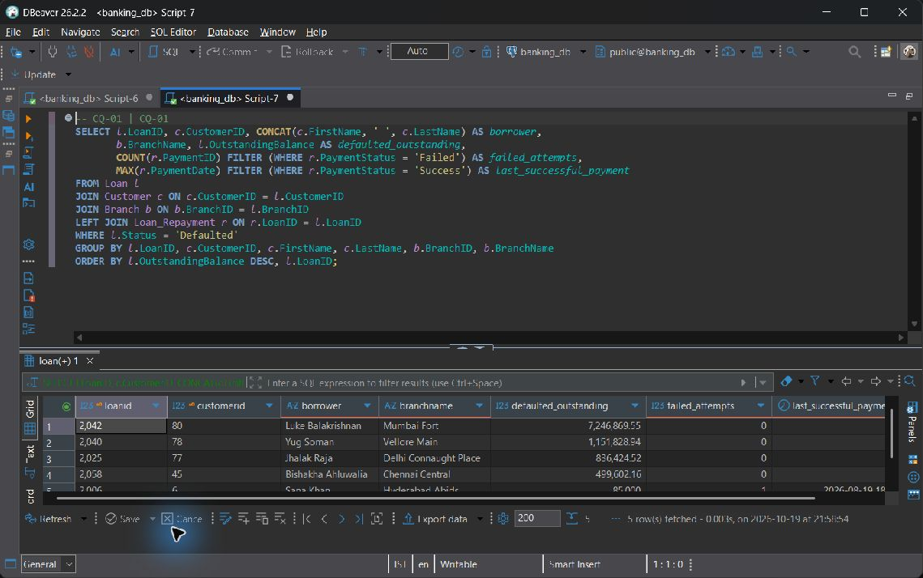  CQ-01 — live screenshot, 2026-10-19.
Explanation | Join Loan to Customer and issuing Branch; LEFT JOIN repayments and group per loan. OutstandingBalance is selected once, never summed across repayments. 'Defaulted' is the schema's NPA proxy: delinquency days cannot be inferred because the schema has no repayment due-date schedule.

CQ-02
ID | CQ-02
Business question | Which branches have the highest observed transaction activity during the last 365 days, and where are those branches located?
SQL | WITH activity AS (  SELECT b.BranchID, b.BranchName, p.City,  COUNT(t.TransactionID) AS transaction_count,  COALESCE(SUM(t.Amount), 0) AS gross_volume  FROM Branch b  JOIN Postal_Directory p ON p.Pincode = b.Pincode  LEFT JOIN Account a ON a.BranchID = b.BranchID  LEFT JOIN Transaction_History t ON t.AccountNo = a.AccountNo  AND t.TransactionDate >= CURRENT_TIMESTAMP - INTERVAL '365 days'  AND t.TransactionDate <= CURRENT_TIMESTAMP  GROUP BY b.BranchID, b.BranchName, p.City  ), ranked AS (  SELECT activity.*, DENSE_RANK() OVER (ORDER BY transaction_count DESC) AS activity_rank  FROM activity  )  SELECT * FROM ranked WHERE activity_rank <= 3  ORDER BY activity_rank, gross_volume DESC, BranchID;
Expected output | One activity total per branch is ranked by recorded events in the last 365 days. Up to the top three distinct ranks are returned, with ties retained and zero-activity branches preserved before ranking.
Actual output screenshot | Actual output: 3 row(s); first 3 shown. NULL denotes a missing SQL value.  Row 1  branchid: 1  branchname: Vellore Main  city: Vellore  transaction_count: 88  gross_volume: 3897829.23  activity_rank: 1  Row 2  branchid: 2  branchname: Chennai Central  city: Chennai  transaction_count: 72  gross_volume: 2290380.09  activity_rank: 2  Row 3  branchid: 6  branchname: Hyderabad Abids  city: Hyderabad  transaction_count: 54  gross_volume: 2110091.99  activity_rank: 3  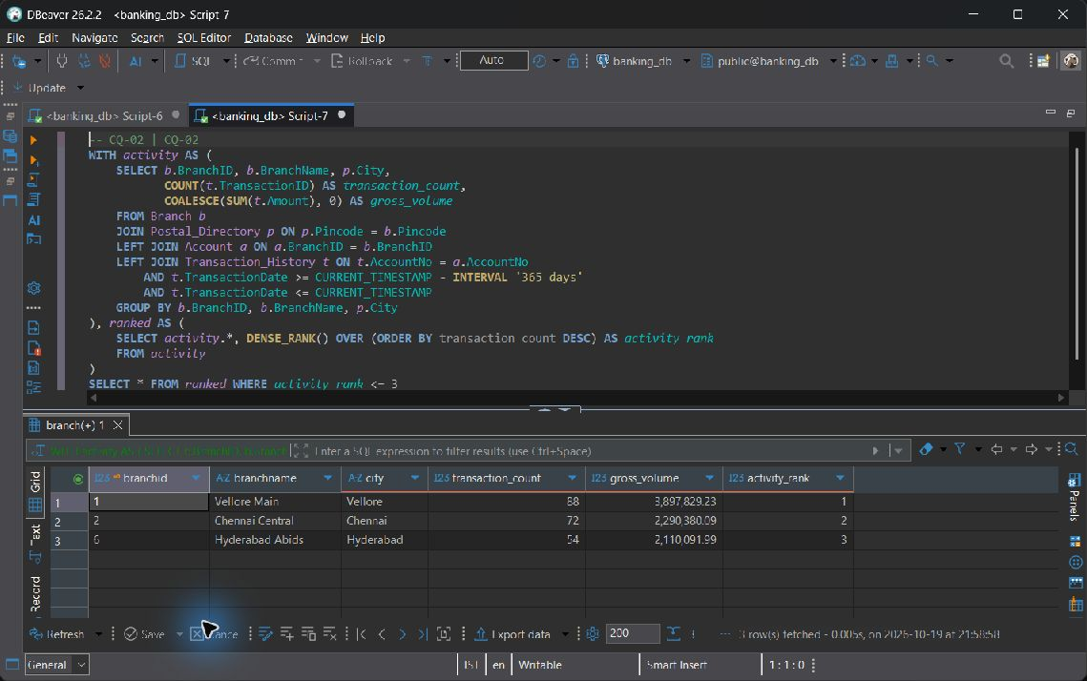  CQ-02 — live screenshot, 2026-10-19.
Explanation | Branch -> Postal_Directory supplies location; LEFT JOIN Account -> Transaction_History preserves zero-activity branches. The time restriction stays in ON so it cannot remove those branches. Rank aggregated event counts and show the top three ranks (including ties). Volume counts each event once.

CQ-03
ID | CQ-03
Business question | Which approved customers with Active fixed deposits and Active accounts have never borrowed, making them potential loan prospects?
SQL | WITH deposits AS (  SELECT CustomerID, COUNT(*) AS active_fd_count, SUM(Amount) AS fd_principal  FROM Fixed_Deposit WHERE Status = 'Active' GROUP BY CustomerID  ), accounts AS (  SELECT CustomerID, SUM(Balance) AS active_account_balance  FROM Account WHERE Status = 'Active' GROUP BY CustomerID  )  SELECT c.CustomerID, CONCAT(c.FirstName, ' ', c.LastName) AS customer_name,  c.Phone, d.active_fd_count, d.fd_principal, a.active_account_balance  FROM Customer c  JOIN deposits d ON d.CustomerID = c.CustomerID  JOIN accounts a ON a.CustomerID = c.CustomerID  WHERE c.KYC_Status = 'Approved'  AND NOT EXISTS (SELECT 1 FROM Loan l WHERE l.CustomerID = c.CustomerID)  ORDER BY d.fd_principal DESC, c.CustomerID;
Expected output | An Approved customer qualifies only when both an Active FD and an Active account exist and no Loan of any status exists. Separate product aggregates prevent an FD amount from being multiplied by account count.
Actual output screenshot | Actual output: 15 row(s); first 3 shown. NULL denotes a missing SQL value.  Row 1  customerid: 88  customer_name: Jacob Koshy  phone: 8998867708  active_fd_count: 1  fd_principal: 990000.00  active_account_balance: 226368.36  Row 2  customerid: 23  customer_name: Hemang Manne  phone: 9724990144  active_fd_count: 1  fd_principal: 919000.00  active_account_balance: 650393.62  Row 3  customerid: 50  customer_name: Wriddhish Raman  phone: 9249196984  active_fd_count: 1  fd_principal: 897000.00  active_account_balance: 667734.57  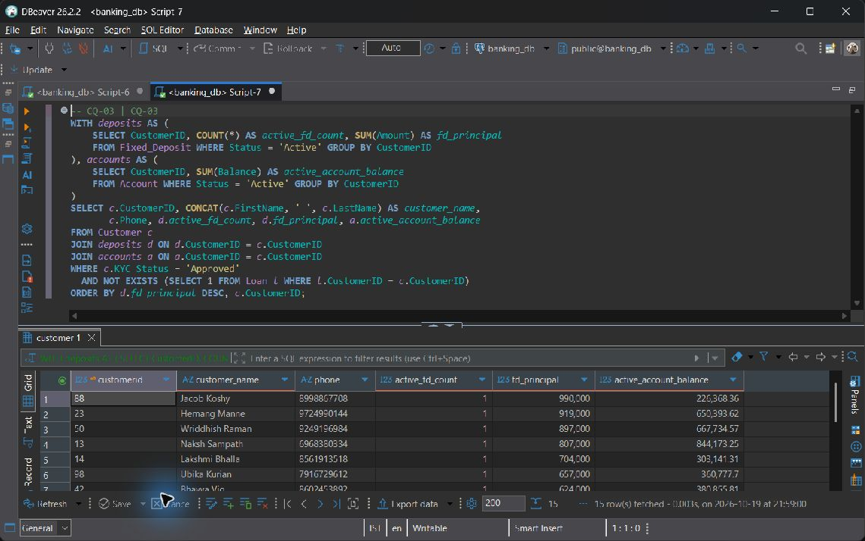  CQ-03 — live screenshot, 2026-10-19.
Explanation | Join Customer to separately aggregated Fixed_Deposit and Account holdings, then use correlated NOT EXISTS on Loan. This counts each FD once even if the customer owns multiple accounts. Sprint 1 has no such customers, so an empty result is expected until a qualifying customer is onboarded.

CQ-04
ID | CQ-04
Business question | Which calendar days have the highest bank-wide gross transaction volume, and how many branches contributed on each day?
SQL | WITH daily AS (  SELECT t.TransactionDate::date AS transaction_day,  COUNT(*) AS event_count, COUNT(DISTINCT b.BranchID) AS contributing_branches,  SUM(t.Amount) AS gross_volume  FROM Transaction_History t  JOIN Account a ON a.AccountNo = t.AccountNo  JOIN Branch b ON b.BranchID = a.BranchID  WHERE t.TransactionDate IS NOT NULL  GROUP BY t.TransactionDate::date  ), ranked AS (  SELECT daily.*, DENSE_RANK() OVER (ORDER BY gross_volume DESC) AS volume_rank  FROM daily  )  SELECT * FROM ranked WHERE volume_rank <= 3  ORDER BY volume_rank, transaction_day;
Expected output | One row per non-NULL stored transaction date is ranked by gross event amount. Only the three highest distinct volume ranks remain. Two history events for one internal transfer contribute twice to gross volume, not net funds moved.
Actual output screenshot | Actual output: 3 row(s); first 3 shown. NULL denotes a missing SQL value.  Row 1  transaction_day: 2026-10-19  event_count: 91  contributing_branches: 8  gross_volume: 1104348.13  volume_rank: 1  Row 2  transaction_day: 2026-10-04  event_count: 2  contributing_branches: 2  gross_volume: 265031.20  volume_rank: 2  Row 3  transaction_day: 2026-09-27  event_count: 3  contributing_branches: 2  gross_volume: 236041.94  volume_rank: 3  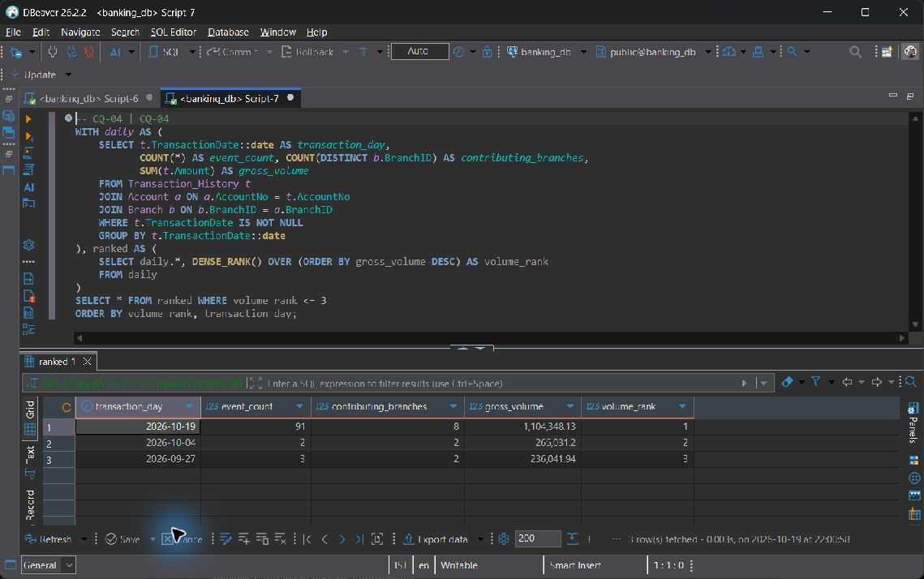  CQ-04 — live screenshot, 2026-10-19.
Explanation | Join Transaction_History -> Account -> Branch, aggregate all events per stored timestamp date, then DENSE_RANK daily SUM(Amount). Return the top three volume ranks, preserving ties. Dates follow the stored local timestamp convention; NULL timestamps cannot be assigned to a calendar day.

CQ-05
ID | CQ-05
Business question | What is each customer's indicative net position across account balances, Active FDs, and outstanding issued loans?
SQL | WITH balances AS (  SELECT CustomerID, SUM(Balance) AS account_balance  FROM Account WHERE Status IN ('Active', 'Dormant', 'Frozen') GROUP BY CustomerID  ), deposits AS (  SELECT CustomerID, SUM(Amount) AS fd_principal  FROM Fixed_Deposit WHERE Status = 'Active' GROUP BY CustomerID  ), debt AS (  SELECT CustomerID, SUM(OutstandingBalance) AS loan_outstanding  FROM Loan WHERE Status IN ('Approved', 'Active', 'Defaulted') GROUP BY CustomerID  )  SELECT c.CustomerID, CONCAT(c.FirstName, ' ', c.LastName) AS customer_name,  COALESCE(a.account_balance, 0) AS account_balance,  COALESCE(f.fd_principal, 0) AS active_fd_principal,  COALESCE(l.loan_outstanding, 0) AS loan_outstanding,  COALESCE(a.account_balance, 0) + COALESCE(f.fd_principal, 0)  - COALESCE(l.loan_outstanding, 0) AS indicative_net_position  FROM Customer c  LEFT JOIN balances a ON a.CustomerID = c.CustomerID  LEFT JOIN deposits f ON f.CustomerID = c.CustomerID  LEFT JOIN debt l ON l.CustomerID = c.CustomerID  ORDER BY indicative_net_position DESC, c.CustomerID;
Expected output | Every customer remains visible. Missing product totals become zero; indicative net position equals non-Closed account balances plus Active FD principal minus issued loan outstanding. Pending and Closed loans are excluded here.
Actual output screenshot | Actual output: 110 row(s); first 3 shown. NULL denotes a missing SQL value.  Row 1  customerid: 13  customer_name: Naksh Sampath  account_balance: 844173.25  active_fd_principal: 807000.00  loan_outstanding: 0  indicative_net_position: 1651173.25  Row 2  customerid: 19  customer_name: Aarush Sarin  account_balance: 791443.47  active_fd_principal: 933000.00  loan_outstanding: 84795.57  indicative_net_position: 1639647.90  Row 3  customerid: 23  customer_name: Hemang Manne  account_balance: 650393.62  active_fd_principal: 919000.00  loan_outstanding: 0  indicative_net_position: 1569393.62  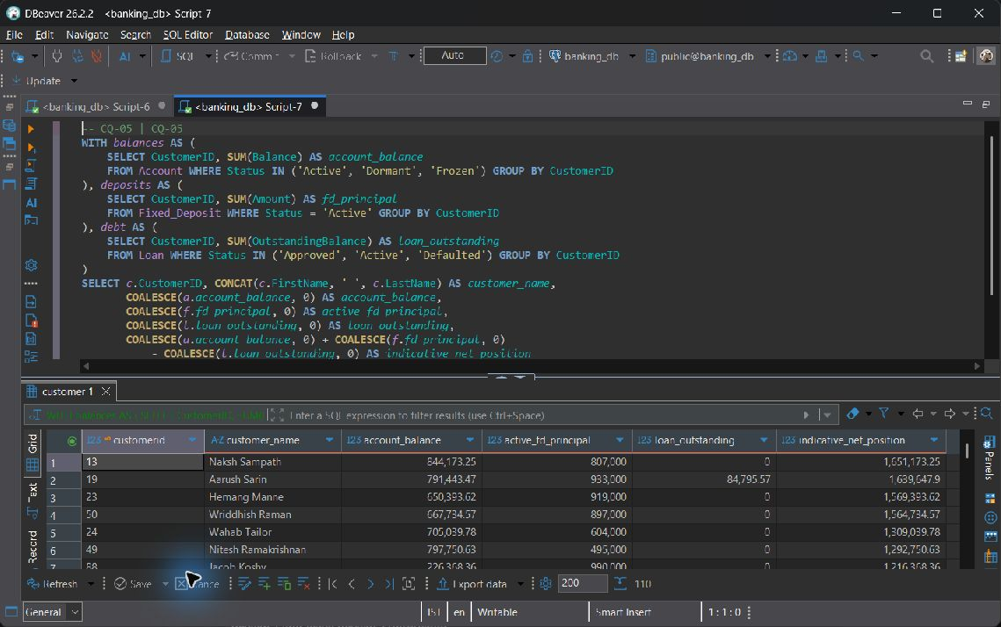  CQ-05 — live screenshot, 2026-10-19.
Explanation | Aggregate Account, Fixed_Deposit, and Loan per Customer first, then LEFT JOIN all three totals to Customer. This avoids product fan-out and retains customers without a product. Use FD principal, not future maturity interest; exclude Closed accounts and Pending/Closed loans. This is a simple product exposure measure, not a valuation including accrued loan interest.

CQ-06
ID | CQ-06
Business question | Which Active FDs are due for maturity, and which account branch could contact the owner about reinvestment?
SQL | WITH contact_accounts AS (  SELECT a.CustomerID, a.AccountNo, b.BranchName,  ROW_NUMBER() OVER (PARTITION BY a.CustomerID  ORDER BY a.OpeningDate, a.AccountNo) AS preference  FROM Account a  JOIN Branch b ON b.BranchID = a.BranchID  WHERE a.Status = 'Active'  )  SELECT f.FD_ID, c.CustomerID, CONCAT(c.FirstName, ' ', c.LastName) AS customer_name,  c.Phone, f.EndDate, CURRENT_DATE - f.EndDate AS days_since_maturity,  f.MaturityAmount, a.AccountNo AS suggested_contact_account,  a.BranchName AS suggested_contact_branch  FROM Fixed_Deposit f  JOIN Customer c ON c.CustomerID = f.CustomerID  LEFT JOIN contact_accounts a ON a.CustomerID = c.CustomerID AND a.preference = 1  WHERE f.Status = 'Active' AND f.EndDate <= CURRENT_DATE  ORDER BY f.EndDate, f.FD_ID;
Expected output | Only Active FDs whose EndDate is today or earlier appear. The oldest Active account supplies a suggested contact branch; a customer without an Active account still has a due FD row with NULL contact fields.
Actual output screenshot | Actual output: 0 row(s); first 0 shown. NULL denotes a missing SQL value.  0 rows returned. The query executed successfully; no record satisfies its predicate.  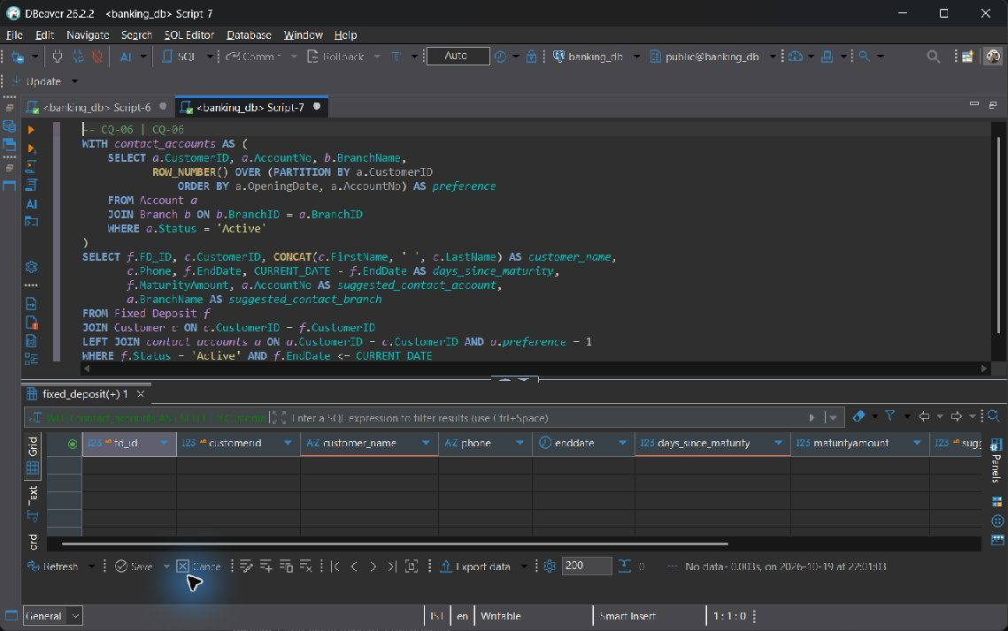  CQ-06 — live screenshot, 2026-10-19.
Explanation | Join Fixed_Deposit and Customer to Account/Branch through a ranked account CTE. Select the owner's oldest Active account as a contact branch, preventing duplicate FDs for multi-account customers. LEFT JOIN keeps due FDs whose owners have no Active account. An FD has no BranchID, so this branch is explicitly a contact suggestion, not an inferred FD issuing branch.

CQ-07
ID | CQ-07
Business question | How do branch staffing costs compare with their deposit balances, and how many customers does each staff member support?
SQL | WITH staffing AS (  SELECT BranchID, COUNT(*) AS staff_count, SUM(Salary) AS monthly_payroll  FROM Employee GROUP BY BranchID  ), holdings AS (  SELECT BranchID, COUNT(DISTINCT CustomerID) AS customer_count,  SUM(Balance) AS deposit_balance  FROM Account WHERE Status IN ('Active', 'Dormant', 'Frozen') GROUP BY BranchID  )  SELECT b.BranchID, b.BranchName, p.City,  COALESCE(s.staff_count, 0) AS staff_count,  COALESCE(s.monthly_payroll, 0) AS monthly_payroll,  COALESCE(h.deposit_balance, 0) AS deposit_balance,  ROUND(COALESCE(h.customer_count, 0)::numeric / NULLIF(s.staff_count, 0), 2)  AS customers_per_employee,  ROUND(COALESCE(h.deposit_balance, 0) / NULLIF(s.monthly_payroll, 0), 2)  AS balance_to_monthly_payroll_ratio  FROM Branch b  JOIN Postal_Directory p ON p.Pincode = b.Pincode  LEFT JOIN staffing s ON s.BranchID = b.BranchID  LEFT JOIN holdings h ON h.BranchID = b.BranchID  ORDER BY customers_per_employee DESC NULLS LAST, b.BranchID;
Expected output | All branches are shown once with independently aggregated payroll and deposits. Customers are distinct within the branch. Ratios become NULL where staff count or payroll is zero.
Actual output screenshot | Actual output: 8 row(s); first 2 shown. NULL denotes a missing SQL value.  Row 1  branchid: 6  branchname: Hyderabad Abids  city: Hyderabad  staff_count: 1  monthly_payroll: 42000.00  deposit_balance: 6125818.88  customers_per_employee: 23.00  balance_to_monthly_payroll_ratio: 145.85  Row 2  branchid: 3  branchname: Bengaluru Central  city: Bengaluru  staff_count: 1  monthly_payroll: 62000.00  deposit_balance: 4183810.68  customers_per_employee: 19.00  balance_to_monthly_payroll_ratio: 67.48  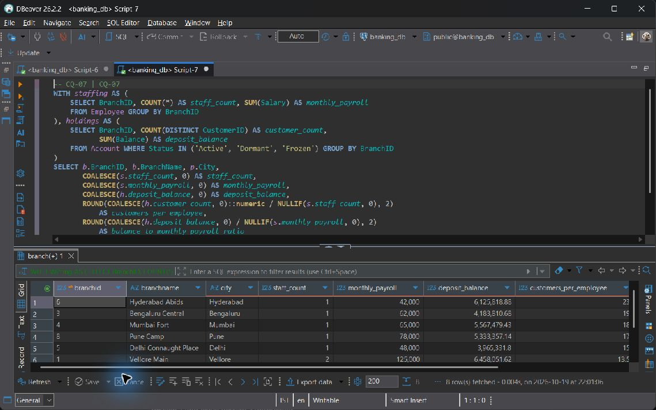  CQ-07 — live screenshot, 2026-10-19.
Explanation | Aggregate Employee and Account separately, then join those totals to Branch and Postal_Directory. Count distinct customers within each branch; do not multiply salaries by account rows. NULLIF protects zero-staff and zero-payroll branches. This is a workload proxy, not a profit calculation.

CQ-08
ID | CQ-08
Business question | Which customers registered the largest potential daily beneficiary limits, and how are those limits distributed by destination bank?
SQL | WITH exposure AS (  SELECT c.CustomerID, CONCAT(c.FirstName, ' ', c.LastName) AS customer_name,  d.BankName, COUNT(*) AS beneficiary_count,  SUM(b.MaxTransferLimit) AS configured_limit_sum  FROM Customer c  JOIN Beneficiary b ON b.CustomerID = c.CustomerID  JOIN Bank_Directory d ON d.IFSC_Code = b.IFSC_Code  GROUP BY c.CustomerID, c.FirstName, c.LastName, d.BankName  )  SELECT exposure.*,  DENSE_RANK() OVER (PARTITION BY BankName ORDER BY configured_limit_sum DESC)  AS limit_rank_within_bank  FROM exposure  ORDER BY BankName, limit_rank_within_bank, CustomerID;
Expected output | There is one customer and destination-bank group, ranked within that bank by the sum of configured per-beneficiary caps. This is configured exposure, not executed transfer value or a customer-wide enforcement rule.
Actual output screenshot | Actual output: 10 row(s); first 3 shown. NULL denotes a missing SQL value.  Row 1  customerid: 1  customer_name: Aarav Sharma  bankname: Campus Bank  beneficiary_count: 1  configured_limit_sum: 100000.00  limit_rank_within_bank: 1  Row 2  customerid: 7  customer_name: Arjun Sen  bankname: Campus Bank  beneficiary_count: 1  configured_limit_sum: 100000.00  limit_rank_within_bank: 1  Row 3  customerid: 2  customer_name: Ananya Iyer  bankname: Campus Bank  beneficiary_count: 1  configured_limit_sum: 75000.00  limit_rank_within_bank: 2  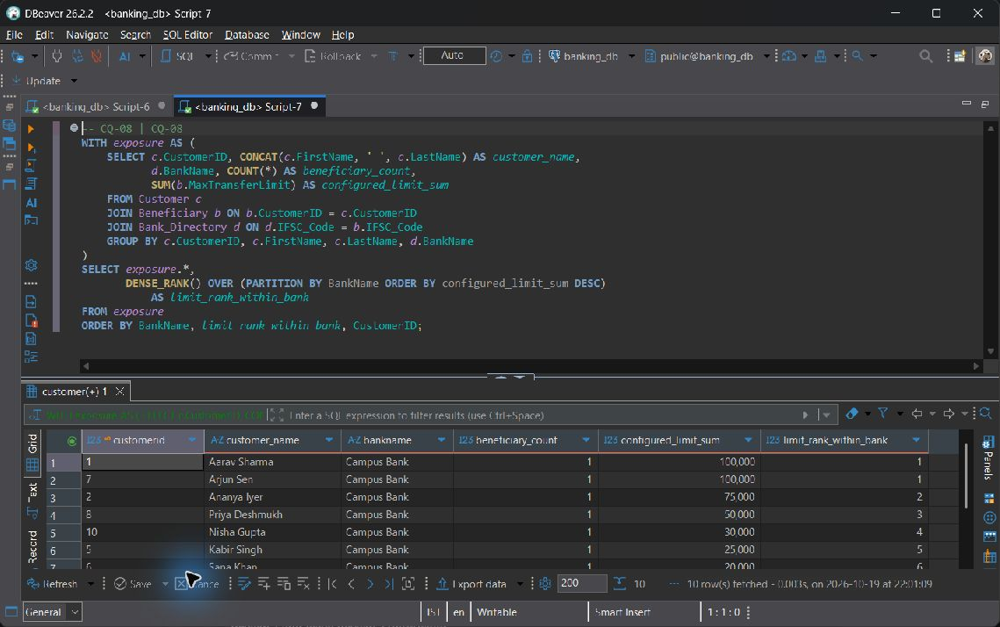  CQ-08 — live screenshot, 2026-10-19.
Explanation | Join Customer -> Beneficiary -> Bank_Directory, aggregate limits per customer/bank, and rank within each bank. These are sums of configured per-beneficiary caps; the schema has no executed-beneficiary transfer linkage, so these are neither observed transfers nor enforced customer-wide limits.

CQ-09
ID | CQ-09
Business question | How much has each loan collected successfully, and which borrowers have failed or pending repayment attempts requiring follow-up?
SQL | SELECT l.LoanID, CONCAT(c.FirstName, ' ', c.LastName) AS borrower,  b.BranchName, l.Status AS loan_status, l.OutstandingBalance,  COALESCE(SUM(r.AmountPaid) FILTER (WHERE r.PaymentStatus = 'Success'), 0)  AS successful_collections,  COUNT(r.PaymentID) FILTER (WHERE r.PaymentStatus = 'Pending') AS pending_attempts,  COUNT(r.PaymentID) FILTER (WHERE r.PaymentStatus = 'Failed') AS failed_attempts,  MAX(r.PaymentDate) FILTER (WHERE r.PaymentStatus = 'Success') AS latest_collection  FROM Loan l  JOIN Customer c ON c.CustomerID = l.CustomerID  JOIN Branch b ON b.BranchID = l.BranchID  LEFT JOIN Loan_Repayment r ON r.LoanID = l.LoanID  GROUP BY l.LoanID, c.CustomerID, c.FirstName, c.LastName, b.BranchID, b.BranchName  ORDER BY failed_attempts DESC, pending_attempts DESC, l.LoanID;
Expected output | Each loan is preserved even with no repayments. Only Success amounts enter collections; Pending and Failed counts remain separate. Principal and outstanding balances are never summed across installment rows.
Actual output screenshot | Actual output: 58 row(s); first 1 shown. NULL denotes a missing SQL value.  Row 1  loanid: 2006  borrower: Sana Khan  branchname: Hyderabad Abids  loan_status: Defaulted  outstandingbalance: 85000.00  successful_collections: 4754.00  pending_attempts: 0  failed_attempts: 1  latest_collection: 2026-08-19T18:41:46.235922  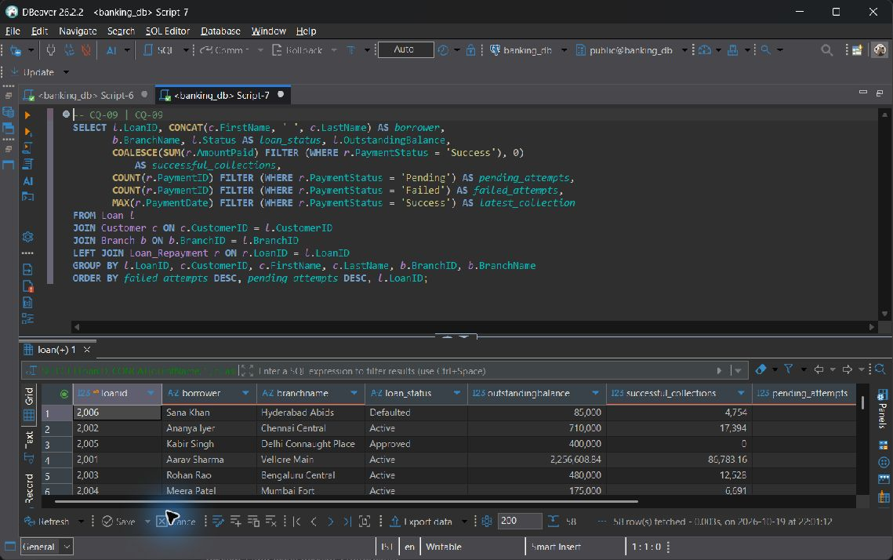  CQ-09 — live screenshot, 2026-10-19.
Explanation | Join Loan -> Customer -> Branch and LEFT JOIN Loan_Repayment. FILTER separates successful collections from pending/failed attempts. Loan principal and outstanding are not summed across repayments. Seed repayments are illustrative: collected amounts are not a principal reconciliation.

CQ-10
ID | CQ-10
Business question | Which accounts need a KYC or account-status review, what activity has been recorded, and what is their most recent account audit entry?
SQL | WITH activity AS (  SELECT AccountNo, COUNT(*) AS historical_events, MAX(TransactionDate) AS last_event  FROM Transaction_History GROUP BY AccountNo  )  SELECT c.CustomerID, CONCAT(c.FirstName, ' ', c.LastName) AS customer_name,  c.KYC_Status, a.AccountNo, a.Status AS account_status, a.Balance,  b.BranchName, COALESCE(t.historical_events, 0) AS historical_events,  t.last_event, audit.ActionType AS latest_audit_action,  audit.Description AS latest_audit_description, audit.LogDate AS latest_audit_date  FROM Customer c  JOIN Account a ON a.CustomerID = c.CustomerID  JOIN Branch b ON b.BranchID = a.BranchID  LEFT JOIN activity t ON t.AccountNo = a.AccountNo  LEFT JOIN LATERAL (  SELECT al.ActionType, al.Description, al.LogDate  FROM Audit_Log al  WHERE LOWER(al.TableName) = 'account' AND al.RecordID = a.AccountNo  ORDER BY al.LogDate DESC NULLS LAST, al.LogID DESC  LIMIT 1  ) audit ON TRUE  WHERE c.KYC_Status IS DISTINCT FROM 'Approved'  OR a.Status IN ('Dormant', 'Frozen')  ORDER BY b.BranchID, c.CustomerID, a.AccountNo;
Expected output | Accounts with unapproved or NULL KYC, Dormant status, or Frozen status appear with historical event totals. At most one latest Account audit is attached through both TableName and RecordID. Historical activity alone does not prove a post-freeze breach.
Actual output screenshot | Actual output: 42 row(s); first 1 shown. NULL denotes a missing SQL value.  Row 1  customerid: 9  customer_name: Dev Menon  kyc_status: Approved  accountno: 100011  account_status: Frozen  balance: 4500.00  branchname: Vellore Main  historical_events: 1  last_event: 2026-08-29T18:41:46.235922  latest_audit_action: SEED  latest_audit_description: Sprint 1 fixture: frozen account inserted  latest_audit_date: 2026-10-18T18:41:46.235922  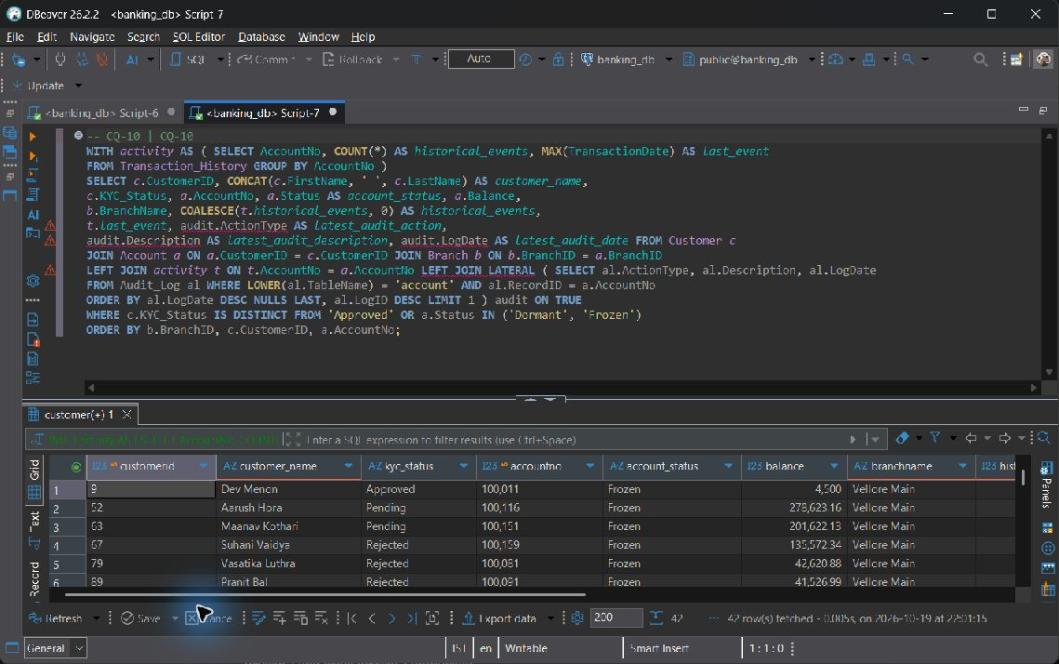  CQ-10 — live screenshot, 2026-10-19.
Explanation | Join Customer -> Account -> Branch, then LEFT JOIN history aggregated per account. A LEFT JOIN LATERAL selects at most one Audit_Log entry with BOTH the Account table discriminator and matching RecordID, since audit IDs are polymorphic. IS DISTINCT FROM also flags a NULL KYC status. Activity is historical context, not proof of a post-freeze violation: the schema has no status-change timestamp. Sprint 1 audits are explicit SEED rows.

8.2 Database Views

vw_customer_passbook
Purpose | Readable passbook joining Customer, Account, Branch and Transaction_History. COALESCE replaces missing narrative only for display.
CREATE VIEW statement | CREATE OR REPLACE VIEW vw_customer_passbook AS  SELECT a.AccountNo, CONCAT(c.FirstName, ' ', c.LastName) AS Name,  b.BranchName, t.TransactionDate AS Date, t.TransactionType AS Type,  t.Amount, COALESCE(t.Remarks, 'No remarks provided') AS Remarks  FROM Customer c  JOIN Account a ON a.CustomerID = c.CustomerID  JOIN Branch b ON b.BranchID = a.BranchID  JOIN Transaction_History t ON t.AccountNo = a.AccountNo;
Query using the view | SELECT * FROM vw_customer_passbook ORDER BY AccountNo;
Screenshot / Live Output | Actual output: 642 row(s); first 2 shown. NULL denotes a missing SQL value.  Row 1  accountno: 100001  name: Aarav Sharma  branchname: Vellore Main  date: 2026-10-18T19:01:28.793210  type: Transfer  amount: 0.01  remarks: Debit to 100003: RBAC transfer proof  Row 2  accountno: 100001  name: Aarav Sharma  branchname: Vellore Main  date: 2026-09-20T18:41:46.235922  type: Withdrawal  amount: 2500.00  remarks: No remarks provided  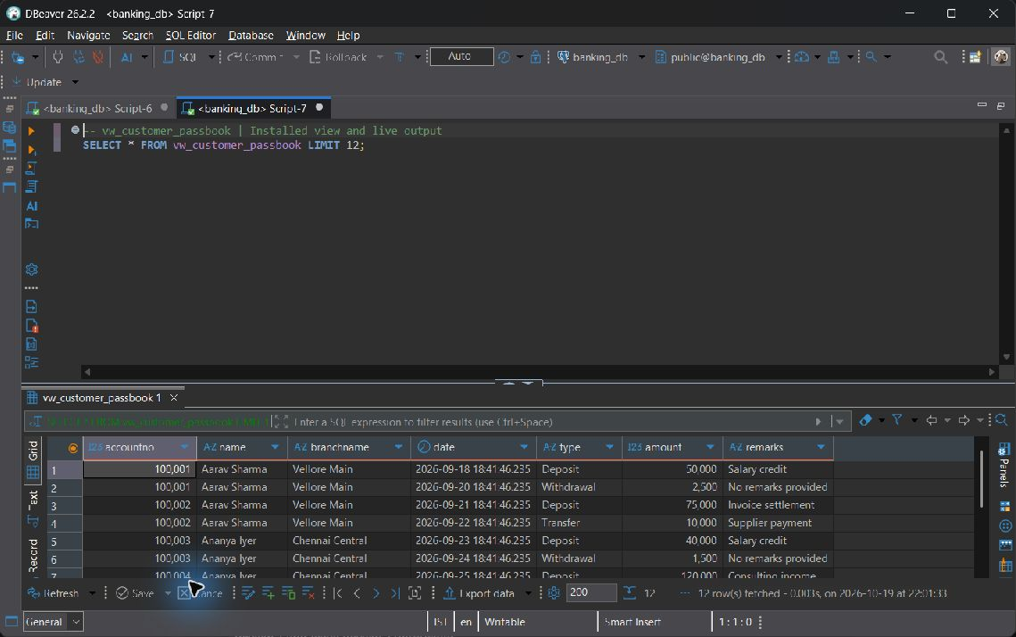  vw_customer_passbook — live screenshot, 2026-10-19.
Why useful | Not automatically updatable. Its top-level FROM contains four joined relations and includes expression columns; PostgreSQL cannot unambiguously route arbitrary view writes to one base table.

vw_branch_financial_summary
Purpose | One row per branch, independently aggregated Active account count, stored loan outstanding and Active FD maturity attribution.
CREATE VIEW statement | CREATE OR REPLACE VIEW vw_branch_financial_summary AS  WITH active_accounts AS (  SELECT BranchID, COUNT(*) AS total_active_accounts  FROM Account WHERE Status = 'Active' GROUP BY BranchID  ), loan_totals AS (  SELECT BranchID, SUM(OutstandingBalance) AS total_loan_outstanding  FROM Loan GROUP BY BranchID  ), primary_branch AS (  SELECT DISTINCT ON (CustomerID) CustomerID, BranchID  FROM Account  ORDER BY CustomerID, (Status = 'Active') DESC NULLS LAST,  (AccountType = 'Savings') DESC, OpeningDate, AccountNo  ), fd_totals AS (  SELECT p.BranchID, SUM(f.MaturityAmount) AS total_fd_maturity_amounts  FROM Fixed_Deposit f JOIN primary_branch p ON p.CustomerID = f.CustomerID  WHERE f.Status = 'Active'  GROUP BY p.BranchID  )  SELECT b.BranchID, b.BranchName,  COALESCE(a.total_active_accounts, 0) AS total_active_accounts,  COALESCE(l.total_loan_outstanding, 0) AS total_loan_outstanding,  COALESCE(f.total_fd_maturity_amounts, 0) AS total_fd_maturity_amounts  FROM Branch b  LEFT JOIN active_accounts a ON a.BranchID = b.BranchID  LEFT JOIN loan_totals l ON l.BranchID = b.BranchID  LEFT JOIN fd_totals f ON f.BranchID = b.BranchID;
Query using the view | SELECT * FROM vw_branch_financial_summary ORDER BY BranchID;
Screenshot / Live Output | Actual output: 8 row(s); first 3 shown. NULL denotes a missing SQL value.  Row 1  branchid: 1  branchname: Vellore Main  total_active_accounts: 20  total_loan_outstanding: 17670827.06  total_fd_maturity_amounts: 4152962.04  Row 2  branchid: 2  branchname: Chennai Central  total_active_accounts: 20  total_loan_outstanding: 9838670.37  total_fd_maturity_amounts: 3189457.73  Row 3  branchid: 3  branchname: Bengaluru Central  total_active_accounts: 13  total_loan_outstanding: 6228793.82  total_fd_maturity_amounts: 3502083.26  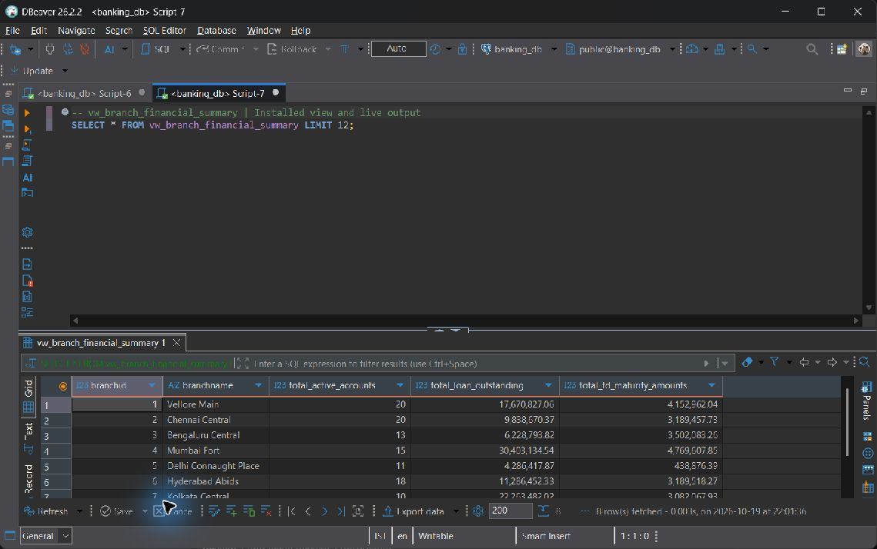  vw_branch_financial_summary — live screenshot, 2026-10-19.
Why useful | Not automatically updatable. GROUP BY aggregates, CTEs and multiple joined sources produce calculated summaries rather than a single directly writable relation.

vw_active_vellore_accounts
Purpose | Restrict visible Account rows to Active accounts serviced by a branch whose postal city is Vellore. security_barrier and CASCADED CHECK OPTION protect the predicate boundary.
CREATE VIEW statement | CREATE OR REPLACE VIEW vw_active_vellore_accounts  WITH (security_barrier = true) AS  SELECT a.AccountNo, a.CustomerID, a.BranchID, a.AccountType, a.Balance,  a.InterestRate, a.OpeningDate, a.Status  FROM Account a  WHERE a.Status = 'Active'  AND EXISTS (  SELECT 1 FROM Branch b  JOIN Postal_Directory p ON p.Pincode = b.Pincode  WHERE b.BranchID = a.BranchID AND p.City = 'Vellore'  )  WITH CASCADED CHECK OPTION;
Query using the view | SELECT * FROM vw_active_vellore_accounts ORDER BY AccountNo;
Screenshot / Live Output | Actual output: 20 row(s); first 2 shown. NULL denotes a missing SQL value.  Row 1  accountno: 100001  customerid: 1  branchid: 1  accounttype: Savings  balance: 1196030.18  interestrate: 3.50  openingdate: 2024-10-18  status: Active  Row 2  accountno: 100002  customerid: 1  branchid: 1  accounttype: Current  balance: 250000.00  interestrate: 0.00  openingdate: 2025-02-25  status: Active  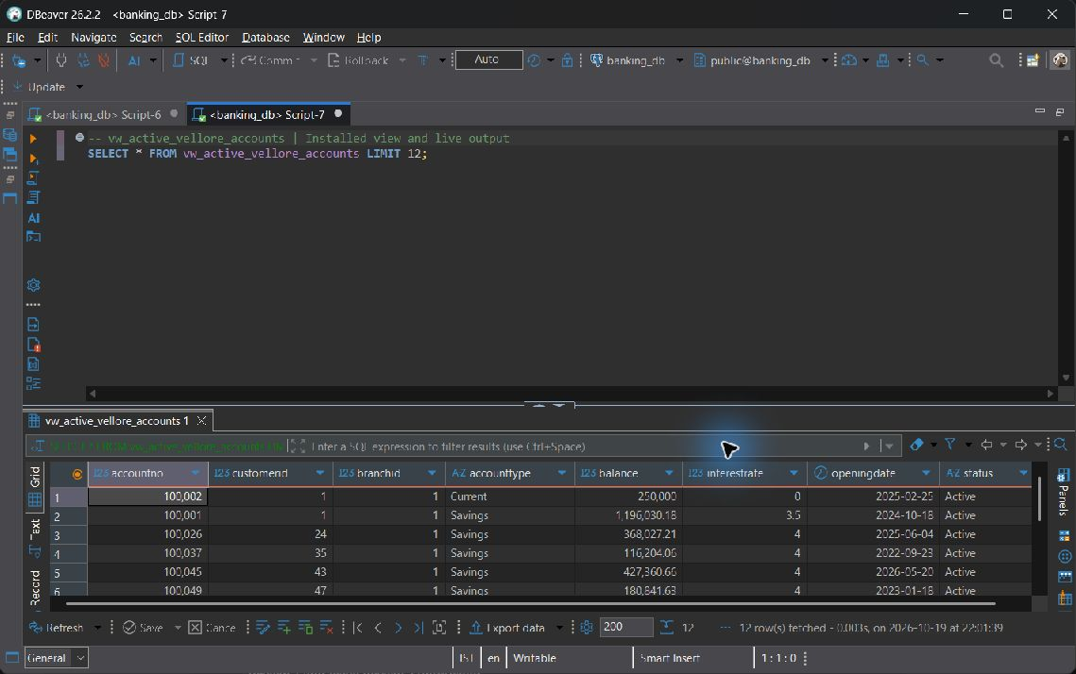  vw_active_vellore_accounts — live screenshot, 2026-10-19.
Why useful | Automatically updatable: the top-level FROM has only Account and its output columns are direct references. Branch and Postal_Directory are consulted through an EXISTS semi-join. CASCADED CHECK OPTION rejects writes that leave the view. Catalogue is_updatable=YES; the view alone is not a complete access-control policy.

Actual PostgreSQL updatability catalogue
Actual output: 3 row(s); first 3 shown. NULL denotes a missing SQL value.
table name | is updatable | check option
vw_active_vellore_accounts | YES | CASCADED
vw_branch_financial_summary | NO | NONE
vw_customer_passbook | NO | NONE

8.3 Stored Procedures

sp_transfer_funds
Purpose: Validate two different Active accounts, a finite positive paise-accurate amount, an allowed payment mode and sufficient funds. Lock accounts in ascending AccountNo order, debit and credit once, write two history events, and explicitly COMMIT.
CREATE OR REPLACE PROCEDURE sp_transfer_funds(
p_sender INT, p_receiver INT, p_amount DECIMAL,
p_mode VARCHAR, p_remarks VARCHAR
) LANGUAGE plpgsql AS $$
DECLARE
v_sender Account%ROWTYPE;
v_receiver Account%ROWTYPE;
BEGIN
IF p_sender IS NULL OR p_receiver IS NULL OR p_sender = p_receiver THEN
RAISE EXCEPTION 'Transfer requires two different account numbers'
USING ERRCODE = '22023';
END IF;
IF p_amount IS NULL OR p_amount <= 0 OR p_amount <> ROUND(p_amount, 2)
OR p_amount::text IN ('NaN', 'Infinity', '-Infinity') THEN
RAISE EXCEPTION 'Transfer amount must be finite, positive, and at most two decimal places'
USING ERRCODE = '22023';
END IF;
IF p_mode IS NULL OR p_mode NOT IN ('UPI', 'NEFT', 'RTGS', 'IMPS', 'Cash', 'Internal') THEN
RAISE EXCEPTION 'Invalid payment mode: %', p_mode USING ERRCODE = '22023';
END IF;
PERFORM AccountNo FROM Account WHERE AccountNo IN (p_sender, p_receiver)
ORDER BY AccountNo FOR UPDATE;
SELECT * INTO v_sender FROM Account WHERE AccountNo = p_sender;
IF NOT FOUND THEN
RAISE EXCEPTION 'Sender account % does not exist', p_sender USING ERRCODE = '22023';
END IF;
SELECT * INTO v_receiver FROM Account WHERE AccountNo = p_receiver;
IF NOT FOUND THEN
RAISE EXCEPTION 'Receiver account % does not exist', p_receiver USING ERRCODE = '22023';
END IF;
IF v_sender.Status IS DISTINCT FROM 'Active'
OR v_receiver.Status IS DISTINCT FROM 'Active' THEN
RAISE EXCEPTION 'Both transfer accounts must be Active' USING ERRCODE = '22023';
END IF;
IF v_sender.Balance < p_amount THEN
RAISE EXCEPTION 'Insufficient balance in sender account %', p_sender
USING ERRCODE = '22023';
END IF;
UPDATE Account SET Balance = Balance - p_amount WHERE AccountNo = p_sender;
UPDATE Account SET Balance = Balance + p_amount WHERE AccountNo = p_receiver;
INSERT INTO Transaction_History (AccountNo, Amount, TransactionType, PaymentMode, Remarks)
VALUES
(p_sender, p_amount, 'Transfer', p_mode,
LEFT(FORMAT('Debit to %s: %s', p_receiver, COALESCE(p_remarks, 'Fund transfer')), 255)),
(p_receiver, p_amount, 'Transfer', p_mode,
LEFT(FORMAT('Credit from %s: %s', p_sender, COALESCE(p_remarks, 'Fund transfer')), 255));
COMMIT;
END;
$$;

Live banking_db verification
CALL public.sp_transfer_funds(100001,100003,1196031.18,'Internal','Report rejection proof');

banking_db; real validation failure before COMMIT; no debit posted. Observed 2026-10-19T22:04:14.364042+05:30. This object demonstration is later than the shared query snapshot; intervening presenter activity can change balances.
Actual output: 1 row(s); first 1 shown. NULL denotes a missing SQL value.
sqlstate | postgresql error
22023 | Insufficient balance in sender account 100001  CONTEXT: PL/pgSQL function _bank_transfer_atomic(integer,integer,numeric,character varying,character varying) line 31 at RAISE  SQL statement "SELECT public._bank_transfer_atomic(p_sender, p_receiver, p_amount, p_mode, p_remarks)"  PL/pgSQL function sp_transfer_funds(integer,integer,numeric,character varying,character varying) line 3 at PERFORM

Test execution
CALL sp_transfer_funds(100001,100003,1000.00,'Internal','Report verification');

Execution context: Disposable verification database; exact 01, 02, 05 scripts. These outputs are isolated commit/trigger demonstrations; live read-only evidence elsewhere remains from banking_db.
Actual output: 2 row(s); first 2 shown. NULL denotes a missing SQL value.
accountno | balance
100001 | 233675.72
100003 | 87250.83

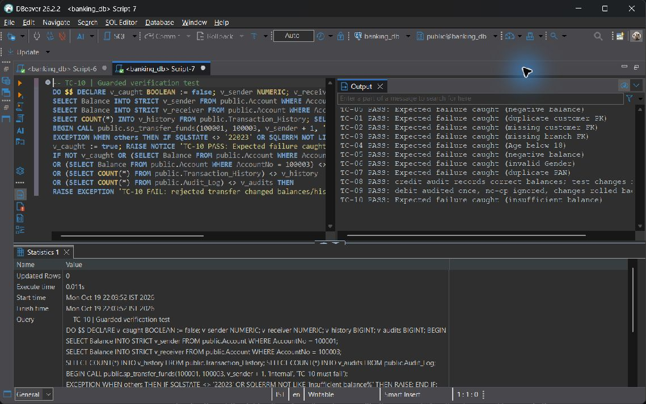
TC-10 — live screenshot, 2026-10-19.
Integrity and transaction benefit: Atomicity includes both account updates, two histories and audit trigger inserts. The caller must use top-level autocommit CALL because this procedure explicitly COMMITs; a validation exception occurs before that COMMIT. Both rows are locked in deterministic order to reduce opposite-direction deadlocks.

sp_pay_loan_emi
Purpose: Lock the owned Active account and the repayable owned loan, deduct LEAST(EMI_Amount, OutstandingBalance), log a withdrawal and insert a successful repayment. The repayment trigger changes debt and closes the final installment.
CREATE OR REPLACE PROCEDURE sp_pay_loan_emi(
p_customer_id INT, p_loan_id INT, p_account_no INT
) LANGUAGE plpgsql AS $$
DECLARE
v_account Account%ROWTYPE;
v_loan Loan%ROWTYPE;
v_payment NUMERIC(15, 2);
BEGIN
SELECT * INTO v_account FROM Account WHERE AccountNo = p_account_no FOR UPDATE;
IF NOT FOUND OR v_account.CustomerID IS DISTINCT FROM p_customer_id
OR v_account.Status IS DISTINCT FROM 'Active' THEN
RAISE EXCEPTION 'Active account % must belong to customer %', p_account_no, p_customer_id
USING ERRCODE = '22023';
END IF;
SELECT * INTO v_loan FROM Loan WHERE LoanID = p_loan_id FOR UPDATE;
IF NOT FOUND OR v_loan.CustomerID IS DISTINCT FROM p_customer_id
OR v_loan.Status IS NULL OR v_loan.Status NOT IN ('Approved', 'Active', 'Defaulted')
OR v_loan.OutstandingBalance <= 0 THEN
RAISE EXCEPTION 'Loan % is not repayable by customer %', p_loan_id, p_customer_id
USING ERRCODE = '22023';
END IF;
v_payment := LEAST(v_loan.EMI_Amount, v_loan.OutstandingBalance);
IF v_payment IS NULL OR v_payment <= 0 OR v_account.Balance < v_payment THEN
RAISE EXCEPTION 'Insufficient balance or invalid EMI for account %', p_account_no
USING ERRCODE = '22023';
END IF;
UPDATE Account SET Balance = Balance - v_payment WHERE AccountNo = p_account_no;
INSERT INTO Transaction_History (AccountNo, Amount, TransactionType, PaymentMode, Remarks)
VALUES (p_account_no, v_payment, 'Withdrawal', 'Internal', FORMAT('Loan EMI: %s', p_loan_id));
INSERT INTO Loan_Repayment (LoanID, AmountPaid, PaymentMode, PaymentStatus)
VALUES (p_loan_id, v_payment, 'Auto-Debit', 'Success');
END;
$$;

Live banking_db verification
BEGIN;
CALL public.sp_pay_loan_emi(1,2001,100001);
SELECT LoanID,EMI_Amount,OutstandingBalance,Status FROM Loan WHERE LoanID=2001;
ROLLBACK;

banking_db; observed inside a transaction and then rolled back. Observed 2026-10-19T22:04:14.364042+05:30. This object demonstration is later than the shared query snapshot; intervening presenter activity can change balances.
Actual output: 1 row(s); first 1 shown. NULL denotes a missing SQL value.
loanid | emi amount | outstandingbalance | status
2001 | 21695.58 | 2234913.26 | Active

Test execution
CALL sp_pay_loan_emi(1,2001,100001);

Execution context: Disposable verification database; exact 01, 02, 05 scripts. These outputs are isolated commit/trigger demonstrations; live read-only evidence elsewhere remains from banking_db.
Actual output: 1 row(s); first 1 shown. NULL denotes a missing SQL value.
loanid | emi amount | outstandingbalance | status
2001 | 21695.58 | 2256608.84 | Active

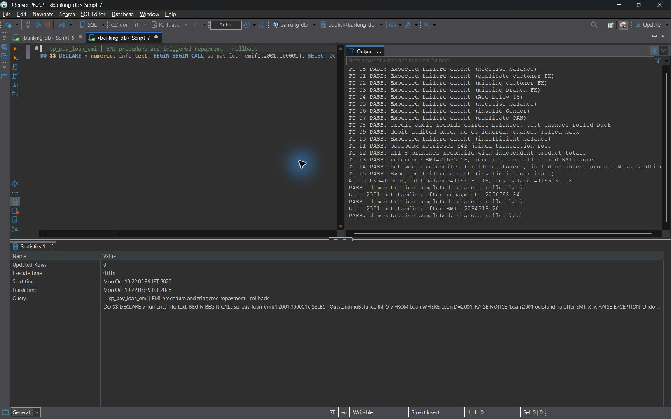
sp_pay_loan_emi — live screenshot, 2026-10-19.
Integrity and transaction benefit: The account debit, withdrawal event, repayment row and triggered debt change share one transaction. The final payment is capped at outstanding. The lab deliberately deducts the entire installment from principal; it has no interest/principal amortization allocation table.

8.4 User Defined Functions

fn_calculate_emi
Purpose: Return the rounded monthly compound-interest installment using P*r*(1+r)^n / ((1+r)^n-1), r=annual percent/1200. Reject invalid finite inputs; extend the function to zero interest as P/n.
CREATE OR REPLACE FUNCTION fn_calculate_emi(
p_principal DECIMAL, p_rate DECIMAL, p_months INT
) RETURNS DECIMAL
LANGUAGE plpgsql IMMUTABLE AS $$
DECLARE
v_rate NUMERIC;
v_factor NUMERIC;
BEGIN
IF p_principal IS NULL OR p_principal <= 0
OR p_principal::text IN ('NaN', 'Infinity', '-Infinity')
OR p_rate IS NULL OR p_rate < 0
OR p_rate::text IN ('NaN', 'Infinity', '-Infinity')
OR p_months IS NULL OR p_months <= 0 THEN
RAISE EXCEPTION 'EMI requires finite positive principal/months and nonnegative rate'
USING ERRCODE = '22023';
END IF;
IF p_rate = 0 THEN
RETURN ROUND(p_principal / p_months, 2);
END IF;
v_rate := p_rate / 1200.0;
v_factor := POWER(1 + v_rate, p_months);
RETURN ROUND(p_principal * v_rate * v_factor / (v_factor - 1), 2);
END;
$$;

Test execution against banking_db
SELECT fn_calculate_emi(2500000,8.50,240), fn_calculate_emi(12000,0,12);

Actual output: 1 row(s); first 1 shown. NULL denotes a missing SQL value.
reference emi | zero rate emi
21695.58 | 1000.00

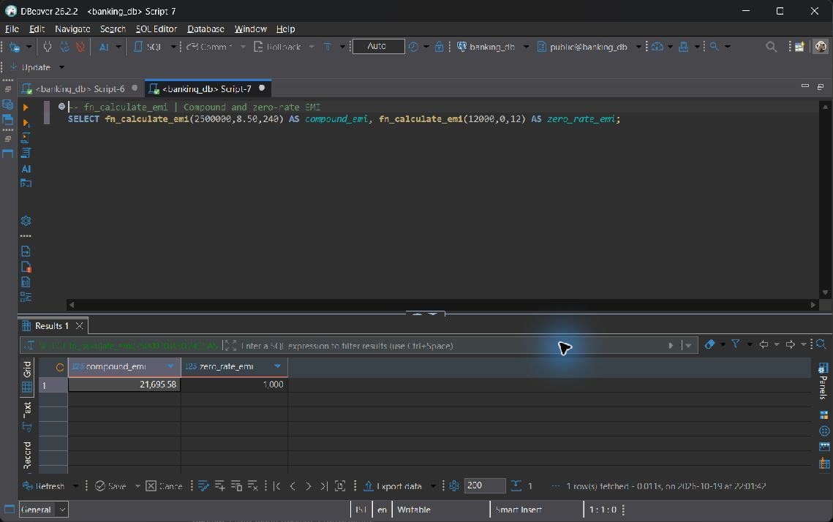
fn_calculate_emi — live screenshot, 2026-10-19.
Integrity and transaction benefit: IMMUTABLE is appropriate because the result depends only on inputs. Loan requires positive interest, but the UDF also handles the mathematically valid zero-rate test. Stored Loan.EMI_Amount is checked against the function in TC-13.

fn_customer_net_worth
Purpose: Return account balances plus Active FD principal minus all stored loan outstanding for an existing customer. Independent aggregates and COALESCE prevent join fan-out and NULL arithmetic.
CREATE OR REPLACE FUNCTION fn_customer_net_worth(p_customer_id INT)
RETURNS DECIMAL LANGUAGE plpgsql STABLE AS $$
BEGIN
IF p_customer_id IS NULL OR NOT EXISTS (
SELECT 1 FROM Customer WHERE CustomerID = p_customer_id
) THEN
RAISE EXCEPTION 'Customer % does not exist', p_customer_id
USING ERRCODE = '22023';
END IF;
RETURN COALESCE((SELECT SUM(Balance) FROM Account
WHERE CustomerID = p_customer_id), 0)
+ COALESCE((SELECT SUM(Amount) FROM Fixed_Deposit
WHERE CustomerID = p_customer_id AND Status = 'Active'), 0)
- COALESCE((SELECT SUM(OutstandingBalance) FROM Loan
WHERE CustomerID = p_customer_id), 0);
END;
$$;

Test execution against banking_db
SELECT fn_customer_net_worth(1);

Actual output: 1 row(s); first 1 shown. NULL denotes a missing SQL value.
customer 1 net worth
-810578.66

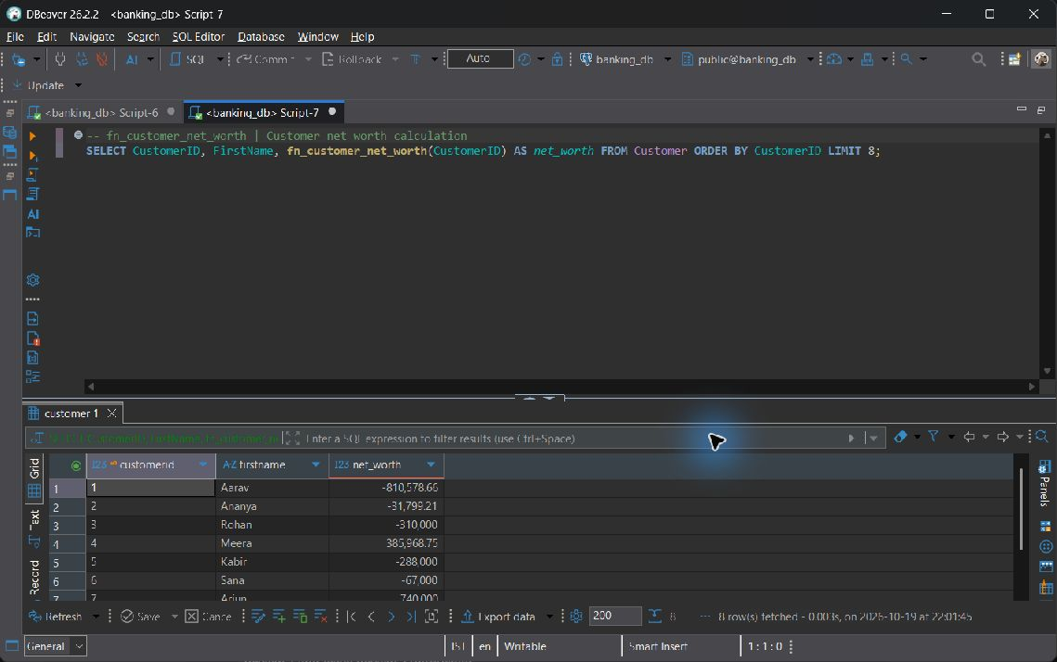
fn_customer_net_worth — live screenshot, 2026-10-19.
Integrity and transaction benefit: STABLE reads a consistent statement snapshot. Missing product rows contribute zero. Unlike CQ-05, this exact function includes every stored loan status and every account balance; the report does not silently equate those distinct metrics.

8.5 Triggers

trg_audit_account_changes
Purpose: AFTER UPDATE OF Balance on Account, write exactly one old/new balance audit when the values are distinct. A no-op update creates no audit; a rolled-back update also rolls back its audit.
CREATE OR REPLACE FUNCTION tg_audit_account_changes()
RETURNS TRIGGER LANGUAGE plpgsql AS $$
BEGIN
INSERT INTO Audit_Log (TableName, RecordID, ActionType, Description)
VALUES ('Account', NEW.AccountNo, 'BALANCE_UPDATE',
FORMAT('AccountNo=%s; old balance=%s; new balance=%s',
NEW.AccountNo, OLD.Balance, NEW.Balance));
RETURN NEW;
END;
$$;

CREATE OR REPLACE TRIGGER trg_audit_account_changes
AFTER UPDATE OF Balance ON Account
FOR EACH ROW WHEN (OLD.Balance IS DISTINCT FROM NEW.Balance)
EXECUTE FUNCTION tg_audit_account_changes();

Live banking_db verification
BEGIN;
UPDATE public.Account SET Balance=Balance+1 WHERE AccountNo=100001;
SELECT TableName,RecordID,ActionType,Description FROM Audit_Log ORDER BY LogID DESC LIMIT 1;
ROLLBACK;

banking_db; observed inside a transaction and then rolled back. Observed 2026-10-19T22:04:14.364042+05:30. This object demonstration is later than the shared query snapshot; intervening presenter activity can change balances.
Actual output: 1 row(s); first 1 shown. NULL denotes a missing SQL value.
tablename | recordid | actiontype | description
Account | 100001 | BALANCE_UPDATE | AccountNo=100001; old balance=1196030.18; new balance=1196031.18

Test execution
BEGIN;
UPDATE Account SET Balance=Balance+1 WHERE AccountNo=100001;
SELECT * FROM Audit_Log ORDER BY LogID DESC LIMIT 1;
ROLLBACK;

Execution context: Disposable verification database; rolled back after observation. These outputs are isolated commit/trigger demonstrations; live read-only evidence elsewhere remains from banking_db.
Audit count before 26; after update 27; both update and audit then rolled back.
Actual output: 1 row(s); first 1 shown. NULL denotes a missing SQL value.
tablename | recordid | actiontype | description
Account | 100001 | BALANCE_UPDATE | AccountNo=100001; old balance=319598.42; new balance=319599.42

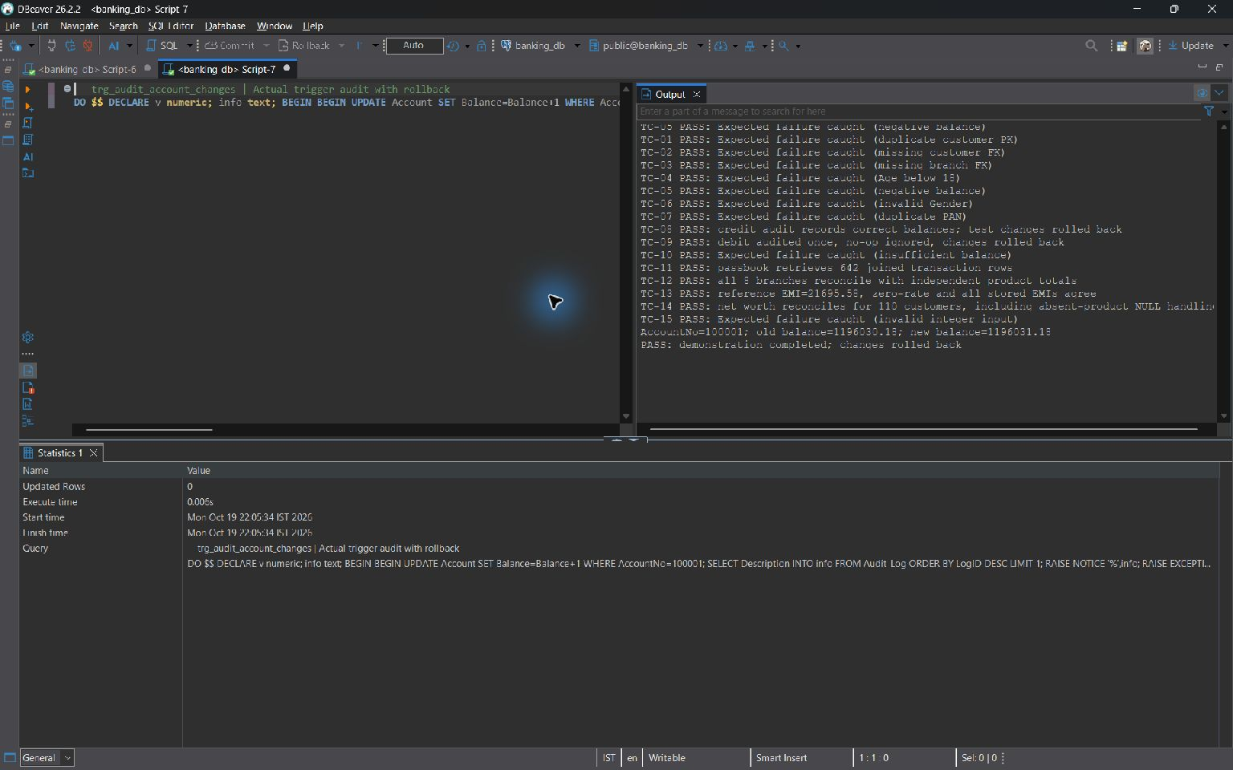
trg_audit_account_changes — live screenshot, 2026-10-19.
Integrity and transaction benefit: The WHEN predicate suppresses meaningless no-op records. Audit and balance changes are transactional together. SQL script 06 makes this support function SECURITY DEFINER with a fixed search_path so permitted manager account updates can still write the protected log.

trg_loan_repayment
Purpose: AFTER INSERT on Loan_Repayment, act only on Success. Lock the loan FOR NO KEY UPDATE, reject overpayment, reduce outstanding, and change Status to Closed when the balance reaches zero.
CREATE OR REPLACE FUNCTION tg_loan_repayment()
RETURNS TRIGGER LANGUAGE plpgsql AS $$
DECLARE
v_loan Loan%ROWTYPE;
v_remaining NUMERIC(15, 2);
BEGIN
IF NEW.PaymentStatus IS DISTINCT FROM 'Success' THEN
RETURN NEW;
END IF;
SELECT * INTO v_loan FROM Loan WHERE LoanID = NEW.LoanID FOR NO KEY UPDATE;
IF NOT FOUND OR v_loan.Status IS NULL
OR v_loan.Status NOT IN ('Approved', 'Active', 'Defaulted')
OR v_loan.OutstandingBalance <= 0 THEN
RAISE EXCEPTION 'Loan % is not repayable', NEW.LoanID USING ERRCODE = '22023';
END IF;
IF NEW.AmountPaid > v_loan.OutstandingBalance THEN
RAISE EXCEPTION 'Repayment exceeds outstanding balance for loan %', NEW.LoanID
USING ERRCODE = '22023';
END IF;
v_remaining := v_loan.OutstandingBalance - NEW.AmountPaid;
UPDATE Loan
SET OutstandingBalance = GREATEST(v_remaining, 0),
Status = CASE WHEN v_remaining <= 0 THEN 'Closed' ELSE Status END
WHERE LoanID = NEW.LoanID;
RETURN NEW;
END;
$$;

CREATE OR REPLACE TRIGGER trg_loan_repayment
AFTER INSERT ON Loan_Repayment
FOR EACH ROW EXECUTE FUNCTION tg_loan_repayment();

Live banking_db verification
BEGIN;
INSERT INTO public.Loan_Repayment(LoanID,AmountPaid,PaymentMode,PaymentStatus) VALUES(2001,10,'UPI','Success');
SELECT LoanID,OutstandingBalance,Status FROM Loan WHERE LoanID=2001;
ROLLBACK;

banking_db; observed inside a transaction and then rolled back. Observed 2026-10-19T22:04:14.364042+05:30. This object demonstration is later than the shared query snapshot; intervening presenter activity can change balances.
Actual output: 1 row(s); first 1 shown. NULL denotes a missing SQL value.
loanid | outstandingbalance | status
2001 | 2256598.84 | Active

Test execution
BEGIN;
INSERT INTO Loan_Repayment(LoanID,AmountPaid,PaymentMode,PaymentStatus)
VALUES(2001,10,'UPI','Success');
SELECT LoanID,OutstandingBalance,Status FROM Loan WHERE LoanID=2001;
ROLLBACK;

Execution context: Disposable verification database; rolled back after observation. These outputs are isolated commit/trigger demonstrations; live read-only evidence elsewhere remains from banking_db.
Outstanding before insert: INR 2256608.84. The successful test repayment is INR 10.
Actual output: 1 row(s); first 1 shown. NULL denotes a missing SQL value.
loanid | outstandingbalance | status
2001 | 2256598.84 | Active

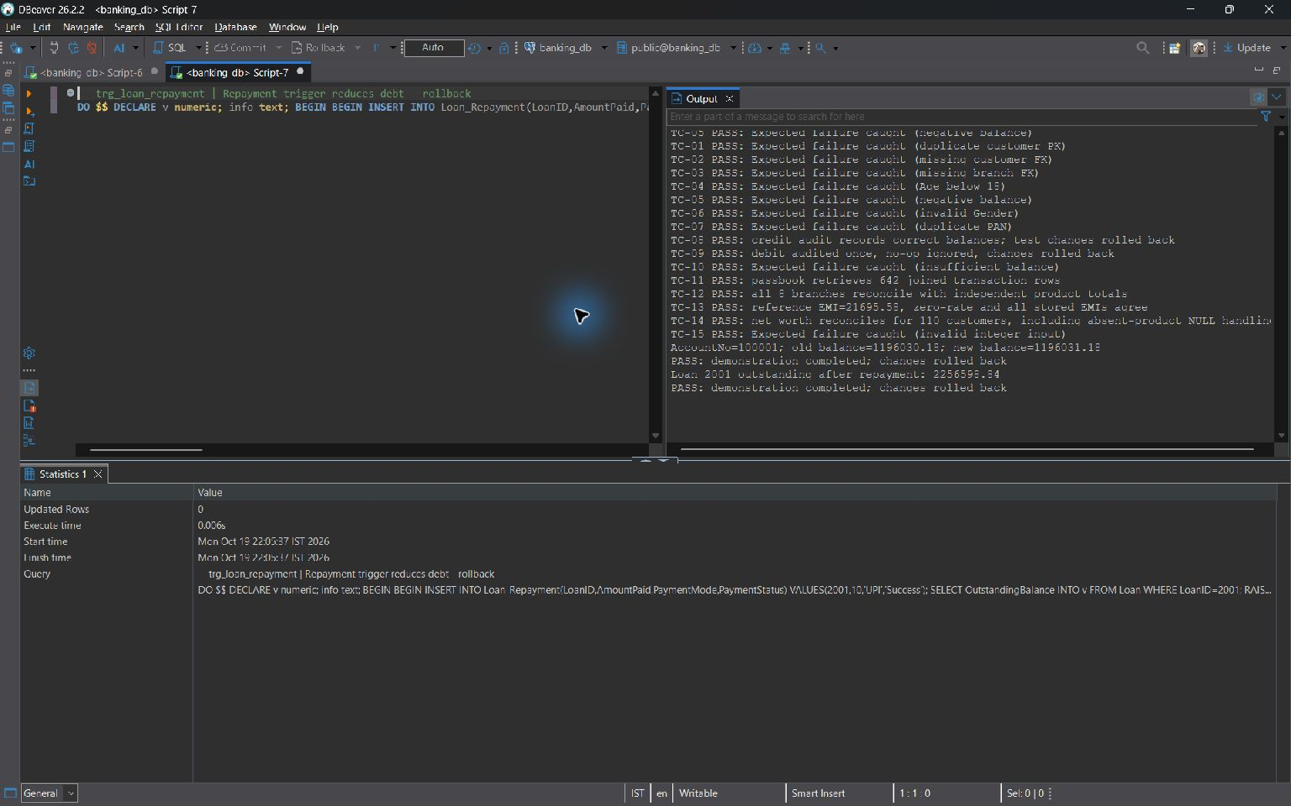
trg_loan_repayment — live screenshot, 2026-10-19.
Integrity and transaction benefit: Only successful attempts affect debt. FOR NO KEY UPDATE serializes debt changes without conflicting with another repayment insert's foreign-key key-share lock. Overpayments are rejected instead of being silently discarded.

8.6 Explicit Cursors

sp_batch_credit_savings_interest
Purpose: Use a bound explicit savings_cursor FOR loop over Active Savings accounts under row locks. Post rounded Balance*InterestRate/1200 as Deposit/Internal, with Monthly Interest Credit remarks. Skip accounts already posted in the current calendar month.
CREATE OR REPLACE PROCEDURE sp_batch_credit_savings_interest()
LANGUAGE plpgsql AS $$
DECLARE
savings_cursor CURSOR FOR
SELECT AccountNo, Balance, InterestRate FROM Account
WHERE Status = 'Active' AND AccountType = 'Savings'
ORDER BY AccountNo FOR UPDATE;
v_account RECORD;
v_interest NUMERIC(15, 2);
v_month TIMESTAMP := DATE_TRUNC('month', CURRENT_TIMESTAMP)::timestamp;
BEGIN
FOR v_account IN savings_cursor LOOP
IF EXISTS (
SELECT 1 FROM Transaction_History
WHERE AccountNo = v_account.AccountNo AND TransactionType = 'Deposit'
AND Remarks = 'Monthly Interest Credit'
AND TransactionDate >= v_month
AND TransactionDate < v_month + INTERVAL '1 month'
) THEN
CONTINUE;
END IF;
IF v_account.InterestRate < 0 THEN
RAISE EXCEPTION 'Negative savings rate on account %', v_account.AccountNo
USING ERRCODE = '22023';
END IF;
v_interest := ROUND((v_account.Balance * v_account.InterestRate / 100) / 12, 2);
IF v_interest <= 0 THEN
CONTINUE; -- Transaction_History requires strictly positive Amount.
END IF;
UPDATE Account SET Balance = Balance + v_interest
WHERE AccountNo = v_account.AccountNo;
INSERT INTO Transaction_History (AccountNo, Amount, TransactionType, PaymentMode, Remarks)
VALUES (v_account.AccountNo, v_interest, 'Deposit', 'Internal', 'Monthly Interest Credit');
END LOOP;
END;
$$;

Live banking_db verification
BEGIN;
CALL public.sp_batch_credit_savings_interest();
SELECT COUNT(*) AS postings_in_this_transaction,COALESCE(SUM(Amount),0) AS credited_amount FROM Transaction_History WHERE xmin=pg_current_xact_id()::text::xid;
ROLLBACK;

banking_db; observed inside a transaction and then rolled back. Observed 2026-10-19T22:04:14.364042+05:30. This object demonstration is later than the shared query snapshot; intervening presenter activity can change balances.
Actual output: 1 row(s); first 1 shown. NULL denotes a missing SQL value.
postings in this transaction | credited amount
0 | 0

Test execution
CALL sp_batch_credit_savings_interest();

Execution context: Disposable verification database; monthly posting markers cleared for this demonstration. These outputs are isolated commit/trigger demonstrations; live read-only evidence elsewhere remains from banking_db.
Actual output: 4 row(s); first 3 shown. NULL denotes a missing SQL value.
accountno | amount | remarks
100001 | 618.28 | Monthly Interest Credit
100003 | 254.48 | Monthly Interest Credit
100006 | 971.78 | Monthly Interest Credit

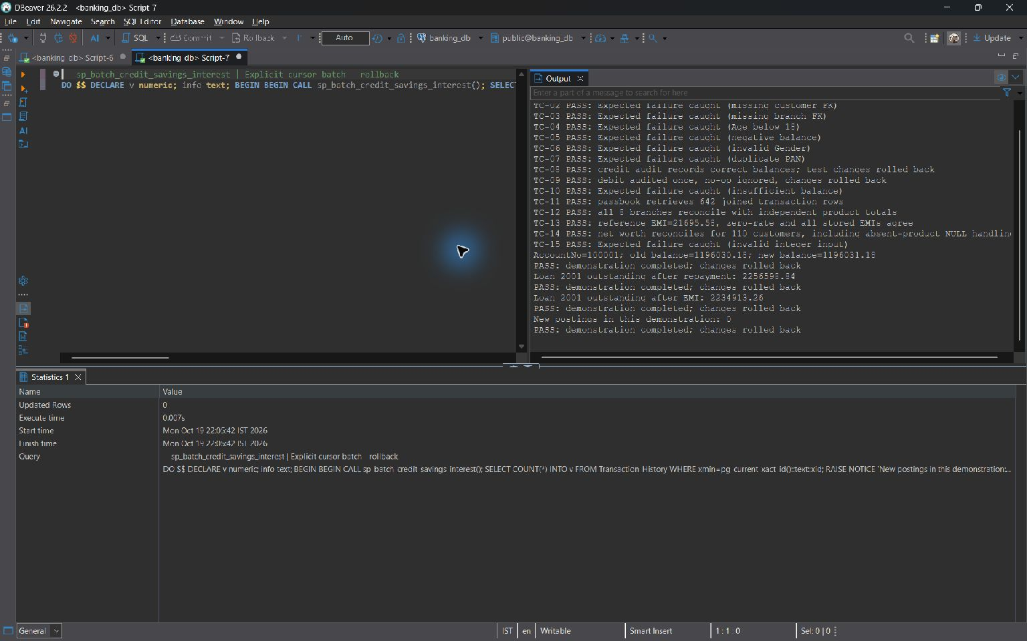
sp_batch_credit_savings_interest — live screenshot, 2026-10-19.
Integrity and transaction benefit: The explicit cursor opens, fetches and closes through a bound FOR loop. Account locks and a fresh posting check avoid double credit in the same month; the complete batch shares one transaction and has no per-row COMMIT.

sp_batch_mature_fixed_deposits
Purpose: Use a bound explicit maturity_cursor FOR loop for Active FDs due by CURRENT_DATE. Credit the oldest Active Savings account, mark the FD Matured, record history and an FD_MATURED audit. Abort the entire batch if an eligible payout account is absent.
CREATE OR REPLACE PROCEDURE sp_batch_mature_fixed_deposits()
LANGUAGE plpgsql AS $$
DECLARE
maturity_cursor CURSOR FOR
SELECT FD_ID, CustomerID, MaturityAmount FROM Fixed_Deposit
WHERE Status = 'Active' AND EndDate <= CURRENT_DATE
ORDER BY FD_ID FOR UPDATE;
v_fd RECORD;
v_account_no INT;
BEGIN
FOR v_fd IN maturity_cursor LOOP
SELECT AccountNo INTO v_account_no FROM Account
WHERE CustomerID = v_fd.CustomerID AND AccountType = 'Savings' AND Status = 'Active'
ORDER BY OpeningDate, AccountNo LIMIT 1 FOR UPDATE;
IF NOT FOUND THEN
RAISE EXCEPTION 'No Active savings account for FD % customer %', v_fd.FD_ID, v_fd.CustomerID
USING ERRCODE = '22023';
END IF;
IF v_fd.MaturityAmount IS NULL OR v_fd.MaturityAmount <= 0 THEN
RAISE EXCEPTION 'Invalid maturity amount on FD %', v_fd.FD_ID USING ERRCODE = '22023';
END IF;
UPDATE Fixed_Deposit SET Status = 'Matured' WHERE FD_ID = v_fd.FD_ID;
UPDATE Account SET Balance = Balance + v_fd.MaturityAmount WHERE AccountNo = v_account_no;
INSERT INTO Transaction_History (AccountNo, Amount, TransactionType, PaymentMode, Remarks)
VALUES (v_account_no, v_fd.MaturityAmount, 'Deposit', 'Internal',
FORMAT('FD Maturity Credit: %s', v_fd.FD_ID));
INSERT INTO Audit_Log (TableName, RecordID, ActionType, Description)
VALUES ('Fixed_Deposit', v_fd.FD_ID, 'FD_MATURED',
FORMAT('Maturity amount %s credited to AccountNo=%s', v_fd.MaturityAmount, v_account_no));
END LOOP;
END;
$$;

Live banking_db verification
BEGIN;
CALL public.sp_batch_mature_fixed_deposits();
SELECT COUNT(*) AS postings_in_this_transaction,COALESCE(SUM(Amount),0) AS credited_amount FROM Transaction_History WHERE xmin=pg_current_xact_id()::text::xid;
ROLLBACK;

banking_db; observed inside a transaction and then rolled back. Observed 2026-10-19T22:04:14.364042+05:30. This object demonstration is later than the shared query snapshot; intervening presenter activity can change balances.
Actual output: 1 row(s); first 1 shown. NULL denotes a missing SQL value.
postings in this transaction | credited amount
0 | 0

Test execution
CALL sp_batch_mature_fixed_deposits();

Execution context: Disposable verification database; FD 3001 reactivated solely for this demonstration. These outputs are isolated commit/trigger demonstrations; live read-only evidence elsewhere remains from banking_db.
Actual output: 1 row(s); first 1 shown. NULL denotes a missing SQL value.
fd id | maturityamount | status
3001 | 107000.00 | Matured

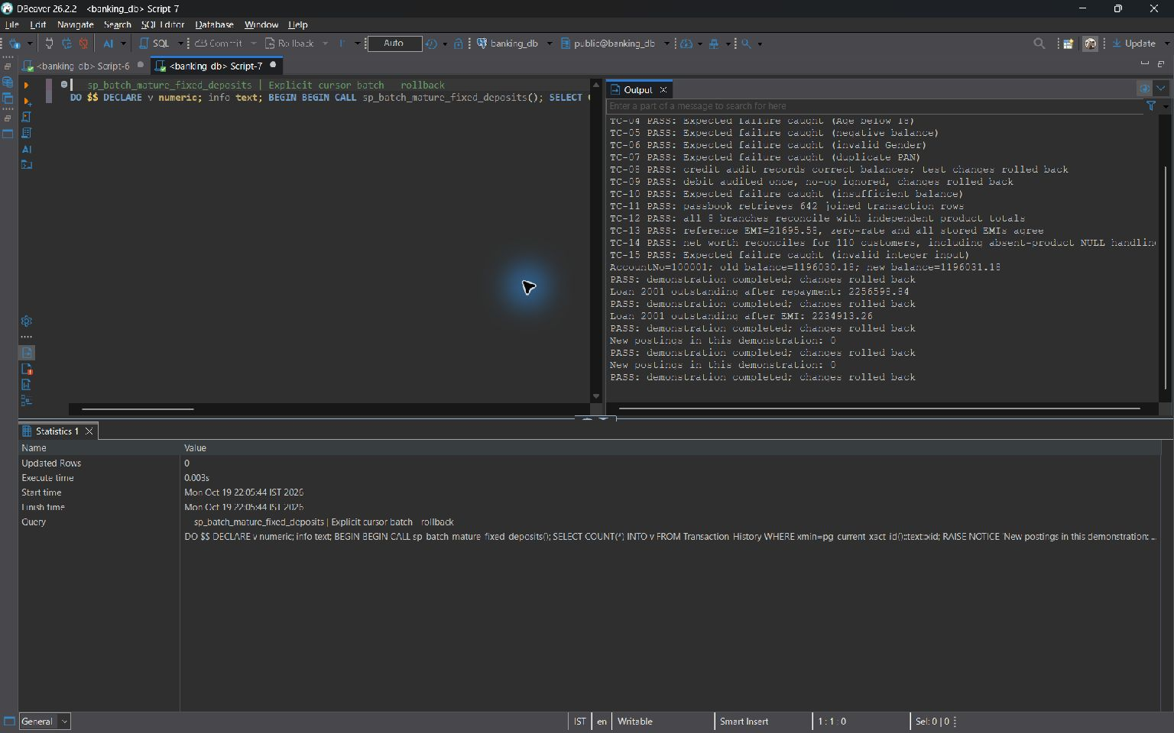
sp_batch_mature_fixed_deposits — live screenshot, 2026-10-19.
Integrity and transaction benefit: Matured status plus the enclosing transaction prevents repeated payouts. The chosen primary savings account is oldest by OpeningDate then AccountNo, restricted to Active. A missing account aborts prior loop effects as well as the current FD.

8.7 SQL Security Implementation
The deployed sql/06_security_concurrency.sql hardens the Review 2 logic. It replaces sp_transfer_funds with a SECURITY INVOKER wrapper calling the narrow SECURITY DEFINER _bank_transfer_atomic helper, then COMMIT. The COMMIT-bearing wrapper cannot itself be SECURITY DEFINER or have a SET clause. The helper uses explicit public names and a fixed pg_catalog, public, pg_temp search_path, is owned by the non-superuser bank_admin role, and is explicitly granted only for the transfer operation.
The following source is the deployed wrapper and helper; it supplements, rather than contradicts, the original full procedure source in Section 8.3.
CREATE OR REPLACE FUNCTION public._bank_transfer_atomic(p_sender integer, p_receiver integer, p_amount numeric, p_mode character varying, p_remarks character varying)
RETURNS void
LANGUAGE plpgsql
SECURITY DEFINER
SET search_path TO 'pg_catalog', 'public', 'pg_temp'
AS $function$
DECLARE
v_sender public.Account%ROWTYPE;
v_receiver public.Account%ROWTYPE;
BEGIN
IF p_sender IS NULL OR p_receiver IS NULL OR p_sender = p_receiver THEN
RAISE EXCEPTION 'Transfer requires two different account numbers' USING ERRCODE = '22023';
END IF;
IF p_amount IS NULL OR p_amount <= 0 OR p_amount <> ROUND(p_amount, 2)
OR p_amount::text IN ('NaN', 'Infinity', '-Infinity') THEN
RAISE EXCEPTION 'Transfer amount must be finite, positive, and at most two decimal places'
USING ERRCODE = '22023';
END IF;
IF p_mode IS NULL OR p_mode NOT IN ('UPI', 'NEFT', 'RTGS', 'IMPS', 'Cash', 'Internal') THEN
RAISE EXCEPTION 'Invalid payment mode: %', p_mode USING ERRCODE = '22023';
END IF;
PERFORM AccountNo FROM public.Account WHERE AccountNo IN (p_sender, p_receiver)
ORDER BY AccountNo FOR UPDATE;
SELECT * INTO v_sender FROM public.Account WHERE AccountNo = p_sender;
IF NOT FOUND THEN
RAISE EXCEPTION 'Sender account % does not exist', p_sender USING ERRCODE = '22023';
END IF;
SELECT * INTO v_receiver FROM public.Account WHERE AccountNo = p_receiver;
IF NOT FOUND THEN
RAISE EXCEPTION 'Receiver account % does not exist', p_receiver USING ERRCODE = '22023';
END IF;
IF v_sender.Status IS DISTINCT FROM 'Active' OR v_receiver.Status IS DISTINCT FROM 'Active' THEN
RAISE EXCEPTION 'Both transfer accounts must be Active' USING ERRCODE = '22023';
END IF;
IF v_sender.Balance < p_amount THEN
RAISE EXCEPTION 'Insufficient balance in sender account %', p_sender USING ERRCODE = '22023';
END IF;
UPDATE public.Account SET Balance = Balance - p_amount WHERE AccountNo = p_sender;
UPDATE public.Account SET Balance = Balance + p_amount WHERE AccountNo = p_receiver;
INSERT INTO public.Transaction_History (AccountNo, Amount, TransactionType, PaymentMode, Remarks)
VALUES
(p_sender, p_amount, 'Transfer', p_mode,
LEFT(FORMAT('Debit to %s: %s', p_receiver, COALESCE(p_remarks, 'Fund transfer')), 255)),
(p_receiver, p_amount, 'Transfer', p_mode,
LEFT(FORMAT('Credit from %s: %s', p_sender, COALESCE(p_remarks, 'Fund transfer')), 255));
END;
$function$

CREATE OR REPLACE PROCEDURE public.sp_transfer_funds(IN p_sender integer, IN p_receiver integer, IN p_amount numeric, IN p_mode character varying, IN p_remarks character varying)
LANGUAGE plpgsql
AS $procedure$
BEGIN
PERFORM public._bank_transfer_atomic(p_sender, p_receiver, p_amount, p_mode, p_remarks);
COMMIT;
END;
$procedure$

Create >= 3 users/roles | DROP ROLE IF EXISTS bank_teller;  DROP ROLE IF EXISTS branch_manager;  DROP ROLE IF EXISTS bank_admin;  CREATE ROLE bank_admin NOLOGIN NOSUPERUSER NOCREATEDB NOCREATEROLE NOREPLICATION;  CREATE ROLE branch_manager NOLOGIN NOSUPERUSER NOCREATEDB NOCREATEROLE NOREPLICATION;  CREATE ROLE bank_teller NOLOGIN NOSUPERUSER NOCREATEDB NOCREATEROLE NOREPLICATION;  Observed installed role catalogue; role creation was not rerun against shared cluster roles.  Actual output: 3 row(s); first 3 shown. NULL denotes a missing SQL value.  Row 1  rolname: bank_admin  rolcanlogin: false  rolsuper: false  rolcreatedb: false  rolcreaterole: false  Row 2  rolname: bank_teller  rolcanlogin: false  rolsuper: false  rolcreatedb: false  rolcreaterole: false  Row 3  rolname: branch_manager  rolcanlogin: false  rolsuper: false  rolcreatedb: false  rolcreaterole: false
GRANT privileges per role matrix | GRANT ALL PRIVILEGES ON DATABASE banking_db TO bank_admin;  GRANT ALL PRIVILEGES ON SCHEMA public TO bank_admin;  GRANT ALL PRIVILEGES ON ALL TABLES IN SCHEMA public TO bank_admin;  GRANT ALL PRIVILEGES ON ALL SEQUENCES IN SCHEMA public TO bank_admin;  GRANT ALL PRIVILEGES ON ALL ROUTINES IN SCHEMA public TO bank_admin;  ALTER FUNCTION public._bank_transfer_atomic(INT, INT, NUMERIC, VARCHAR, VARCHAR) OWNER TO bank_admin;  ALTER FUNCTION public.tg_audit_account_changes() OWNER TO bank_admin;  ALTER PROCEDURE public.sp_pay_loan_emi(INT, INT, INT) OWNER TO bank_admin;  ALTER PROCEDURE public.sp_batch_credit_savings_interest() OWNER TO bank_admin;  ALTER PROCEDURE public.sp_batch_mature_fixed_deposits() OWNER TO bank_admin;  -- GRANT matrix (existing objects):  -- Role Tables/views Routines  -- bank_admin ALL tables/views + sequence ALL ALL  -- branch_manager SELECT/INSERT/UPDATE Customer, all 4 procedures;  -- Account, Loan transfer helper EXECUTE  -- bank_teller SELECT vw_customer_passbook only transfer + its helper  -- No memberships in bank_admin are granted to the other roles.  GRANT SELECT, INSERT, UPDATE ON public.Customer, public.Account, public.Loan TO branch_manager;  GRANT EXECUTE ON ALL PROCEDURES IN SCHEMA public TO branch_manager;  GRANT SELECT ON public.vw_customer_passbook TO bank_teller;  GRANT EXECUTE ON PROCEDURE public.sp_transfer_funds(INT, INT, NUMERIC, VARCHAR, VARCHAR) TO bank_teller;  REVOKE ALL ON FUNCTION public._bank_transfer_atomic(INT, INT, NUMERIC, VARCHAR, VARCHAR) FROM PUBLIC;  GRANT EXECUTE ON FUNCTION public._bank_transfer_atomic(INT, INT, NUMERIC, VARCHAR, VARCHAR)  TO branch_manager, bank_teller;  Actual output: 3 row(s); first 3 shown. NULL denotes a missing SQL value.  Row 1  role_name: bank_admin  account_select: true  account_insert: true  account_update: true  account_delete: true  passbook_select: true  transfer_execute: true  Row 2  role_name: bank_teller  account_select: false  account_insert: false  account_update: false  account_delete: false  passbook_select: true  transfer_execute: true  Row 3  role_name: branch_manager  account_select: true  account_insert: true  account_update: true  account_delete: false  passbook_select: false  transfer_execute: true
REVOKE demonstration | GRANT DELETE ON public.Account TO bank_teller;  REVOKE DELETE ON public.Account FROM bank_teller;  Actual effective DELETE privilege: after GRANT = true; after REVOKE = false. Both statements were verified inside a transaction rolled back to preserve the existing grants.
Least privilege proof | DO $$  DECLARE v_denied BOOLEAN := false;  BEGIN  SET LOCAL ROLE bank_teller;  BEGIN  DELETE FROM public.Account WHERE false;  EXCEPTION WHEN insufficient_privilege THEN  v_denied := true;  RAISE NOTICE 'PASS: bank_teller DELETE denied (SQLSTATE %)', SQLSTATE;  END;  RESET ROLE;  IF NOT v_denied THEN RAISE EXCEPTION 'Least privilege failed: teller can DELETE Account'; END IF;  IF HAS_TABLE_PRIVILEGE('bank_teller', 'public.Account', 'UPDATE')  OR HAS_TABLE_PRIVILEGE('bank_teller', 'public.Account', 'SELECT')  OR HAS_FUNCTION_PRIVILEGE('bank_teller', 'public.fn_customer_net_worth(integer)', 'EXECUTE') THEN  RAISE EXCEPTION 'Teller inherited unintended base-table or routine access';  END IF;  SET LOCAL ROLE bank_teller;  PERFORM * FROM public.vw_customer_passbook LIMIT 1;  RESET ROLE;  RAISE NOTICE 'PASS: teller can read passbook while base Account access remains denied';  END;  $$;  NOTICE: PASS: bank_teller DELETE denied (SQLSTATE 42501)  NOTICE: PASS: teller can read passbook while base Account access remains denied
Secure exposure | ALTER PROCEDURE public.sp_pay_loan_emi(INT, INT, INT) SECURITY DEFINER;  ALTER PROCEDURE public.sp_pay_loan_emi(INT, INT, INT) SET search_path = pg_catalog, public, pg_temp;  ALTER PROCEDURE public.sp_batch_credit_savings_interest() SECURITY DEFINER;  ALTER PROCEDURE public.sp_batch_credit_savings_interest() SET search_path = pg_catalog, public, pg_temp;  ALTER PROCEDURE public.sp_batch_mature_fixed_deposits() SECURITY DEFINER;  ALTER PROCEDURE public.sp_batch_mature_fixed_deposits() SET search_path = pg_catalog, public, pg_temp;  -- Direct manager Account updates must still write protected audit records.  ALTER FUNCTION public.tg_audit_account_changes() SECURITY DEFINER;  ALTER FUNCTION public.tg_audit_account_changes() SET search_path = pg_catalog, public, pg_temp;  REVOKE CREATE ON SCHEMA public FROM PUBLIC;  REVOKE ALL PRIVILEGES ON ALL TABLES IN SCHEMA public FROM PUBLIC;  REVOKE ALL PRIVILEGES ON ALL SEQUENCES IN SCHEMA public FROM PUBLIC;  REVOKE EXECUTE ON ALL ROUTINES IN SCHEMA public FROM PUBLIC;  GRANT SELECT ON public.vw_customer_passbook TO bank_teller;  GRANT EXECUTE ON PROCEDURE public.sp_transfer_funds  (INT,INT,NUMERIC,VARCHAR,VARCHAR) TO bank_teller;  Installed privilege evidence: teller Account SELECT/INSERT/UPDATE/DELETE=false; passbook SELECT=true; transfer EXECUTE=true. The helper EXECUTE grant is required by the invoker wrapper. No bank_admin membership is granted to teller or manager.

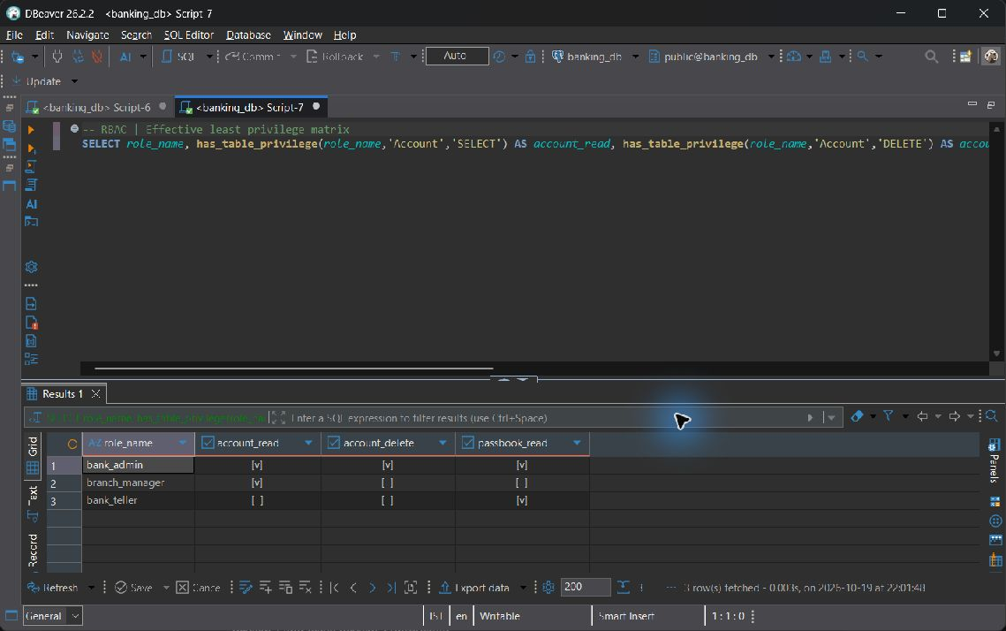
RBAC — live screenshot, 2026-10-19.
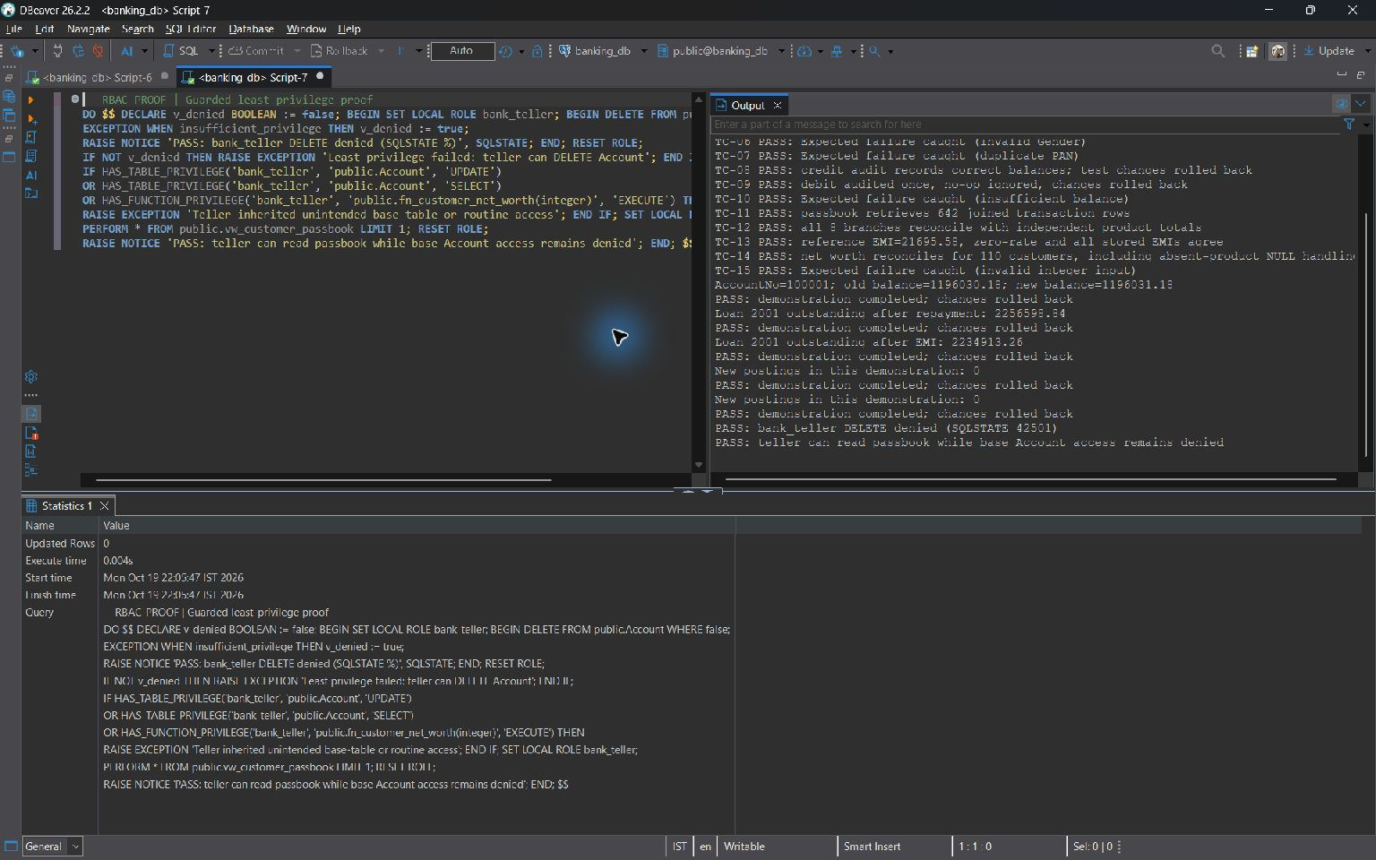
RBAC-PROOF — live screenshot, 2026-10-19.
Security boundary: bank_admin, branch_manager and bank_teller are NOLOGIN group roles; a trusted session uses SET ROLE for the proof. Employee.Role is descriptive staff data, not an automatic database login or role membership. FastAPI currently connects as postgres and exposes simulated portal identity selection, so application route authorization and branch-limited access are not claimed to be enforced by these grants.

8.8 Transactions Indexing and Query Optimization
PostgreSQL does not accept literal SAVEPOINT or ROLLBACK TO SAVEPOINT commands inside a PL/pgSQL DO body. The exact script therefore demonstrates literal SQL transaction control at top level, and a separate BEGIN/EXCEPTION block as the supported implicit-subtransaction equivalent.
BEGIN;
SAVEPOINT account_demo;
UPDATE public.Account SET Balance = Balance + 1 WHERE AccountNo = 100001;
ROLLBACK TO SAVEPOINT account_demo; -- also undoes the balance audit trigger
RELEASE SAVEPOINT account_demo;
COMMIT;
DO $$
DECLARE v_before NUMERIC;
BEGIN
SELECT Balance INTO STRICT v_before FROM public.Account WHERE AccountNo = 100001;
BEGIN -- implicit SAVEPOINT
UPDATE public.Account SET Balance = Balance + 1 WHERE AccountNo = 100001;
RAISE EXCEPTION 'Intentional subtransaction rollback' USING ERRCODE = 'Z0001';
EXCEPTION WHEN SQLSTATE 'Z0001' THEN
-- Equivalent to ROLLBACK TO SAVEPOINT for this inner block.
RAISE NOTICE 'PASS: inner update and trigger audit rolled back; outer DO continues';
END;
IF (SELECT Balance FROM public.Account WHERE AccountNo = 100001) IS DISTINCT FROM v_before THEN
RAISE EXCEPTION 'Subtransaction failed to restore balance';
END IF;
-- Outside the inner exception block, top-level DO may COMMIT.
COMMIT;
END;
$$;

Observation | Actual value
Balance before | 1196030.18
Balance inside savepoint | 1196031.18
Balance after rollback | 1196030.18
Audit count before / after | 131 / 131

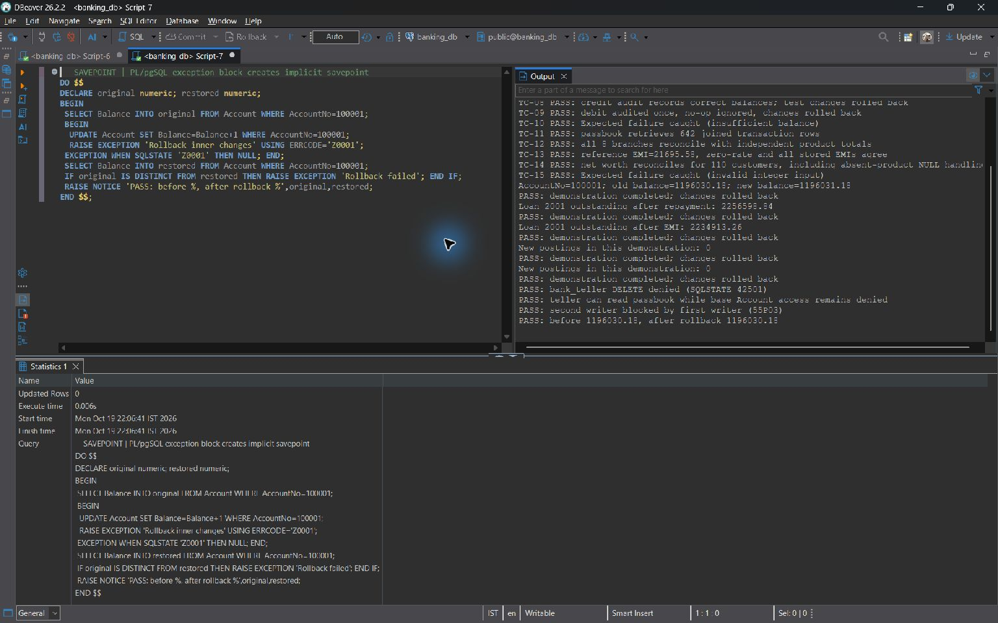
SAVEPOINT — live screenshot, 2026-10-19.
The literal proof ended with COMMIT after restoring the row and its audit. An EXCEPTION block rolls back only its inner changes and permits the outer block to continue. Transactional rollback does not reclaim SERIAL sequence values; gaps do not indicate missing business rows.
Three project indexes
CREATE INDEX idx_customer_name ON public.customer USING btree (lastname, firstname);

CREATE INDEX idx_loan_status ON public.loan USING btree (customerid, status);

CREATE INDEX idx_txn_account_date ON public.transaction_history USING btree (accountno, transactiondate);

The transaction index leads with AccountNo for equality, then TransactionDate for range/ordering. The customer name index matches last-name/first-name access. The loan index supports customer equality followed by status. Indexes consume storage and add maintenance work to writes, so they are not an unconditional improvement.
BEGIN;
DROP INDEX IF EXISTS public.idx_txn_account_date;
EXPLAIN (ANALYZE, BUFFERS)
SELECT TransactionID, AccountNo, TransactionDate, Amount
FROM public.Transaction_History
WHERE AccountNo = 100001 AND TransactionDate >= CURRENT_DATE - INTERVAL '365 days'
ORDER BY TransactionDate;
ROLLBACK;
-- Original index is restored by transactional rollback.
EXPLAIN (ANALYZE, BUFFERS)
SELECT TransactionID, AccountNo, TransactionDate, Amount
FROM public.Transaction_History
WHERE AccountNo = 100001 AND TransactionDate >= CURRENT_DATE - INTERVAL '365 days'
ORDER BY TransactionDate;

Actual plan without idx_txn_account_date
Sort (cost=23.98..24.00 rows=8 width=24) (actual time=0.046..0.047 rows=21.00 loops=1)
Sort Key: transactiondate
Sort Method: quicksort Memory: 25kB
Buffers: shared hit=13
-> Seq Scan on transaction_history (cost=0.00..23.86 rows=8 width=24) (actual time=0.008..0.038 rows=21.00 loops=1)
Filter: ((accountno = 100001) AND (transactiondate >= (CURRENT_DATE - '365 days'::interval)))
Rows Removed by Filter: 621
Buffers: shared hit=13
Planning:
Buffers: shared hit=7
Planning Time: 0.107 ms
Execution Time: 0.056 ms

Actual plan with idx_txn_account_date available
Sort (cost=17.23..17.25 rows=8 width=24) (actual time=0.032..0.033 rows=21.00 loops=1)
Sort Key: transactiondate
Sort Method: quicksort Memory: 25kB
Buffers: shared hit=9
-> Bitmap Heap Scan on transaction_history (cost=4.36..17.11 rows=8 width=24) (actual time=0.016..0.025 rows=21.00 loops=1)
Recheck Cond: ((accountno = 100001) AND (transactiondate >= (CURRENT_DATE - '365 days'::interval)))
Heap Blocks: exact=7
Buffers: shared hit=9
-> Bitmap Index Scan on idx_txn_account_date (cost=0.00..4.36 rows=8 width=0) (actual time=0.007..0.008 rows=22.00 loops=1)
Index Cond: ((accountno = 100001) AND (transactiondate >= (CURRENT_DATE - '365 days'::interval)))
Index Searches: 1
Buffers: shared hit=2
Planning:
Buffers: shared hit=19
Planning Time: 0.113 ms
Execution Time: 0.044 ms

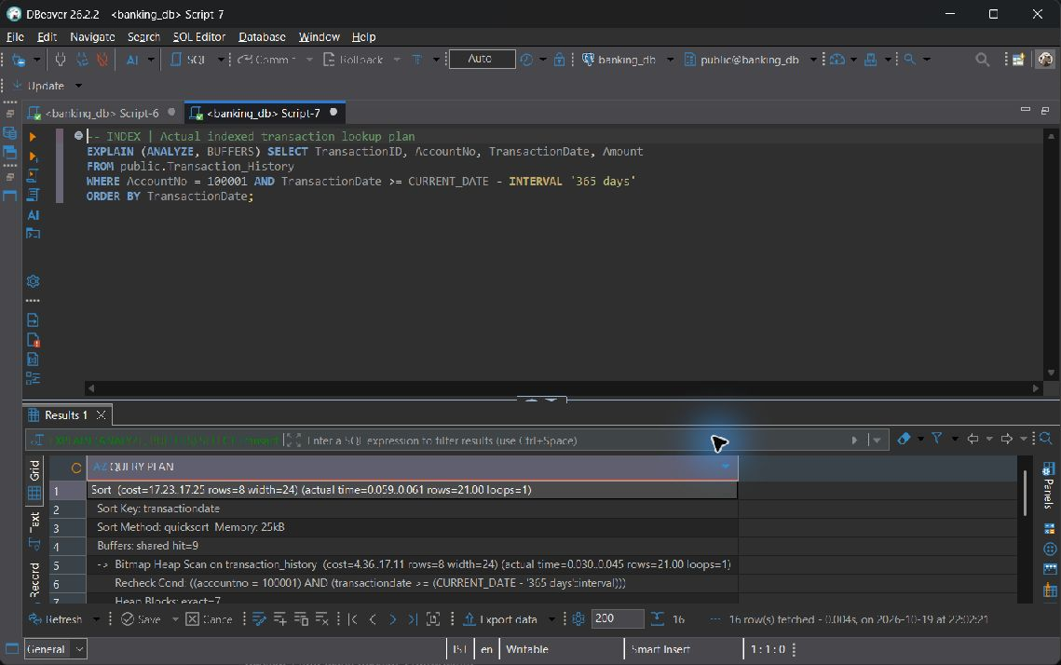
INDEX — live screenshot, 2026-10-19.
The captured plans above use the same predicate and return the same qualifying rows. With the named index available, PostgreSQL chooses Bitmap Index Scan and Bitmap Heap Scan; the plan explicitly shows whether a sort remains. Measured execution is 0.056 ms without the named index versus 0.044 ms with it available. Compare actual rows, rows removed, heap blocks and shared buffer hits rather than cost estimates alone. These timings are a single cache-sensitive sample, not a statistically valid speedup claim. Reruns and larger representative data are needed for performance conclusions; choosing a sequential scan for a small table can be correct.

8.9 Review 2 Requirements Checklist
# | Mandatory component | Script and concrete evidence | Status
1 | CREATE TABLE scripts and constraints | sql/01_ddl.sql  Twelve relations and eleven foreign keys; clean disposable rebuild committed; live constraints and definitions in Section 6. | Completed & Verified
2 | INSERT UPDATE DELETE | sql/02_dml.sql; seed_bulk_data.py  DML cycle executed during clean seed; all twelve live counts recorded; atomic bulk loader inspected. | Completed & Verified
3 | Query categories | sql/03_standard_queries.sql  Exactly 35 statements executed, with actual outputs in Section 7; all A-G functions covered, including combined Category F examples. | Completed & Verified
4 | Views | sql/05_advanced_logic.sql  Three live views, catalogue updatability evidence and output samples; four-table passbook, aggregate summary and writable restricted view. | Completed & Verified
5 | COMMIT ROLLBACK SAVEPOINT | sql/05_advanced_logic.sql; sql/06_security_concurrency.sql  Committed isolated transfer/EMI; live before/after SAVEPOINT restoration; implicit subtransaction proof. | Completed & Verified
6 | Procedures and functions | sql/05_advanced_logic.sql  Two core procedures, two business UDFs and two additional cursor procedures installed and exercised. | Completed & Verified
7 | Triggers | sql/05_advanced_logic.sql; sql/07_test_cases.sql  Two triggers and required support functions; TC-08/09 verify old/new audit growth and no-op suppression; repayment changes debt. | Completed & Verified
8 | Indexes and EXPLAIN comparison | sql/06_security_concurrency.sql  Three installed indexes and identical before/after live EXPLAIN ANALYZE BUFFERS plans reproduced. | Completed & Verified
9 | Execution evidence | sql/03_standard_queries.sql; sql/04_complex_queries.sql; sql/07_test_cases.sql  Live SQL outputs and exact PostgreSQL NOTICE text embedded; matching DBeaver screenshots accompany the shared SQL demonstrations. | Completed & Verified
10 | Design changes since Review 1 | sql/01_ddl.sql; PROJECT_SPEC.md  Section 6.1 change log with dependency reasons; generated-column formal qualification is explicit. | Completed & Verified

9 Work break down
The responsibility allocation is approximately 60% / 20% / 20%. Architecture and transactional correctness are concentrated in the first role; query coverage, datasets, interface modules and verification provide separate, reviewable contributions for the other two roles. Percentages describe assigned scope, not measured hours.
Registration Number | Name | Work Assigned
24BDS0202 | MIRZA MOHAMMAD ABBAS | Core architecture and heavy engineering. Twelve-table schema redesign and normalization; generated financial columns; sp_transfer_funds and sp_pay_loan_emi; trg_audit_account_changes and trg_loan_repayment; both explicit cursor batches; SAVEPOINT/ROLLBACK transaction design; three indexes and EXPLAIN ANALYZE comparison. Review 3 extension: all Review 2 architecture plus two-session FOR UPDATE concurrency, database RBAC architecture, FastAPI transaction engine and core React transactional API integration.
24BAI0128 | ADITYA KUMAR SAHU | Querying and data foundations. Categories A-D: basic, aggregate WHERE/HAVING contrast, all join forms and subqueries including the NOT IN NULL pitfall and fix. Three database views and atomic Faker bulk seeding through seed_bulk_data.py. Review 3 extension: Customer NetBanking passbook, transfers, beneficiaries and FD Vault screens; execute and document TC-01 through TC-08.
24BAI0001 | RISHAV MANJHI | Analytics and function verification. Categories E-G: set operations, advanced built-ins and window functions. CQ-01 through CQ-10 business-query verification; fn_calculate_emi and fn_customer_net_worth implementation and reference checks. Review 3 extension: official executive analytics, customer 360, loan origination and audit screens; execute and document TC-09 through TC-15.

10 Review Requirements
The final review demonstrates an end-to-end banking workflow backed by the same twelve-table design. The verification evidence below separates installed database security, transaction and trigger correctness, query plans, concurrency and the visible React modules. The operational dataset is retained while reproducible destructive setup is demonstrated only in a dedicated evaluation database.

10.1 Concurrency and Locking Demonstration
Two real PostgreSQL connections were used. Session A locked account 100001 without changing it. Session B attempted FOR UPDATE NOWAIT on the same row and received SQLSTATE 55P03. Both sessions then rolled back, releasing all locks. Without NOWAIT, the second writer waits and, at Read Committed, reads the current committed row after acquiring its lock.
-- Session A
BEGIN;
SELECT AccountNo, Balance FROM public.Account
WHERE AccountNo=100001 FOR UPDATE;
-- Keep transaction open while Session B runs.
ROLLBACK;
-- Session B while A holds the row
DO $$ BEGIN
PERFORM AccountNo FROM public.Account
WHERE AccountNo=100001 FOR UPDATE NOWAIT;
RAISE EXCEPTION 'Expected a conflicting row lock';
EXCEPTION WHEN lock_not_available THEN
RAISE NOTICE 'PASS: second writer blocked by first writer (55P03)';
END $$;

Session | Actual observation
A | Locked AccountNo=100001, Balance=1196030.18
B | could not obtain lock on row in relation "account"; SQLSTATE 55P03
Result | PASS; both sessions rolled back, no account row changed.

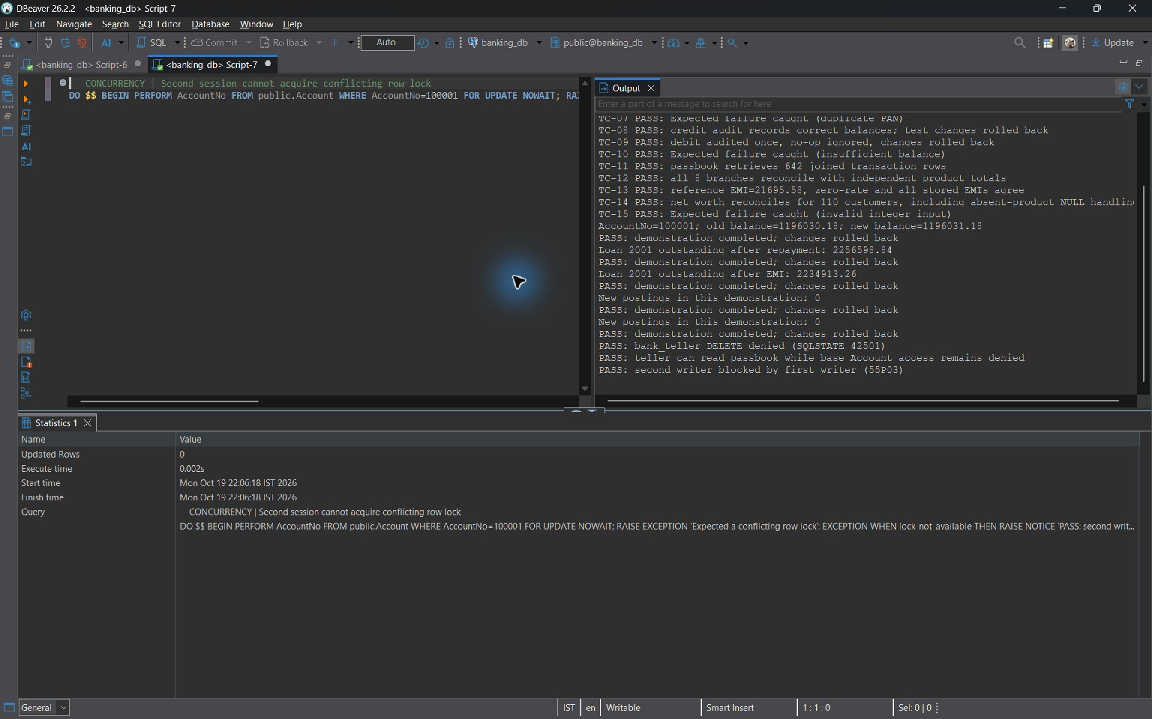
CONCURRENCY — live screenshot, 2026-10-19.
Lost-update reasoning: if two writers read balance B before locking, then each writes B minus its own payment, one debit can overwrite the other. Our cash and procedure workflows acquire row locks before reading the balance, then validate and post inside the same transaction. Internal transfers lock both account numbers in ascending order; EMI locks Account before Loan. Atomic UPDATE Balance=Balance-amount also avoids a stale application-supplied absolute value, but must still be coupled with an atomic sufficient-funds check.

10.2 Comprehensive Verification Test Suite
Every exact TC block from sql/07_test_cases.sql was executed against banking_db. Intentional errors are caught by nested EXCEPTION handlers that check the expected SQLSTATE and, where relevant, the exact constraint. A missing rejection or unrelated failure raises a fatal test error. Successful audit-test changes are deliberately rolled back. All fifteen cases passed; sequence numbers may advance despite row rollback.
Test ID | Test Category | Input / Action | Expected Result | Actual PostgreSQL Output | Status
TC-01 | Primary key | INSERT a copy of CustomerID 1 | 23505 customer_pkey rejects duplicate | NOTICE: TC-01 PASS: Expected failure caught (duplicate customer PK) | PASS
TC-02 | Foreign key | Set Account 100001 CustomerID=-2147483648 | 23503 account_customerid_fkey | NOTICE: TC-02 PASS: Expected failure caught (missing customer FK) | PASS
TC-03 | Foreign key | Set Loan 2001 BranchID=-2147483648 | 23503 loan_branchid_fkey | NOTICE: TC-03 PASS: Expected failure caught (missing branch FK) | PASS
TC-04 | CHECK age | Set Customer 1 Age=17 | 23514 customer_age_check | NOTICE: TC-04 PASS: Expected failure caught (Age below 18) | PASS
TC-05 | CHECK balance | Set Account 100001 Balance=-1 | 23514 account_balance_check | NOTICE: TC-05 PASS: Expected failure caught (negative balance) | PASS
TC-06 | CHECK gender | Set Customer 1 Gender='Invalid' | 23514 customer_gender_check | NOTICE: TC-06 PASS: Expected failure caught (invalid Gender) | PASS
TC-07 | UNIQUE PAN | Give Customer 2 Customer 1 PAN | 23505 customer_pan_number_key | NOTICE: TC-07 PASS: Expected failure caught (duplicate PAN) | PASS
TC-08 | Audit credit | Credit 1 to Account 100001; check exact old/new text, then undo | One new correct audit inside test; no retained change | NOTICE: TC-08 PASS: credit audit records correct balances; test changes rolled back | PASS
TC-09 | Audit debit and no-op | Debit 0.01 from 100003 then self-assign balance; undo | One audit for real debit; none for no-op; rollback restores both | NOTICE: TC-09 PASS: debit audited once, no-op ignored, changes rolled back | PASS
TC-10 | Procedure rejection | Transfer sender balance+1 to 100003 | 22023 insufficient balance; balances/history/audits unchanged | NOTICE: TC-10 PASS: Expected failure caught (insufficient balance) | PASS
TC-11 | Passbook view | Compare view row count with four-table join | Nonempty matching count; no displayed NULL Remarks | NOTICE: TC-11 PASS: passbook retrieves 642 joined transaction rows | PASS
TC-12 | Summary view | Reconcile branch counts, loans and attributed FDs | One row per branch; no independent-product fan-out | NOTICE: TC-12 PASS: all 8 branches reconcile with independent product totals | PASS
TC-13 | EMI UDF | Reference EMI, zero rate and every stored loan | 21695.58 reference; 1000 zero-rate; generated values agree | NOTICE: TC-13 PASS: reference EMI=21695.58, zero-rate and all stored EMIs agree | PASS
TC-14 | Net worth UDF | Compare every customer to signed UNION ALL products | All customers reconcile, including missing-product NULLs | NOTICE: TC-14 PASS: net worth reconciles for 110 customers, including absent-product NULL handling | PASS
TC-15 | Data type | Dynamic SQL assigns 'not-an-integer' to Age | 22P02 invalid integer input | NOTICE: TC-15 PASS: Expected failure caught (invalid integer input) | PASS

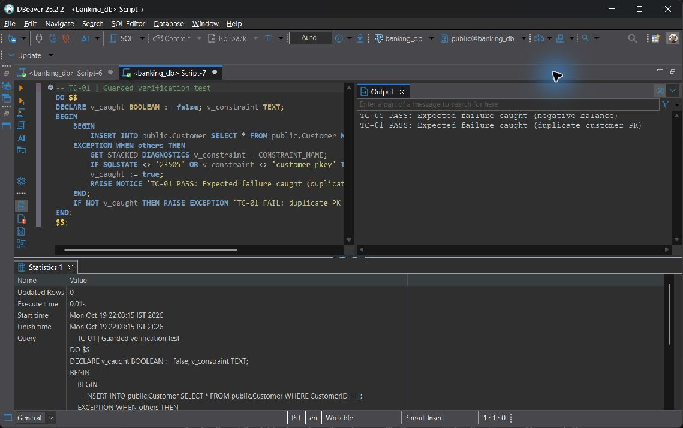
TC-01 — live screenshot, 2026-10-19.
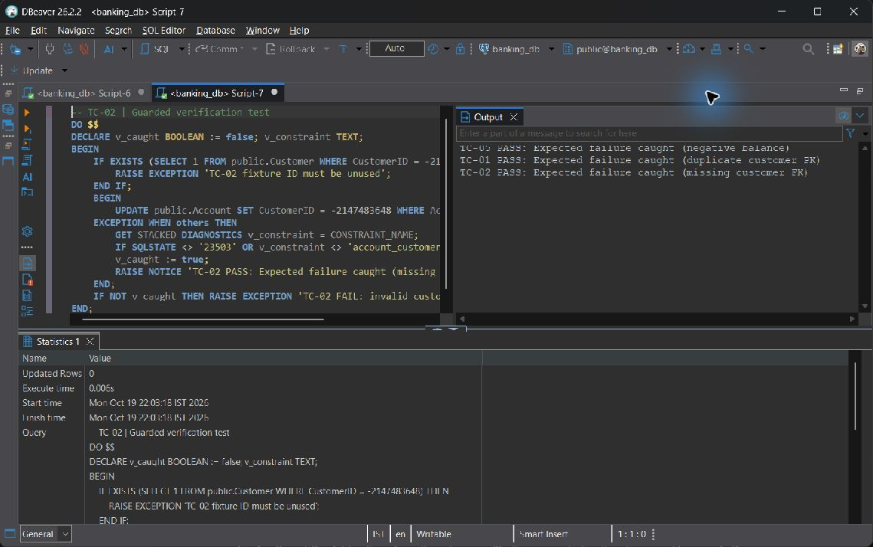
TC-02 — live screenshot, 2026-10-19.
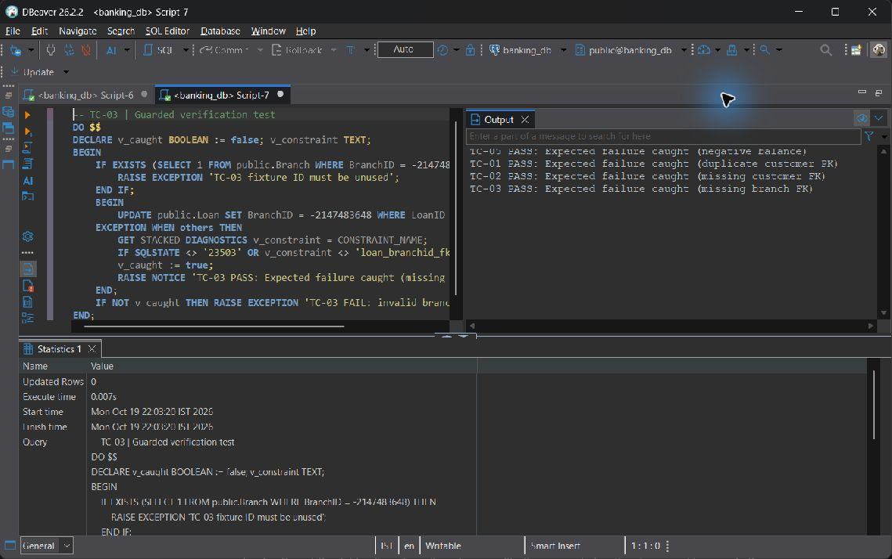
TC-03 — live screenshot, 2026-10-19.
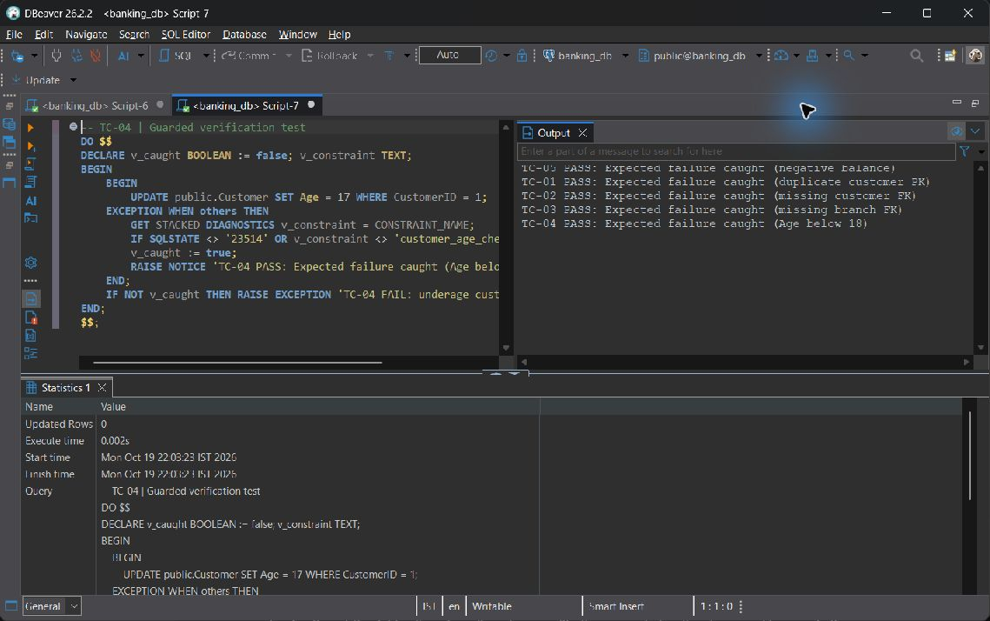
TC-04 — live screenshot, 2026-10-19.
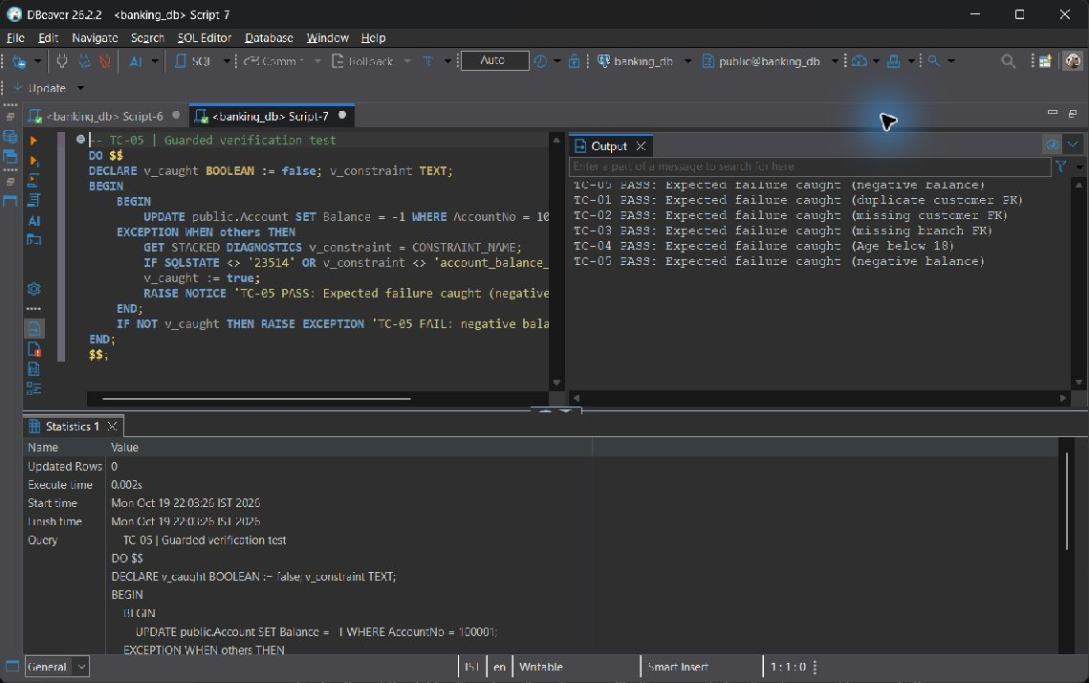
TC-05 — live screenshot, 2026-10-19.
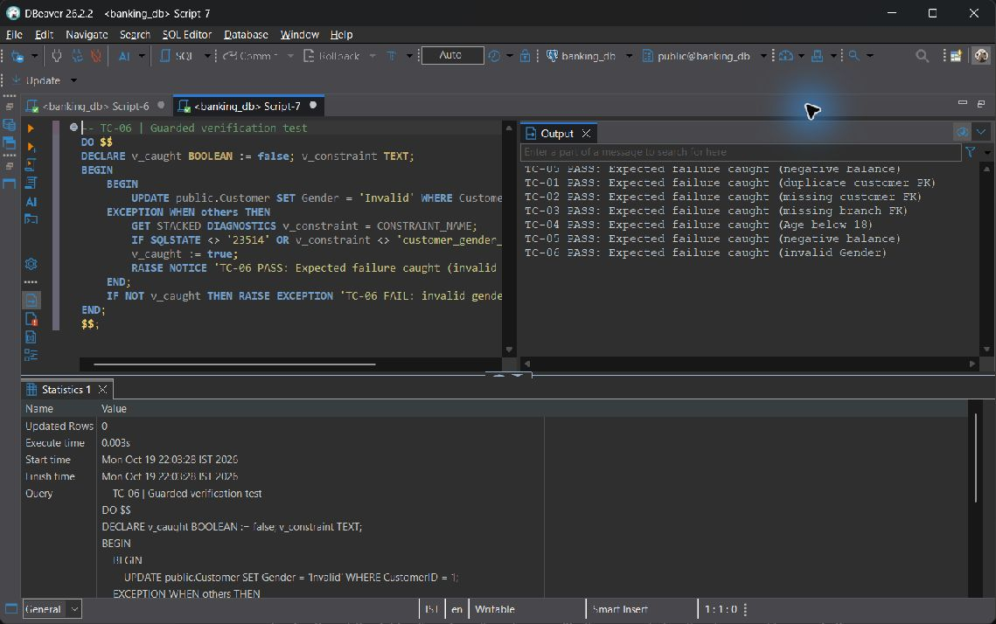
TC-06 — live screenshot, 2026-10-19.
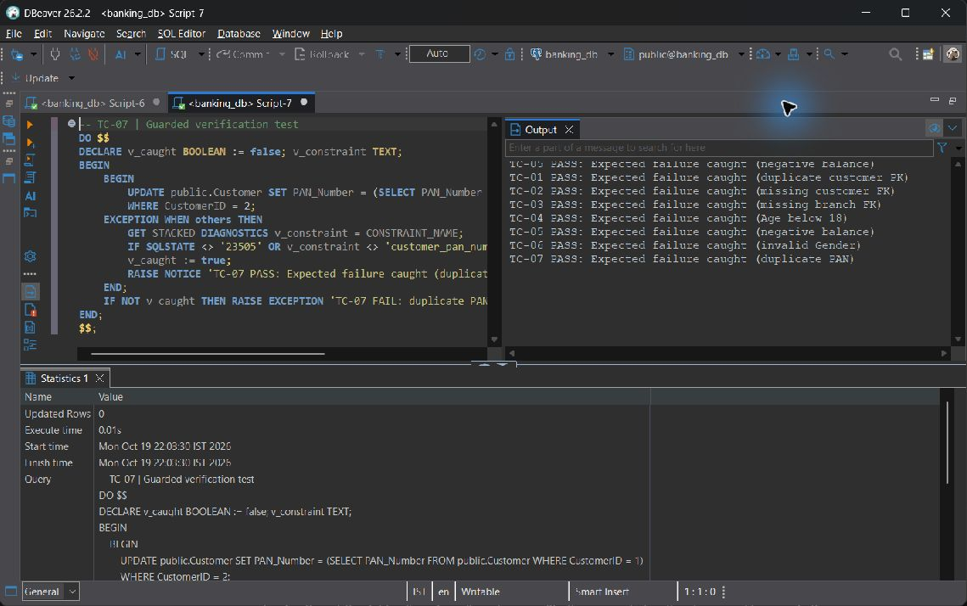
TC-07 — live screenshot, 2026-10-19.
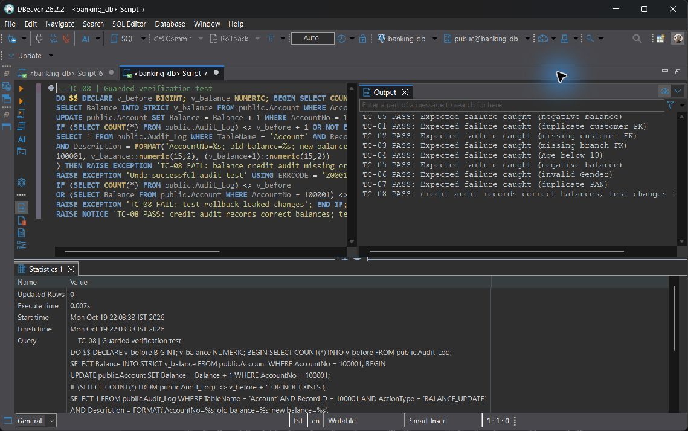
TC-08 — live screenshot, 2026-10-19.
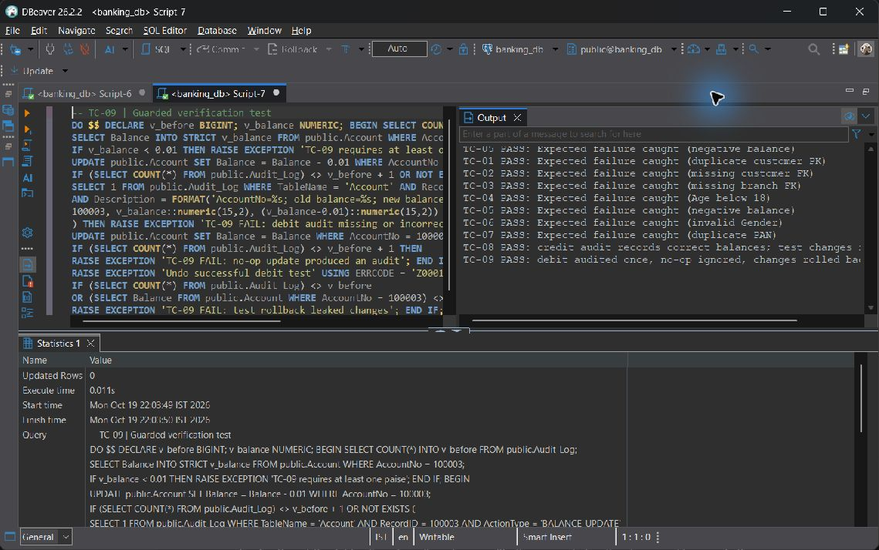
TC-09 — live screenshot, 2026-10-19.
TC-10 — live screenshot, 2026-10-19.
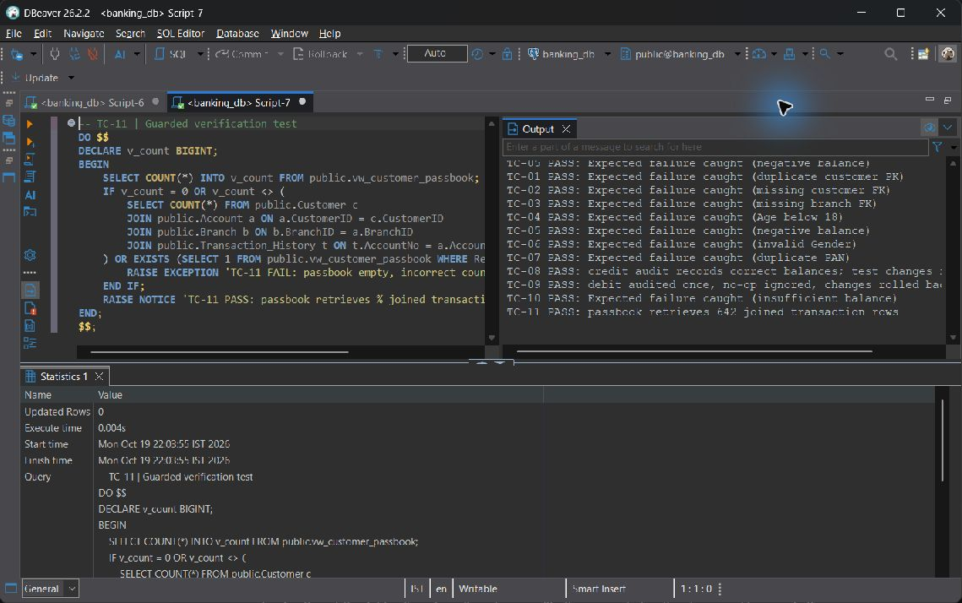
TC-11 — live screenshot, 2026-10-19.
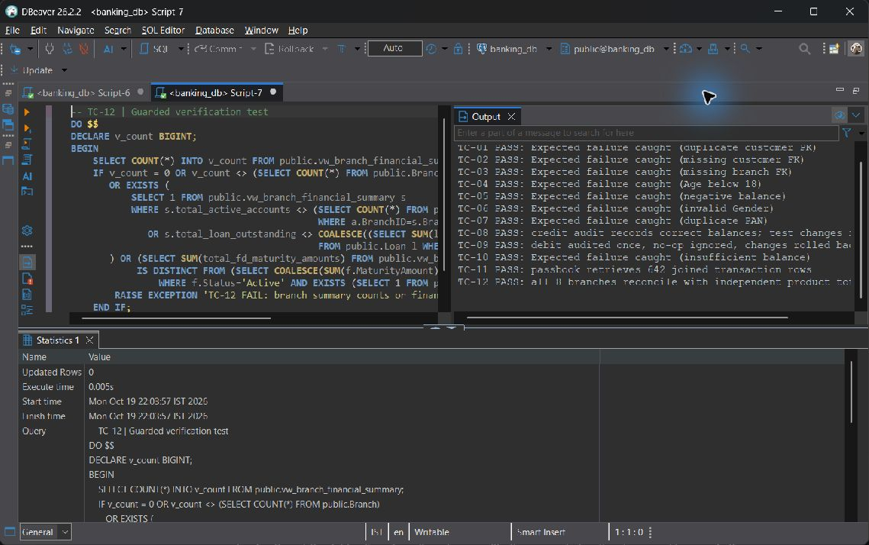
TC-12 — live screenshot, 2026-10-19.
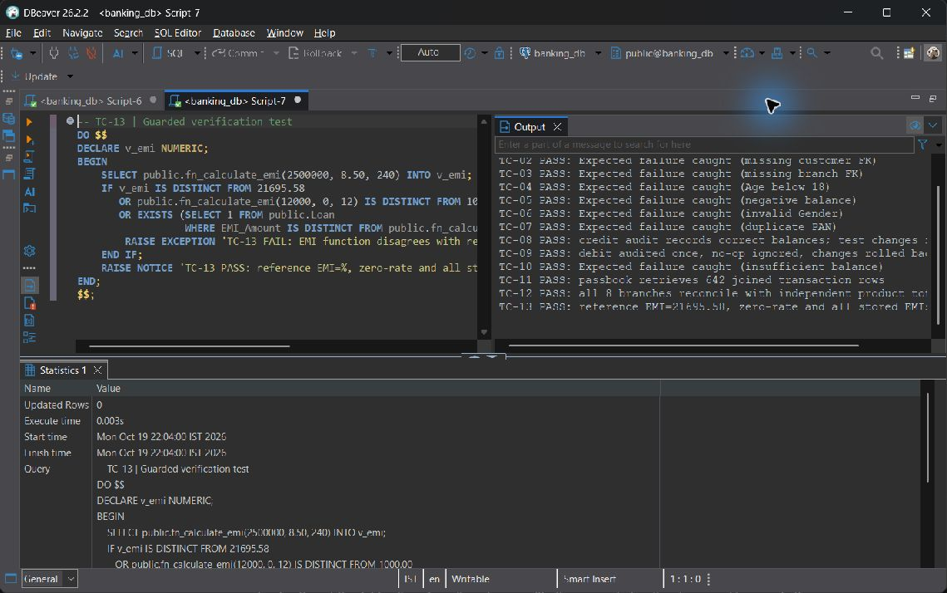
TC-13 — live screenshot, 2026-10-19.
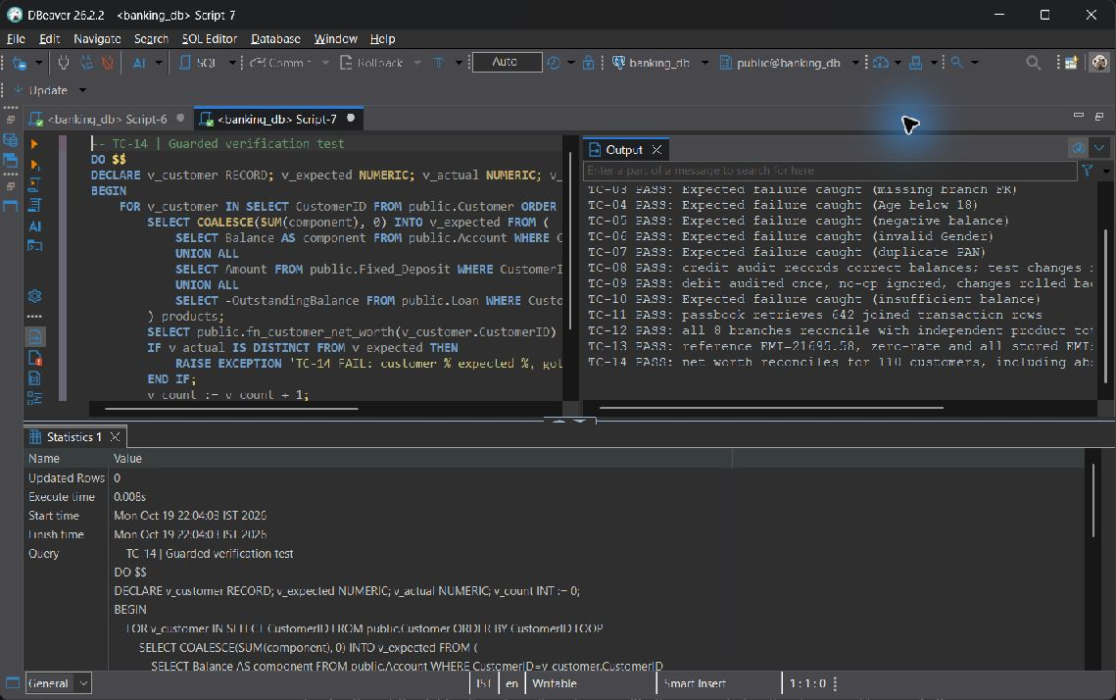
TC-14 — live screenshot, 2026-10-19.
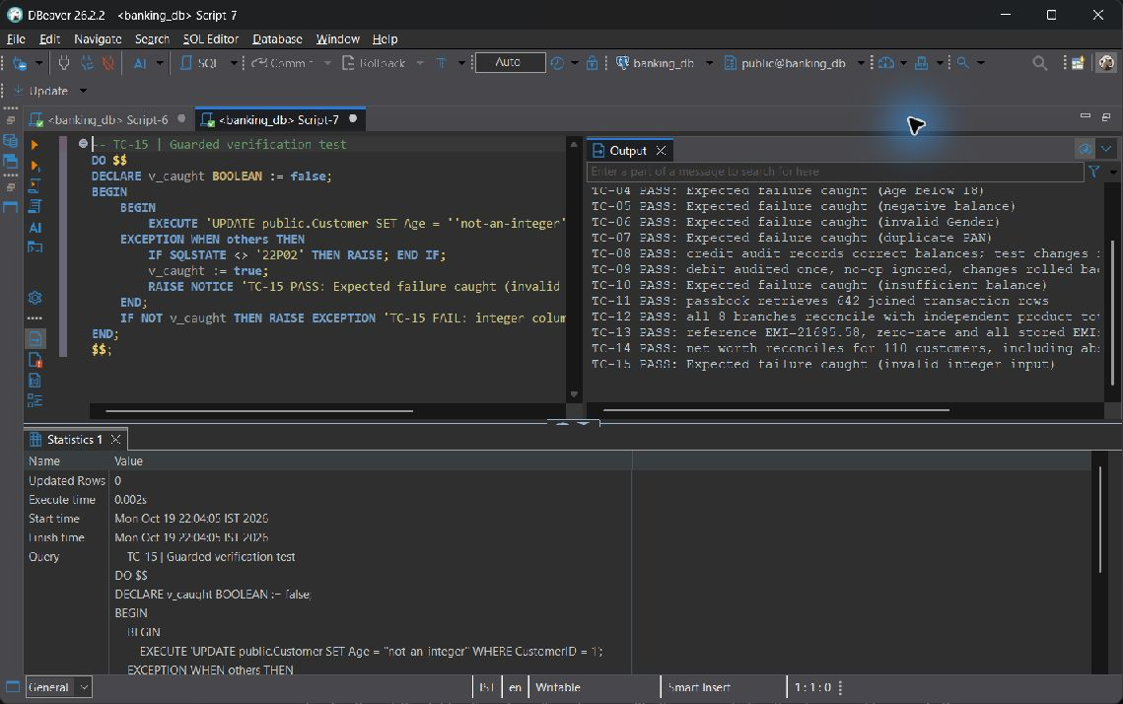
TC-15 — live screenshot, 2026-10-19.
The original executable test file remains the authoritative input. For an evaluator who wants to see the wrapped failure pattern, TC-05 is reproduced below; the remaining blocks follow the same guarded structure with test-specific assertions.
DO $$
DECLARE v_caught BOOLEAN := false; v_constraint TEXT;
BEGIN
BEGIN
UPDATE public.Account SET Balance = -1 WHERE AccountNo = 100001;
EXCEPTION WHEN others THEN
GET STACKED DIAGNOSTICS v_constraint = CONSTRAINT_NAME;
IF SQLSTATE <> '23514' OR v_constraint <> 'account_balance_check' THEN RAISE; END IF;
v_caught := true;
RAISE NOTICE 'TC-05 PASS: Expected failure caught (negative balance)';
END;
IF NOT v_caught THEN RAISE EXCEPTION 'TC-05 FAIL: negative balance accepted'; END IF;
END;
$$;

10.3 Live Demonstration Runbook
Allocate approximately eleven minutes. Use a dedicated disposable evaluation database for the clean DDL/DML step: sql/01_ddl.sql drops data and dependants. Do not point the reset at the populated banking_db shown in the application. Keep two SQL sessions ready and an API/React terminal running before the viva.
Step and time | Presenter action | Concrete evidence to show
1 Clean DDL and DML  0:00-1:30 | Create a separate evaluation database; run 01_ddl.sql and 02_dml.sql with ON_ERROR_STOP; install 05 definitions/verification before 06. The report evidence collector already proves the clean 01/02/05 sequence. | Twelve relations, constraints, DML cycle and seed counts. Use the live row-count table to distinguish the populated operational snapshot.
2 Role based access  1:30-3:00 | Use the installed roles on banking_db. SET ROLE bank_teller; SELECT * FROM vw_customer_passbook LIMIT 3; attempt DELETE FROM Account WHERE false in the guarded proof; RESET ROLE. | Passbook allowed, direct DELETE denied with 42501. Show the effective privilege matrix. Do not rerun the cluster-wide role reset in a second database.
3 Transaction and deliberate failure  3:00-5:00 | Choose an owned Active sender and receiver. Demonstrate a valid transfer on disposable fixtures; then request sender balance+1 or use a Frozen receiver. Run TC-10 for a repeatable wrapped rejection. | Commit notification for the valid workflow; exact SQL exception for rejection; both balances/history/audit unchanged on failure.
4 Trigger firing  5:00-6:30 | Run TC-08/09; show audit growth during the update and restoration after rollback. Demonstrate EMI in the verification dataset and inspect Loan_Repayment plus Loan outstanding. | One old/new balance audit; no-op creates none. A Success repayment changes debt, Pending/Failed does not.
5 Index comparison  6:30-8:30 | Run the identical EXPLAIN (ANALYZE, BUFFERS) predicate first with the named index dropped inside BEGIN/ROLLBACK, then with it restored. | Plan node change, actual row counts, buffer hits and timings. Explain small-table/cache limits; do not force a speedup.
6 Two session concurrency  8:30-11:00 | Session A locks Account 100001 FOR UPDATE; B tries FOR UPDATE NOWAIT. Show 55P03; rollback A and retry B. | Second writer cannot act on the locked row; explain the stale-read lost-update example and deterministic lock order. End with both transactions closed.

# Example safe clean setup in PowerShell
docker exec banking-postgres createdb -U postgres banking_viva
Get-Content -Raw sql/01_ddl.sql | docker exec -i banking-postgres psql -X -v ON_ERROR_STOP=1 -U postgres -d banking_viva
Get-Content -Raw sql/02_dml.sql | docker exec -i banking-postgres psql -X -v ON_ERROR_STOP=1 -U postgres -d banking_viva
Get-Content -Raw sql/05_advanced_logic.sql | docker exec -i banking-postgres psql -X -v ON_ERROR_STOP=1 -U postgres -d banking_viva
# Shared role grants are already installed on banking_db by 06.
# Use their guarded proof there, rather than resetting cluster roles here.

10.4 Working Application Modules
The frontend is React 19 with Vite, Tailwind CSS v4, Recharts and Lucide; Axios calls FastAPI on port 8000. Customer and official dashboards have six and seven distinct tabs. A shared sun/moon switch follows the system preference initially, persists explicit choice in localStorage and themes charts, tables, inputs, dialogs and notifications. Navigation can switch real customer or employee profiles instantly.

Smart Login and Global Identity Switcher
Inputs: Customer NetBanking or Bank Official role; searchable real customer directory showing IDs, owned accounts, balances and KYC; direct CustomerID/AccountNo option; employee or system-admin choice. API calls: GET /api/directory/customers-preview, /employees-preview and /lookups, followed by POST /api/login. Output: selected profile and portal route, saved locally. The switcher uses the same real directory without guessing IDs.
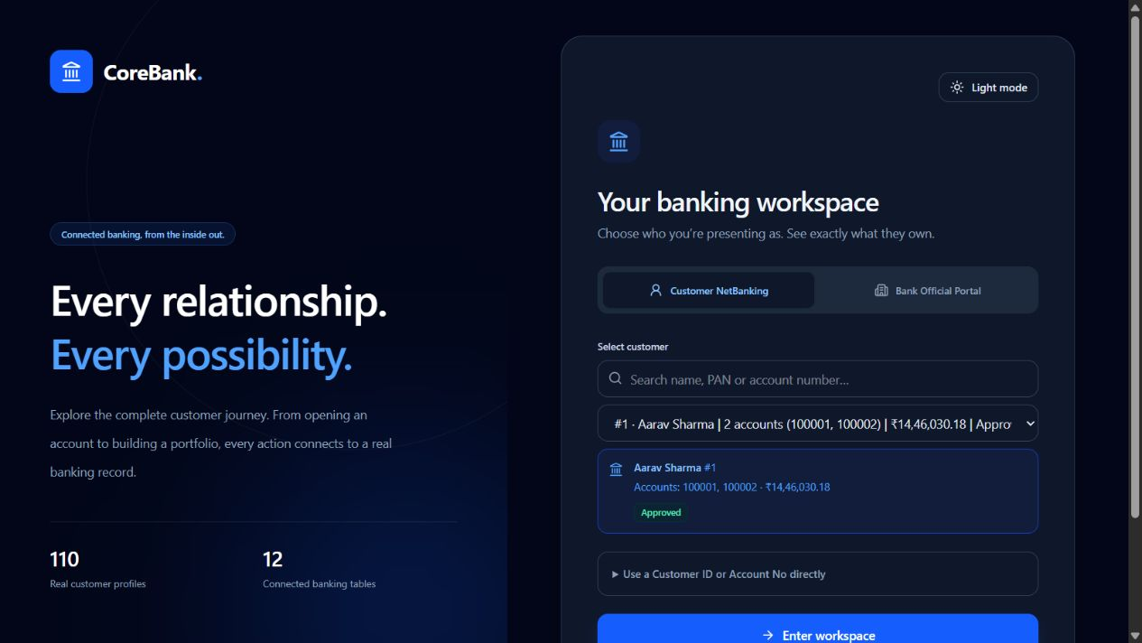
Smart Login and Identity Switcher — live screenshot, 2026-10-19.

Customer NetBanking Portal
Tab 1 Portfolio Overview
Accessible inputs: Customer identity selected at login; Refresh portfolio.
Backend API and SQL: GET /api/customer/{id}/overview; fn_customer_net_worth(id); independent Account, Fixed_Deposit and Loan aggregates.
Visible outputs: Net worth, liquid balance, Active FD principal and maturity, loan liability, KYC and beneficiary count; asset/liability chart and recent transaction feed.
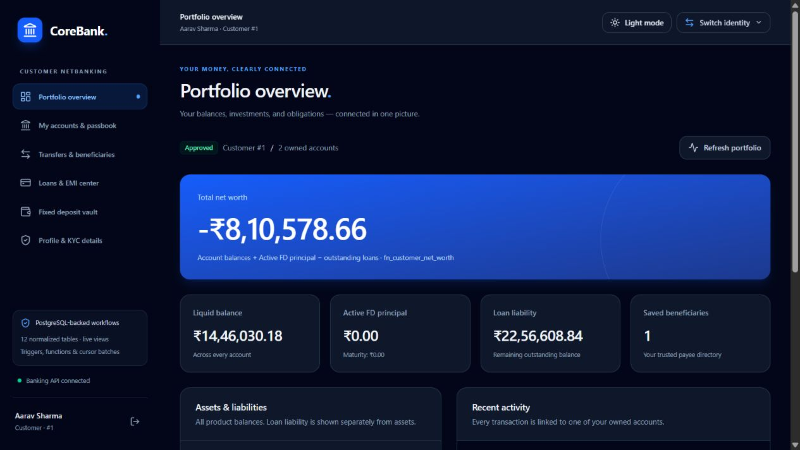
Portfolio Overview — live screenshot, 2026-10-19.
Tab 2 My Accounts and Passbook
Accessible inputs: Account cards; Deposit and Withdraw dialogs with owned AccountNo, amount, mode and remarks; statement filters for account, type and channel.
Backend API and SQL: GET /api/customer/{id}/accounts and /transactions; POST /api/transaction/deposit or /withdraw; SELECT FOR UPDATE, Account UPDATE, Transaction_History INSERT, audit trigger.
Visible outputs: Exact account ownership, servicing branch and IFSC, rates, status, opening dates and balances. Successful writes refresh the statement; invalid or Frozen/Dormant accounts show rejection.
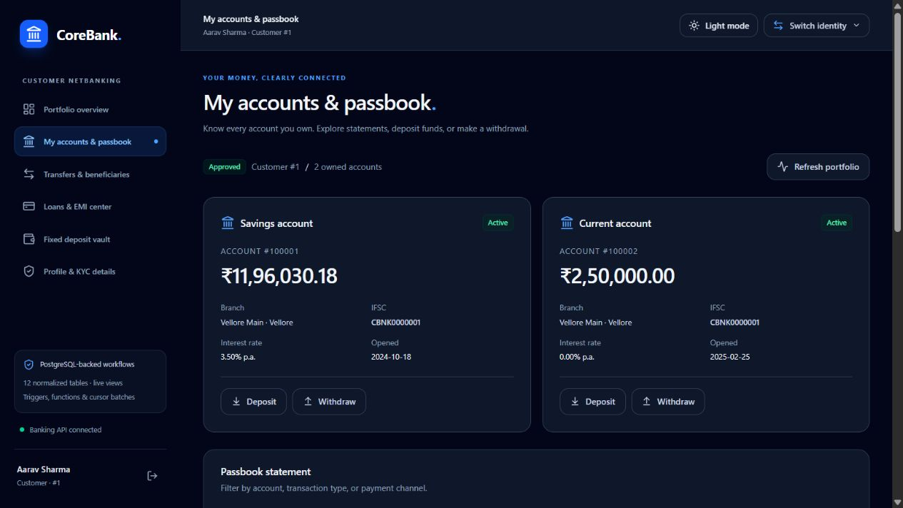
My Accounts and Passbook — live screenshot, 2026-10-19.
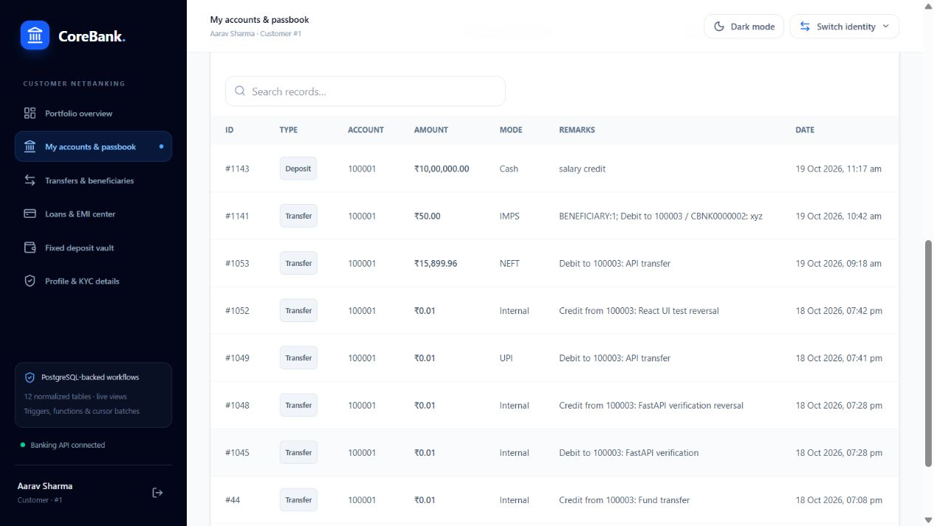
Passbook statement rows — live screenshot, 2026-10-19.
Tab 3 Fund Transfers and Beneficiaries
Accessible inputs: Choose internal account or saved beneficiary; select sender, receiver/payee, amount, mode, remarks. Add payee name, external-capable account, existing/new IFSC and limit; delete a saved payee.
Backend API and SQL: POST /api/transaction/transfer; internal CALL sp_transfer_funds; saved-payee lock and _bank_transfer_atomic for internal settlement, or an atomic outward debit for external destinations. GET/POST /api/customer/{id}/beneficiaries; DELETE /api/beneficiaries/{id}?customer_id=... .
Visible outputs: Commit/error notification and refreshed balances/history. Daily limits sum tagged outgoing events across owned sender accounts. External payments are recorded local outward events, not real payment-rail settlement.
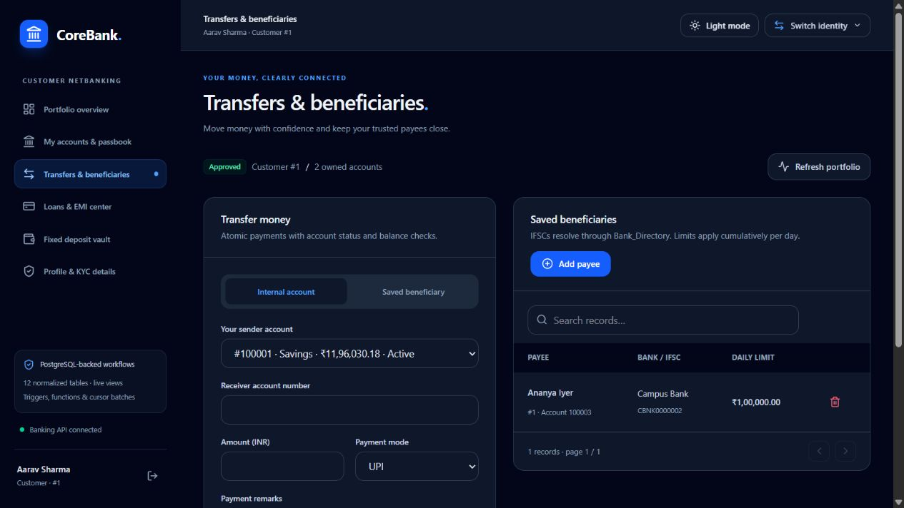
Fund Transfers and Beneficiaries — live screenshot, 2026-10-19.
Tab 4 Loans and EMI Center
Accessible inputs: Select a loan; Pay Monthly EMI with owned funding AccountNo; View repayments.
Backend API and SQL: GET /api/customer/{id}/loans; GET /api/loans/{id}/repayments?customer_id=...; POST /api/loans/pay-emi -> CALL sp_pay_loan_emi.
Visible outputs: Principal, rate, tenure, generated EMI, outstanding, status and paid-principal progress; real Loan_Repayment history refreshes after the trigger fires. No fictional amortization or due-date schedule is generated.
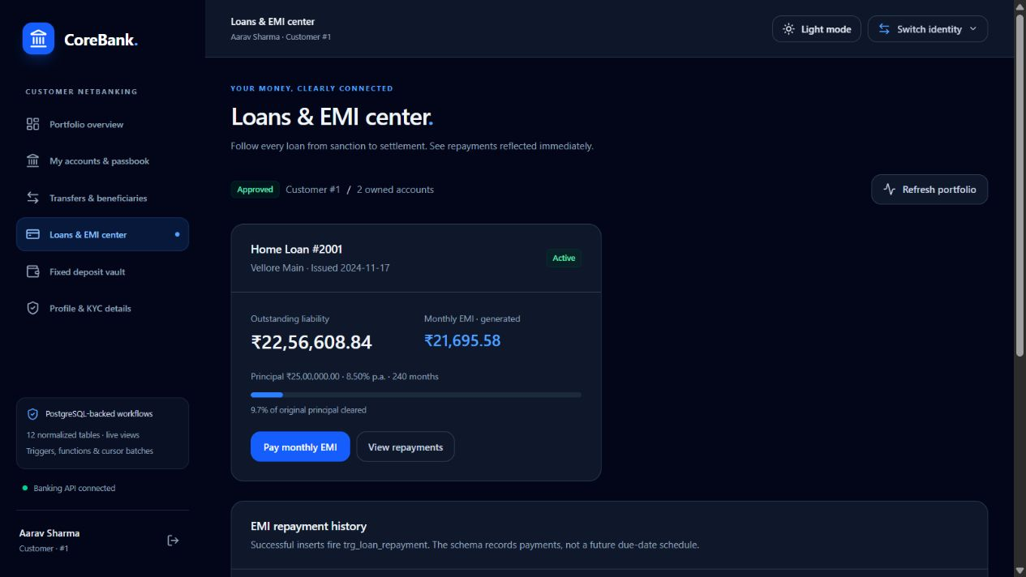
Loans and EMI Center — live screenshot, 2026-10-19.
Tab 5 Fixed Deposit Vault
Accessible inputs: Open New Fixed Deposit: funding AccountNo, principal >= INR 1,000, annual rate, StartDate and EndDate; live estimated maturity.
Backend API and SQL: GET/POST /api/customer/{id}/fixed-deposits; one transaction debits the owned Active account, logs funding and INSERTs Fixed_Deposit without MaturityAmount.
Visible outputs: FD lifecycle table and database-generated maturity; a failed date CHECK rolls back both the FD insert and prior funding debit.
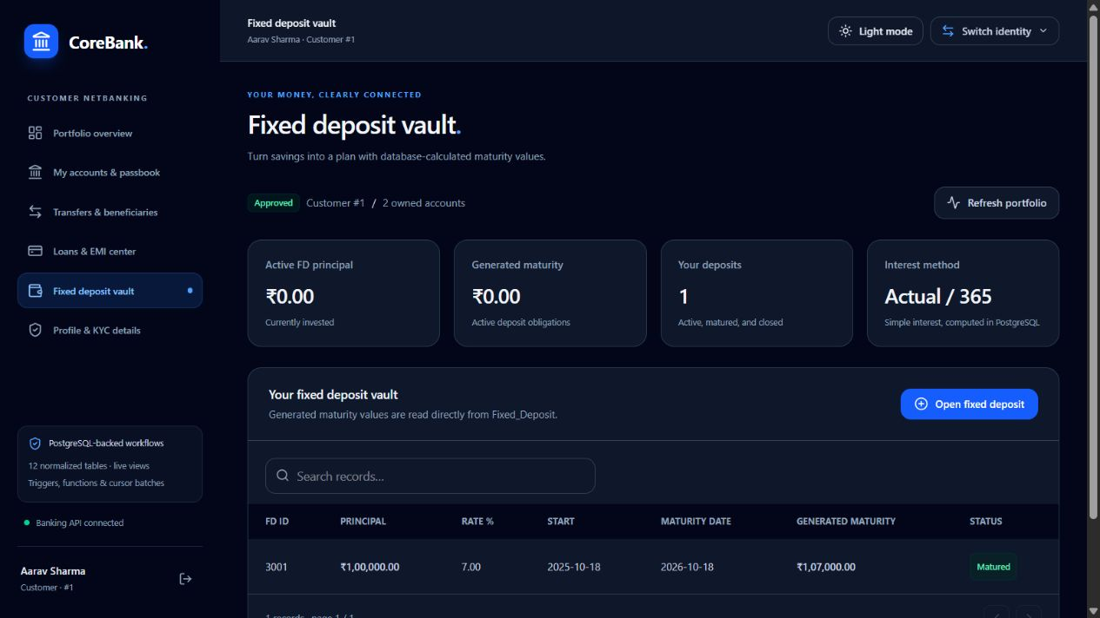
Fixed Deposit Vault — live screenshot, 2026-10-19.
Tab 6 Profile and KYC Details
Accessible inputs: Select the customer using the global identity switcher; read-only KYC record.
Backend API and SQL: GET /api/customer/{id}/overview -> Customer.
Visible outputs: CustomerID, full name, Gender, Age, Address, Phone, Email, PAN_Number and KYC_Status. KYC approval is an official workflow.
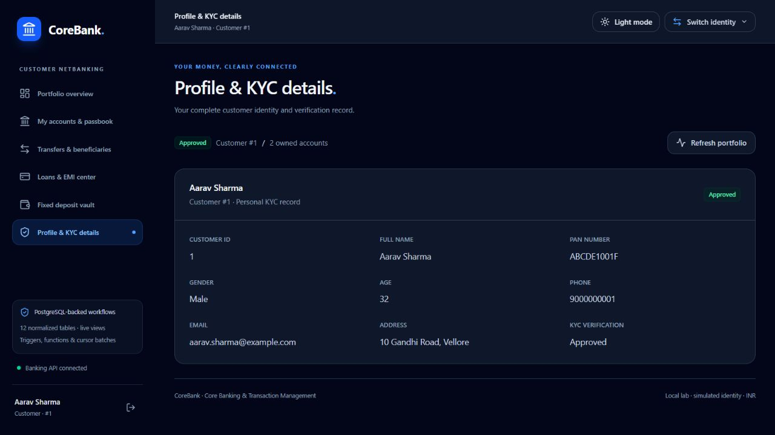
Profile and KYC Details — live screenshot, 2026-10-19.

Bank Official Portal
Tab 1 Executive Analytics and Views
Accessible inputs: Refresh records; bank-wide KPI, chart and table inspection.
Backend API and SQL: GET /api/admin/dashboard and /summary; vw_branch_financial_summary; vw_active_vellore_accounts; independent product aggregates and all 12 table counts.
Visible outputs: CASA deposits, active loan and FD books, customers/branches/staff, branch deposits versus loans, account/loan distributions, payment-mode volume, and live view results.
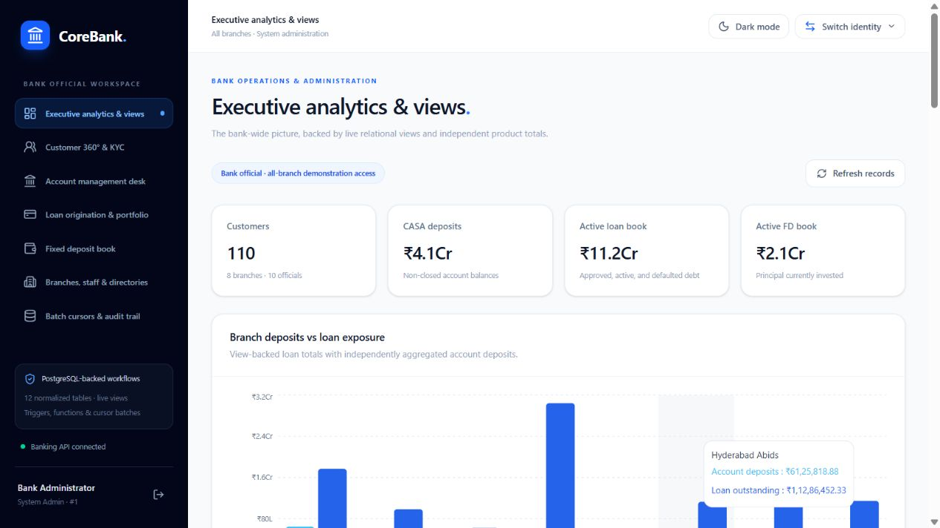
Executive Analytics and Views — live screenshot, 2026-10-19.
Tab 2 Customer 360 and KYC Directory
Accessible inputs: Search by identity/PAN/account; KYC filter; Inspect 360; Approve/Reject; Onboard New Customer with KYC/contact fields.
Backend API and SQL: GET /api/admin/customers-master?search=&kyc_status=; GET /api/admin/customer/{id}/full-360; POST /api/admin/customers; PATCH /api/admin/customers/{id}/kyc.
Visible outputs: Owner-to-account chips, total balances, active loan/FD counts, complete portfolio modal and KYC feedback. Advisory-lock ID allocation and database UNIQUE/CHECK constraints protect onboarding.
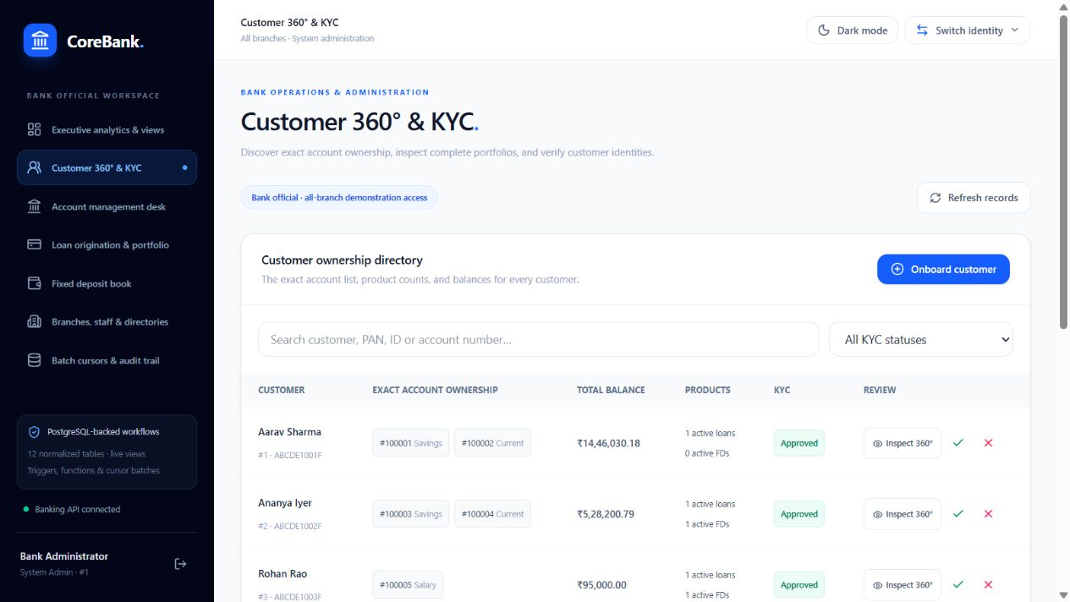
Customer 360 and KYC Directory — live screenshot, 2026-10-19.
Tab 3 Account Management Desk
Accessible inputs: Search/filter master accounts; open account by Customer, Branch, Savings/Current/Salary, deposit and rate; set Active, Dormant, Frozen or Closed.
Backend API and SQL: GET/POST /api/admin/accounts; PATCH /api/admin/accounts/{account_no}/status; opening deposit is recorded in Transaction_History in the same transaction.
Visible outputs: Owner identity, account number, branch, type, balance and rate; immediate status updates. A frozen account is subsequently rejected by the transfer/withdrawal logic.
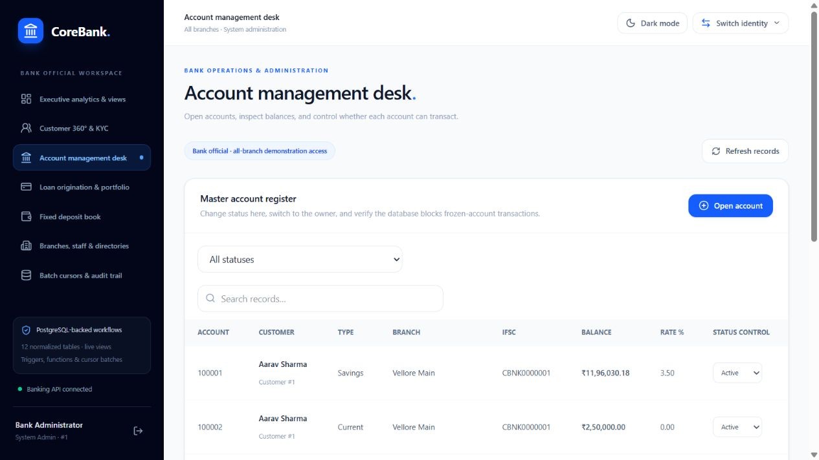
Account Management Desk — live screenshot, 2026-10-19.
Tab 4 Loan Origination and Portfolio
Accessible inputs: Borrower, issuing branch, Home/Personal/Auto/Education/Business, principal, rate, months; optional borrower disbursement account.
Backend API and SQL: GET/POST /api/admin/loans; GET /api/admin/emi-preview -> fn_calculate_emi; generated Loan.EMI_Amount; optional Account credit/history in one transaction.
Visible outputs: Live database EMI preview, loan master with ownership and terms, Approved loan without disbursement or Active loan with disbursement. Only the borrower accounts appear as funding destinations.
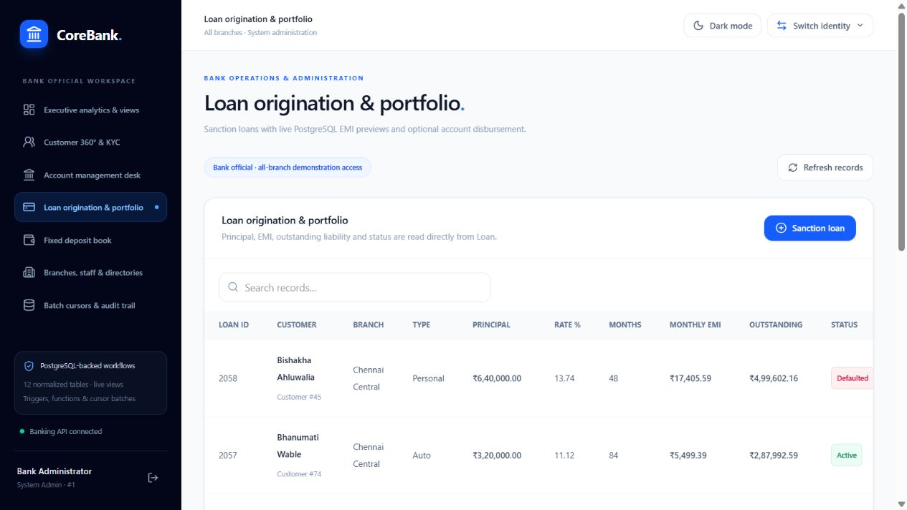
Loan Origination and Portfolio — live screenshot, 2026-10-19.
Tab 5 Fixed Deposit Book
Accessible inputs: Status filter Active/Matured/Closed; search across customer investments.
Backend API and SQL: GET /api/admin/fixed-deposits?status= -> Fixed_Deposit JOIN Customer.
Visible outputs: All FD IDs, owner names, principal, rates, dates, generated maturity and lifecycle state.
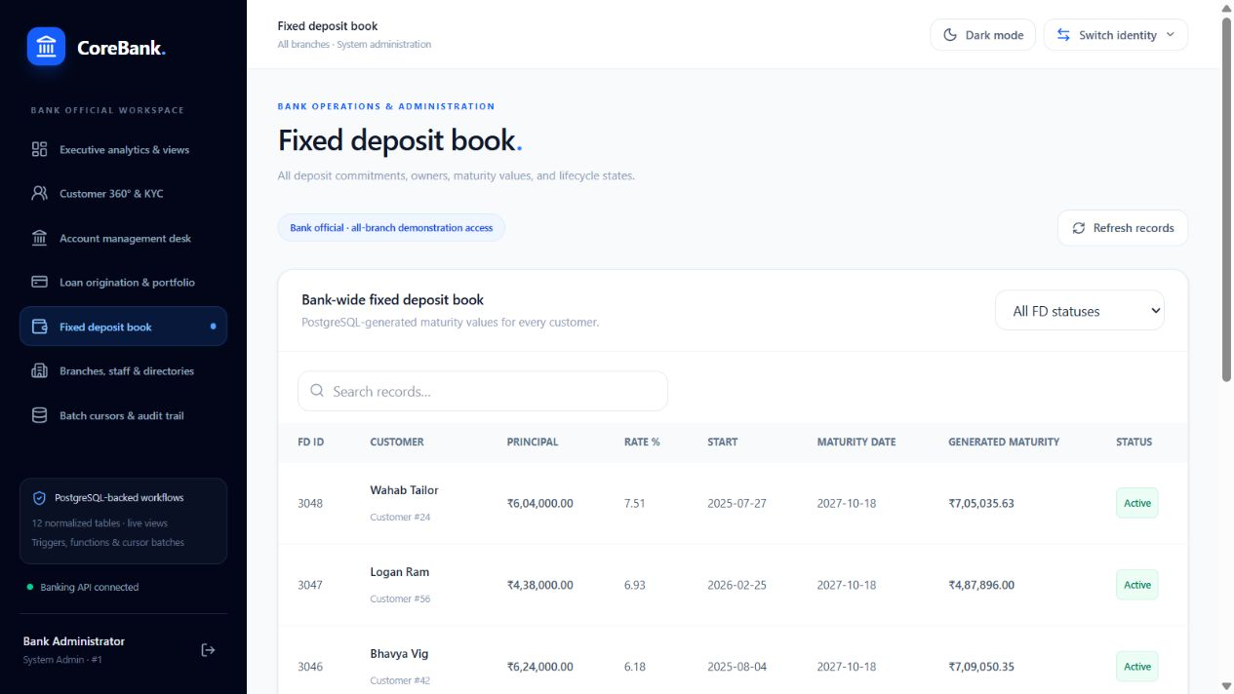
Fixed Deposit Book — live screenshot, 2026-10-19.
Tab 6 Branches Staff and Lookup Directories
Accessible inputs: Sub-tabs for branch network, officials, postal and IFSC directories; add branch/pincode, bank IFSC or employee using normalized lookups.
Backend API and SQL: GET /api/admin/infrastructure; POST /api/admin/branches, /employees, /postal-directory and /bank-directory.
Visible outputs: Branch locations/contacts; employee roster; canonical Pincode -> City/State and IFSC -> BankName. Conflicting existing shared facts are rejected rather than silently overwritten.
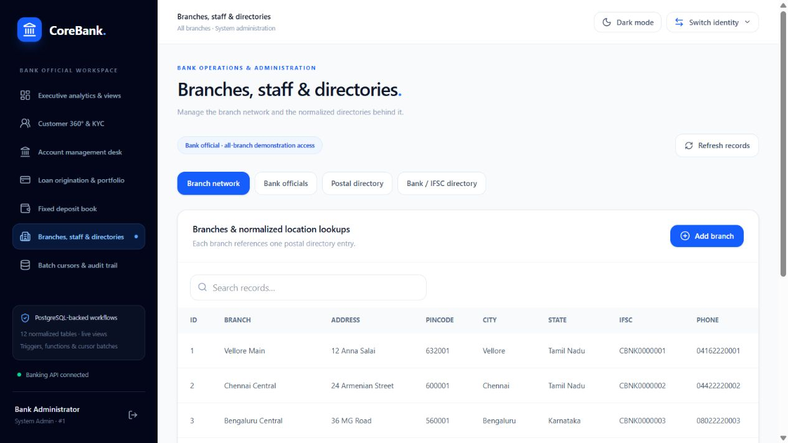
Branches Staff and Lookup Directories — live screenshot, 2026-10-19.
Tab 7 Batch Cursors and Live Trigger Audit
Accessible inputs: Run savings interest or FD maturity batch; filter audit by TableName and ActionType; Refresh records.
Backend API and SQL: POST /api/admin/batch/interest and /mature-fds -> corresponding cursor procedures; GET /api/admin/audit-log and /programmability.
Visible outputs: Processed counts, latest 100 audit rows polled every 10 seconds while the tab is visible, and installed view/routine/trigger catalogue. Duplicate posting guards make immediate batch reruns no-ops.
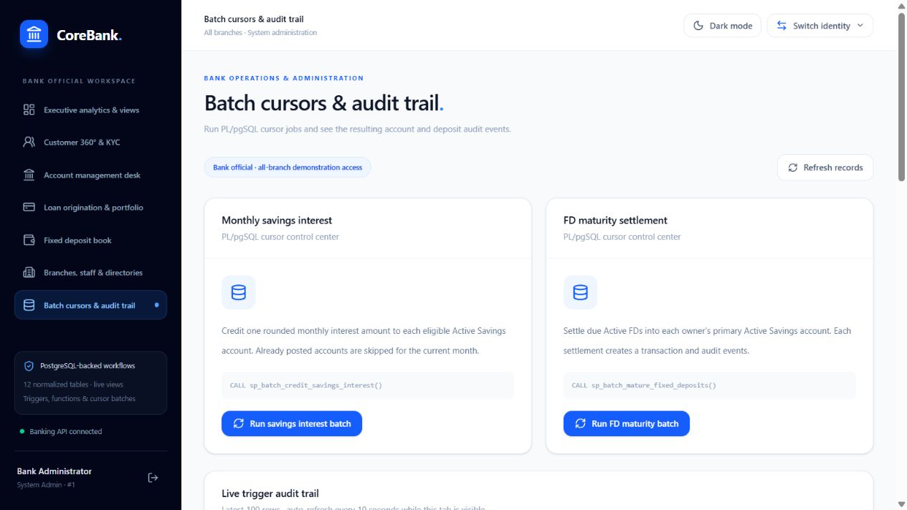
Batch Cursors and Live Trigger Audit — live screenshot, 2026-10-19.
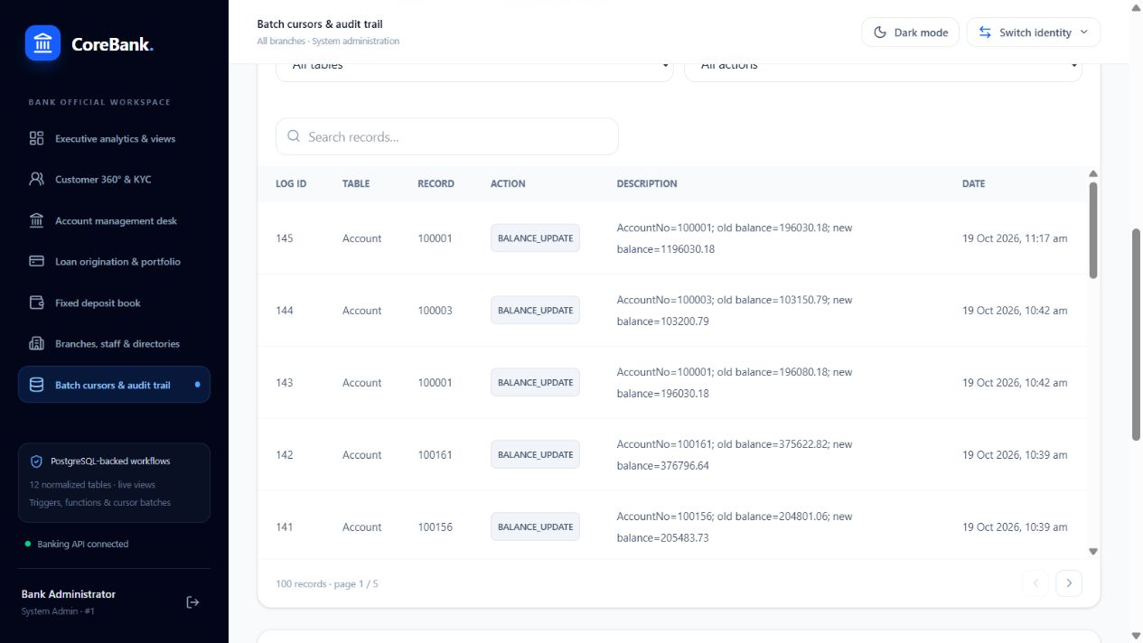
Live audit rows — live screenshot, 2026-10-19.
Transaction contract: request amounts are validated as finite decimal values, sent through Psycopg2 parameters and returned as decimal strings. Direct sp_transfer_funds CALL uses its own autocommit connection for explicit COMMIT; multi-statement application workflows use a single managed transaction. PostgreSQL failures retain their original text and SQLSTATE for the review demonstration. Validation failures are 422, ownership mismatches can return 403, and absent records return 404.
API security qualification: current portal route guards and saved identities are navigation conveniences, not authenticated authorization. No passwords are stored by the app. Development CORS is unrestricted, and the API uses the supplied local postgres account. Production deployment would require authenticated identities, role/branch authorization, a least-privileged service account, secret management and an intentional error-disclosure policy; those are not represented as delivered security controls.

10.5 Viva Preparation and Evaluation Anchors
1. Why use AccountNo as the primary key?
It identifies one account independently of its owner and branch. CustomerID cannot be the account key because one customer can hold multiple accounts.
2. Show a functional dependency and closure.
In Postal_Directory, Pincode -> City,State, so Pincode+ is {Pincode,City,State}; it is a candidate key under the canonical-postal-location assumption.
3. Which update anomaly was removed?
Repeating City/State in Branch would allow two branches with one pincode to disagree after an update. The lookup holds the canonical fact once.
4. Are the generated-column tables strictly 3NF or BCNF?
Their independent base facts are normalized; their stored generated extensions have non-key determinants. Section 6 states this qualification rather than asserting BCNF.
5. When might you denormalize?
A cached branch aggregate may help high-volume reporting, but introduces refresh/consistency costs. Our view aggregates product totals without a separate persistent summary table.
6. Where is the M:N junction?
This model has no joint-account or arbitrary customer-product junction. Customer-to-Branch can be traversed through Account, whose AccountNo distinguishes multiple accounts for one owner/branch pair.
7. Why only selected delete cascades?
Customer -> Account/Beneficiary and Loan -> Loan_Repayment are declared cascades. Transaction history can still block account deletion. Broad cascades could destroy financial evidence.
8. What if a referenced parent is deleted?
The FK NO ACTION rule rejects deletion while protected child rows exist, unless the FK explicitly declares CASCADE. Demonstrate only in a rollback transaction.
9. Why combine CHECK and NOT NULL?
CHECK rejects false but accepts unknown. Balance is NOT NULL plus CHECK Balance>=0; a nullable status CHECK does not by itself reject NULL.
10. DELETE TRUNCATE or DROP?
DELETE removes qualifying rows and fires row DELETE triggers; TRUNCATE removes all rows with stronger locking and separate trigger rules; DROP removes objects. PostgreSQL can roll these DDL/data effects back, subject to dependency rules.
11. Why LEFT JOIN in a business report?
CQ-09 retains loans without any repayment attempt; an INNER JOIN would omit them and hide zero-collection loans.
12. WHERE versus HAVING?
B-04 applies Active status before grouping, then tests the branch SUM in HAVING. SUM cannot be used in that WHERE level.
13. Why does NOT IN fail with NULL?
An unmatched comparison against a set containing NULL is UNKNOWN. D-06 filters the inner NULLs; NOT EXISTS is another intentional anti-join design.
14. EXISTS versus IN?
EXISTS tests row existence without multiplying the outer customer; D-04 uses it with correlated criteria. PostgreSQL may transform either form into a semi-join; measure the actual plan.
15. Correlated subquery or join on large data?
A join rewrite must preserve multiplicity, NULL and aggregation semantics. Neither syntax is always faster; compare representative plans, estimates and buffers.
16. UNION or UNION ALL?
UNION removes duplicates; UNION ALL retains individual product rows in E-02. Removing duplicates can destroy intended multiplicity and adds distinct-processing work.
17. COUNT star column and DISTINCT?
COUNT(*) counts rows, COUNT(Remarks) skips NULL remarks, COUNT(DISTINCT Remarks) counts distinct non-NULL values. A-06 proves missing remarks exist.
18. Why index AccountNo before TransactionDate?
The demonstration uses equality on account and a date range. A predicate only on the trailing date has different selectivity/access costs and is not guaranteed to use this index.
19. When can an index be ignored?
For a small table or a predicate matching most rows, sequential scanning can cost less than index access plus heap fetches. Planner choice is not an implementation failure.
20. Explain the measured plan.
The baseline scans 642 rows and retains 21; the indexed plan uses a bitmap index then heap scan and sorts by date. Actual timings are too small and cache-sensitive for a general speedup claim.
21. How to prove an index benefit?
Use larger representative datasets, maintained statistics, repeated measurements and buffer/row analysis with identical predicates. Do not force enable_seqscan off as proof of a natural planner benefit.
22. What do more indexes cost?
Every INSERT/DELETE and indexed-column UPDATE maintains index entries; storage, WAL, vacuum and cache pressure can grow. Add indexes for measured access patterns.
23. What prevents two debits from overspending?
Lock the account before reading and checking its balance, then debit in the same transaction. A competing writer waits; an unlocked stale application read is insufficient.
24. Two ways to prevent a lost update?
Use SELECT FOR UPDATE before read-modify-write, or a conditional atomic UPDATE with a Balance>=amount predicate and checked row count. Serializable transactions can also require application retries.
25. What anomalies remain at Read Committed?
PostgreSQL never exposes dirty reads. Read Committed uses a new snapshot per statement, so non-repeatable reads and phantoms can occur. Repeatable Read removes those snapshot changes but can still need serialization reasoning.
26. How is committed data durable?
WAL and commit flush behavior, checkpoints, fsync and synchronous_commit settings determine recovery guarantees. The project relies on PostgreSQL defaults and does not claim a separately tested power-loss recovery experiment.
27. How can deadlocks occur?
Opposite transfers locking sender first can form a cycle. Our transfer locks both Account numbers in one ascending order; clients must still handle retryable deadlock/serialization errors.
28. Procedure function or trigger?
EMI calculation is a SELECT-callable function; transfer is a CALL procedure with transaction control. Auditing and repayment side effects are triggers. Hidden trigger recursion or unbounded side effects would be hazards.
29. Why keep explicit cursors?
A set-based UPDATE is often more efficient, but the rubric requires explicit iteration. Our bound cursor loops illustrate per-row checks and coordinated audit/history postings within one atomic batch.
30. How are injection branch access and passwords handled?
Psycopg2 parameters separate values from SQL; RBAC does not replace parameterization. The current API has simulated identity and no password store or enforced branch authorization. A production design would authenticate users and use branch-filtered policies with least-privileged connections.
31. How would you recover an accidental deletion?
A verified base backup plus archived WAL can support point-in-time recovery before the deletion. A routine pg_dump alone is not arbitrary PITR. No archived-WAL/PITR environment is implemented or tested in this lab.

